Zymobacter palmae pyruvate decarboxylase production process development: Cloning in Escherichia coli, fed-batch culture and purification
Natàlia Alcover¹, Albert Carceller¹, Gregorio Álvaro¹, Marina Guillén¹
¹Bioprocess Engineering and Applied Biocatalysis Group, Department of Chemical Biological and Environmental Engineering, Universitat Autònoma de Barcelona, 08193 Bellaterra, Spain.

Corresponding author:
Marina Guillén
Department of Chemical, Biological and Environmental Engineering, Universitat Autònoma de Barcelona, 08193 Bellaterra, Spain
Telephone: +34 93 581 4793
Fax: +34 93 581 2013
marina.guillen@uab.cat

Keywords: Pyruvate decarboxylase (PDC), Zymobacter palmae, fed-batch culture, PDC purification, high cell density cultures
List of abbreviations: PDC, Pyruvate decarboxylase; DCW, Dry cell weight, HCDC, High cell density culture; MANA-agarose, Amino functionalized agarose; LB, Luria-Bertrani medium; DM Defined medium; TES, Trace elements solution.
Practical Application
Pyruvate decarboxylase (PDC) is a very powerful tool in bioprocesses. PDC has an important role in the ethanol synthesis pathway; therefore its overexpression in target microorganisms is of interest for ethanol production. Moreover, PDC can be found in several multienzymatic systems of interest in biocatalysis such as the synthesis of chiral amines in combination with transaminases, where it drives the equilibrium towards formation of the target chiral amine by producing acetaldehyde and CO₂ from pyruvate. Despite its importance in biocatalysis, the use of PDC at large scale is hampered by the lack of an efficient production process. The present study develops a recombinant production and a purification process for PDC from Zymobacter palmae expressed in Escherichia coli, broadening its application of use at high scale. This is the first work reporting the evaluation of the production and downstream processing of PDC on a bioreactor scale.

Abstract
Pyruvate decarboxylase (PDC) is responsible for the decarboxylation of pyruvate, producing acetaldehyde and CO₂ and is of high interest for industrial applications. PDC is a very powerful tool in the enzymatic synthesis of chiral amines by combining it with transaminases when alanine is used as amine donor. However, one of the main drawbacks that hampers its use in biocatalysis is its production and the downstream processing on scale.
In this paper, a production process of PDC from Zymobacter palmae has been developed. The enzyme has been cloned and overexpressed in Escherichia coli. It is presented, for the first time, the evaluation of the production of recombinant PDC in a bench-scale bioreactor, applying a substrate-limiting fed-batch strategy which led to a volumetric productivity and a final PDC specific activity of 6942 U L⁻¹ h⁻¹ and 3677 U gDCW⁻¹. Finally, PDC was purified in FPLC equipment by ion exchange chromatography. The developed purification process resulted in 100% purification yield and a purification factor of 3.8.

1 Introduction
Pyruvate decarboxylase (PDC) (E.C. 4.1.1.1) is responsible for the decarboxylation of pyruvate producing acetaldehyde and CO₂ using Mg⁺² and thiamine pyrophosphate (TPP) as cofactors [1]. This enzyme is a key biocatalyst in the fermentative ethanol pathways since the obtained acetaldehyde is subsequently reduced to ethanol by an alcohol dehydrogenase. PDCs are present in eukaryotes including plants, yeast and fungi. However, this enzyme has been found in a few prokaryotes: Gluconobacter oxydans [2], Zymomonas mobilis [3,4], Sarcina ventriculi [5], Zymobacter palmae [6,7] , Acetobacter pasteurianus [8] and Gluconoacetobacter diazotrophicus [9].
PDC is considered to be an enzyme of high interest for industrial applications. This biocatalyst has been widely studied for the production of bioethanol, especially from cellulosic biomass. In that sense, PDC has been cloned and overexpressed in several microorganisms, such as Escherichia coli, Hansenula polymorpha, Bacillus sp and Klebsiella oxytoca, to improve ethanol production [10–15]. Pyruvate decarboxylase has also been applied to the synthesis of pharmaceutical precursors [16,17], compounds for the cosmetic industry [18], or chiral amines and amino acids which play an important role in the pharmaceutical, agrochemical and chemical industries [19]. However, the use of PDC at industrial scale is still hampered. One of the main drawbacks that hinder the use of enzymes, including PDC, in large-scale industrial processes is the price of the biocatalyst. The production cost of enzymes, including their subsequent purification, is one of the main contributions to the final price of the enzyme [20–22].
Approximately 90% of all industrial enzymes are produced by recombinant microorganisms, especially for high-volume, low-value enzymes [21]. The use of Escherichia coli as a host for recombinant protein production is the most common strategy for process development [23–25]. Thus, Gram negative bacteria remain the preferred system for laboratory investigations and initial development in commercial activities and is a benchmark for comparison with other expression platforms [25,26]. This is due to different factors such as ease of genetic manipulation, high specific growth rates and availability of optimized expression plasmids. High cell density culture (HCDC) techniques for culturing E. coli have been developed to improve productivity, and also to provide advantages such as reduced culture volume, enhanced downstream processing, reduced wastewater, lower production costs and reduced investment in equipment [27]. High cell density cultures can be obtained by fed-batch operational strategies, where the use of exponential feeding has been widely used as an efficient strategy to maintain a desired specific growth rate before the induction of protein expression [28,29].
In the present paper the bacterial PDC from Z. palmae was cloned and expressed in E. coli under the lac promoter, inducible by IPTG. The best-performing clone was selected according to results obtained in Erlenmeyer-scale cultures using rich and defined medium. The selected clone was then tested for the production of the enzyme at HCDC, applying a substrate-limiting fed-batch strategy in a 2L-bioreactor. In addition, an efficient purification process was subsequently studied and developed, aiming to obtain a process for PDC production including both, upstream and downstream steps.
2 Material and methods
2.1 Reagents
All reagents were purchased from Sigma Aldrich® (St. Louis, MO, USA) and were of analytical grade if not stated elsewhere.
Amino functionalized agarose (MANA-agarose) was purchased from Agarose Bead Technologies® (ABT®, Madrid, Spain).
2.2 Bacterial strains and plasmids
A pJAM3440 plasmid containing the Zymobacter palmae PDC gene was kindly donated by the Microbiology and Cell Science Department of the University of Florida (Gaisnesville, FL, USA). For protein overproduction, the gene was cloned into a pQE-40 vector and transformed into two E. coli strains, M15[pREP4] and SG13009[pREP4]. M15 and SG13009 strains were derived from E. coli K12 and have the phenotype NaIS, StrS, RifS, Thi–, Lac–, Ara+, Gal+, Mtl–, F–, RecA+, Uvr+, Lon+. Both pQE-40 and the strains were obtained from a QIAexpress type IV vector kit from Qiagen® (Venlo, Netherlands).
2.3 PDC cloning in E. coli
Plasmid pJAM3440 containing the PDC gene was isolated from the donated E. coli strain using a PureYield™ Plasmid Miniprep System from Promega® (Madison, WI, USA) according to the manufacturer's instructions. The PDC gene was then amplified by PCR using a Phusion High-Fidelity DNA Polymerase from Thermo Scientific® (Waltham, MA, USA) and two primers designed with the restriction sequences of BamHI and SalI inserted. Double digestion of the PDC gene and pQE-40 was performed with the mentioned restriction enzymes, followed by an overnight ligation at 16ºC. After cleaning with Wizard® SV Gel and PCR Clean-Up System (Promega®), the new plasmid construction was transformed to M15[pREP4] and SG13009[pREP4] electrocompetent cells with a Gene Pulser II electroporator from Bio-Rad® (Hercules, CA, USA) (V= 2500 v; C= 25 μF; R= 200 Ω). Transformed clones were selected using LB-agar plates supplemented with ampicillin 100 mg L⁻¹ and kanamycin 0.05 g L⁻¹. Transformations were confirmed by colony-PCR using GoTaq® Green Master Mix (Promega®).
2.4 Media composition
Luria-Bertrani (LB) medium, containing 10 g L⁻¹ tryptone, 5 g L⁻¹ yeast extract and 10 g L⁻¹ NaCl, was used for pre-inoculum preparations and preliminary production studies in shake-flasks.
A defined medium (DM) with glucose as the main carbon source was used for shake flasks and bioreactor cultivations. For shake flask inoculums, the media contained 5 g L⁻¹ glucose, 13.2 g L⁻¹ K₂HPO₄, 2.6 g L⁻¹ KH₂PO₄, 2 g L⁻¹ NaCl, 4.1 g L⁻¹ (NH₄)₂SO₄, 0.5 g L⁻¹ MgSO₄·7H₂O, 0.026 g L⁻¹ FeCl₃, 0.005 g L⁻¹ CaCl₂·2H₂O, 0.1 g L⁻¹ thiamine, 0.033 g L⁻¹ citrate, 0.1 g L⁻¹ ampicillin, 0.05 g L⁻¹ kanamycin and 3 mL L⁻¹ of trace elements solution (TES) (TES: 0.04 g L⁻¹ AlCl₃, 1.74 g L⁻¹ ZnSO₄·7H₂O, 0.16 g L⁻¹ CoCl₂·6H2O, 1.55 g L⁻¹ CuSO₄·H₂O, 0.01 g L⁻¹ H₃BO₃, 1.42 g L⁻¹ MnCl₂·4H₂O, 0.01 g L⁻¹ NiCl₂·6H₂O, 0.02 g L⁻¹ Na₂MoO₄). The same composition was used for the batch phase cultivation in the bioreactor, but with an increased glucose concentration of 25 g L⁻¹.
Feeding medium for fed-batch phase contained 425 g L⁻¹ glucose, 11.6 g L⁻¹ MgSO₄·7H2O, 0.6 g L⁻¹ FeCl₃, 0.35 g L⁻¹ thiamine, 0.09 g L⁻¹ CaCl₂·2H₂O, 0.1 g L⁻¹ ampicillin, 0.05 g L⁻¹ kanamycin and 76.6 mL L⁻¹ of TES.
Stock solutions of ampicillin and kanamycin were prepared in a concentration of 10 mg mL⁻¹ and 50 mg mL⁻¹ respectively and stored at -20ºC. IPTG stock was prepared at 100 mM concentration and stored at -20ºC.
Vitamins, antibiotics, TES FeCl₃, CaCl₂·2H₂O and IPTG were sterilized by filtration (0.2 μm). Glucose and saline solutions were separately sterilized by autoclaving at 121ºC for 30 minutes.
2.5 Cultivation conditions
Pre-inoculum
From cryostocks stored at -80ºC, pre-inoculums were prepared in 15 mL of LB medium containing 0.1 mg L⁻¹ ampicillin and 0.05 mg L⁻¹ kanamycin. The growth was performed in Falcon tubes overnight at 37ºC and 150 rpm.
Shake flask cultures in LB and define medium (DM)
Around 5 mL of pre-inoculum was transferred to shake flasks containing 100 mL of LB or defined medium and 0.1 mg L⁻¹ ampicillin and 0.05 mg L⁻¹ kanamycin in order to obtain an initial optical density OD₆₀₀ of 0.1. Cultures were maintained at 37ºC and 150 rpm until a OD₆₀₀ of 1 was reached. Then, protein production was induced by the addition of IPTG to a final concentration of 1 mM.
Inoculum preparation for bioreactor cultures
Inoculums were prepared following the same procedure as described for shake flasks cultures in 100 mL defined medium using 10 g L⁻¹ of glucose. The cultures were kept at 37ºC and 150 rpm until an OD₆₀₀ of around 1.2 was reached.
Fed-batch cultures in bioreactor
Substrate limiting fed-batch cultures were performed in an Applikon ez-Control (Applikon Biotechnology®, Delft, Netherlands) equipped with a 2 L vessel. The first phase of the batch was performed by transferring 80 mL of inoculum to 720 mL defined medium. The temperature was maintained at 37ºC and the pH at 7.00 by the addition of 15% NH₄OH. Oxygen saturation was maintained at 60% by supplying air at a flow rate of 1.5 L min⁻¹ and with a cascade agitation from 450 to 1150 rpm. When the cascade was not enough to maintain that pO₂ value, pure oxygen was added with a maximum flow rate of 0.5 L min⁻¹.
The substrate limiting fed-batch phase was started when glucose was totally exhausted. An exponential addition of feeding medium took place to maintain a specific growth rate of 0.225 h⁻¹ using an automatic microburete of 2.5 mL capacity. Furthermore, every 30 OD increase, 5 mL of a concentrated phosphate solution (500 g L⁻¹ K₂HPO₄ and 100 g L⁻¹ KH₂PO₄) was injected into the bioreactor. When OD_{600nm} reached a value of approximately 70, IPTG was injected to a final concentration of 100 μM in order to induce protein production. Fermentation ended when a glucose accumulation was detected. Fed-batch cultures were carried out in duplicate. The calculated error indicates the confidence interval with a confidential level of 90%.
2.6 Analytical methods
Monitoring bacterial growth
Optical density measurements at 600 nm (OD₆₀₀) were performed to determine cell concentration using a HACH D3900 (Hach®, Loveland, CO, USA) spectrophotometer. Biomass concentration expressed as Dry Cell Weight (DCW) was calculated considering that 1 OD₆₀₀ is equivalent to 0.3 gDCW L⁻¹ [30]. Analyses were carried out in duplicate.
Glucose analysis
Biomass was removed from 1ml of broth sample by centrifugation and filtration (0.45 μm). The obtained supernatant was then used for the glucose analysis using an enzymatic analysis performed on an YSI 20170 system (Yellow Spring System). Analyses were carried out in duplicate.
Total protein content
Culture samples were adjusted to an OD₆₀₀ of 4 and centrifuged at 10,000 g during 10 minutes at 4ºC. The obtained pellet was then re-suspended in lysis buffer (200 mM citrate buffer (pH 6.2), 1mM of MgCl₂ and 1mM TPP). Cell suspensions were kept on ice and sonicated using a Vibracell ® model VC50 (Sonic & Materials, Newton, CT, USA) with four times 15 second pulses and 2 min intervals on ice between each pulse. The lysate was then centrifuged at 10,000 g during 10 minutes and the clear supernatant was used for protein content analysis. Total intracellular protein content present in cell lysates was determined with the Bradford Method using a Coomassie Protein Assay Reagent Kit (Thermo Scientific®) and Bovine Serum Albumin (BSA) as standard. The assays were performed in 96-microwell plates and Thermo Scentific® Multiskan FC equipment was used for the absorbance reading. Analyses were carried out in duplicate.
SDS-Page electrophoresis
To determine the percentage of enzyme among the rest of intracellular soluble proteins present in the lysates, a NuPAGE electrophoresis system (Invitrogen®, Carlsbad, CA, USA) was used. Lysates were obtained as previously described. A volume of 10µL sample was mixed with 5µL NuPAGETM LDS Sample Buffer (4X), 2µL NuPAGETM Reducing Agent (10X) and 3µL deionized water. After 10 minutes incubation at 70ºC samples were charged to NuPAGE 12% Bis-Tris electrophoresis gel and run using MES-SDS as running buffer at 200 V during 40 minutes. The resultant gel was fixed with a solution containing 40% v v⁻¹ and 10% v v⁻¹ acetic acid in water and stained with Bio-SafeTM Coomassie Stain (BIO-RAD). Pictures were taken with a Gel Doc EZ Imaging System (Bio-Rad®) and analyzed with Image LabTM 6.0 Software (Bio-Rad®)
PDC enzymatic activity assay
PDC activity present in lysates was determined by coupling the pyruvate decarboxylation with alcohol dehydrogenase (ADH) and following NADH oxidation at 340 nm (Ɛ_{NADPH} = 6.22 mM⁻¹ cm⁻¹) and 25ºC with a SPECORD® 200 PLUS (Analytik jena®, Jena, Germany) spectrophotometer. Lysates were obtained as described in the previous sections. The reaction mixture contained 33 mM sodium pyruvate, 0.11 mM NADH, 3.5 U mL⁻¹ ADH from Saccharomyces cerevisiae (Sigma-Aldrich®), 0.1 mM TPP and 0.1 mM MgCl₂ in citrate buffer 200 mM and pH 6. One unit of enzyme activity corresponds to the amount of pyruvate decarboxylase that converts 1 μmole of pyruvate to acetaldehyde per minute. Analyses were carried out in duplicate.
2.7 Enzyme purification
Cell disruption
Biomass samples (3 g) were suspended in lysis buffer (15 mL): 200 mM citrate buffer (pH 6.2), 1mM of MgCl₂ and 1mM TPP. Cell suspensions were kept on ice and sonicated using Vibracell ® model VC50 (Sonic & Materials®, Newton, CT, USA) with four times 15 second pulses and 2 min intervals on ice between each pulse. The crude cell lysate was then centrifuge at 10,000 g during 10 minutes at 4ºC and cell debris was rejected.
PDC purification by sequential precipitation with ammonium sulphate
Ammonium sulphate precipitation was carried out in two steps, using a solution of saturated (NH₄)₂SO₄ (4.1 M at 25ºC). In the first step of purification, (NH₄)₂SO₄ was added into a cell lysate in order to promote protein precipitation while keeping the PDC soluble. For that purpose, different concentrations of salt were tested. The mixture was incubated for at least 30 minutes at 25ºC or 5ºC. The precipitated protein was separated from the supernatant by centrifugation at 10,000 g for 5 minutes. In the second step, additional (NH₄)₂SO₄ was added to the resulting supernatant in order to increase salt concentration that promotes pyruvate decarboxylase precipitation; the mixture was incubated for 30 minutes at 5ºC. The precipitated enzyme was separated from the supernatant by centrifugation at 10,000 g for 5 minutes. All fractions were sampled to analyse enzyme activity and protein concentration. Samples corresponding to precipitates were re-suspended in lysis buffer before the analysis.
Enzyme purification by ionic adsorption using MANA-agarose
Ionic adsorption was carried out first in batch mode, where 1.07 grams of MANA-agarose support was mixed with 1 mL of cell lysate and adjusted to 20 U mL of support⁻¹ using 8 mL of phosphate or acetate buffer (at pH 6.2 and 5, respectively) containing 1 mM MgCl₂ and 1 mM TPP (Thiamine pyrophosphate). The suspension was incubated at 25ºC for 30 minutes with mild agitation and 100 µL aliquots of the supernatant and the suspension were taken every 15 minutes. After incubation, the supernatant was separated from the support by filtration, the support was washed with 9 mL of the buffer as described above and a sample was taken from the combined supernatants and analysed as above. Finally, elution of the adsorbed proteins was done by adding 9 mL of the buffer containing 1 M NaCl and incubating at 25ºC for 1 hour with mild agitation. Supernatant was recovered by filtration and a sample of 100 µL was taken. In parallel, a blank was performed under the same conditions, except for the MANA-agarose support that was substituted by distilled water. All the samples were used to analyse enzyme activity, protein concentration and PDC content by SDS-Page electrophoresis.
Using Fast Protein Liquid Chromatography (FPLC) performed in an ÄKTA Pure (GE Healthcare®, Chicago, IL, USA), 0.5 mL of cell lysate was applied at 0.1 mL min⁻¹ to a MANA-agarose column (packed with 1.16 mL of support), equilibrated with buffer A (50mM acetate buffer at pH 5). The column was washed at 0.8 mL min⁻¹ with buffer A during 5-15 column volumes. In the elution step, a linear gradient of buffer B (50 mM acetate buffer, 1 M NaCl, at pH 5) from 0 to 100% during 10 column volumes or a step gradient (first step at 31% of buffer B and second step at 100% buffer B during 10 column volumes each step) was applied at 0.8 mL min⁻¹. Within each chromatographic procedure, fractions of 1 mL were collected and analysed for enzyme activity, protein concentration and SDS-Page electrophoresis.
Desalting
Purified PDC fractions, obtained after MANA-agarose chromatography with step gradient, were pooled and applied at a rate of 10 mL min⁻¹ to a XK 26/20 (GE Healthcare®) column packed with 60 mL of Sephadex 10 and equilibrated with lysis buffer (200 mM citrate at pH 6.2 with 1 mM MgCl₂ and 1 mM TPP). After sample application, lysis buffer was applied to the column at a rate of 10 mL min⁻¹ during 2 column volumes. Fractions of 10 mL each were obtained and analysed for enzyme activity and protein concentration.
3 Results and discussion
3.1 Shake-flask preliminary experiments
Firstly, clones of E. coli strains M15[pREP4] and SG13009[pREP4] expressing PDC were prepared following the procedure described in the Methods section. Several transformed clones were obtained and two of them, one from each E. coli strain, were selected. The colony PCR confirmed that both selected clones contained the PDC gene.
Aiming to compare the capability of both clones to grow and to produce PDC, preliminary cultures were performed in shake flasks with 100 mL LB medium supplemented with the corresponding antibiotics (Figure 1). Both in the case of M15[pREP4][pQE-PDC] and SG13009[pREP4][pQE-PDC], growth took place with a maximum specific growth rate of around 0.9 h⁻¹ and a final biomass concentration of about 0.65 gDCW L⁻¹ was achieved. During the exponential growth phase an early pulse of IPTG, to a final concentration of 1 mM, was applied at approximately 0.3 gDCW L⁻¹ in order to induce PDC expression. In both cases, 2 hours after induction, a maximum activity of around 5000 U gDCW⁻¹ was achieved and the culture contained a total protein concentration of about 230 mg protein gDCW⁻¹. No PDC activity or PDC protein were detected in the samples taken before induction (Figure 2), thus indicating that the PDC promoter is strongly repressed by the pREP4 plasmid in both strains. Therefore, using LB rich media no significant differences were detected between M15[pREP4][pQE-PDC] and SG13009[pREP4][pQE-PDC] during cell growth or PDC expression.
One of the main objectives of this work was to prove that PDC can be produced in E. coli in a bioreactor using a substrate-limiting fed-batch strategy. Therefore, the performance of each strain was also studied in a defined medium which allows economical process scale-up. Under these conditions, M15[pREP4][pQE-PDC] and SG13009[pREP4][pQE-PDC] showed similar maximum specific growth rate and final biomass concentration in shake flask cultures (Table 1). Nevertheless, PDC specific activity obtained with the SG13009[pREP4][pQE-PDC] strain was 1.7-fold higher compared to that of M15[pREP4][pQE-PDC] (Table 1). According to these results, SG13009[pREP4][pQE-PDC] was selected for further scale-up experiments.
3.2 PDC production in bioreactor cultures using a substrate limiting fed-batch strategy
The selected strain SG13009[pREP4][pQE-PDC] was used for PDC production using a substrate limiting fed-batch strategy (see Methods section). Figure 3 shows glucose, DCW, and specific PDC activity profile against time. Glucose was completely depleted during the batch phase after 11 hours of culture, reaching a final biomass concentration of 9.32 gDCW L⁻¹. During this batch phase the yield was 0.37 gDCW g glucose⁻¹ and the maximum specific growth rate reached 0.51 h⁻¹. The substrate limiting fed-batch phase was then started to maintain a constant growth rate of 0.22 h⁻¹. Once biomass reached 20 g L⁻¹ (3.5 hours after initiation of the fed-batch phase), induction was performed adding a pulse of IPTG to a final concentration in the bioreactor of 100 µM. The culture was stopped after 4 hours post-induction since the glucose started to accumulate in the media, probably due to cellular metabolic stress [31–34]. The maximum biomass concentration and PDC specific activity were 34 gDCW L⁻¹ and 3677 U gDCW⁻¹, respectively. Enzyme volumetric productivity was also calculated, achieving 6942 U L⁻¹ h⁻¹. Protein analysis revealed a total protein concentration and of 432 mg gDCW⁻¹ with 30% being PDC (128 mg PDC gDCW⁻¹) which means a quality of 29 U mg PDC⁻¹. Similar values have been obtained previously by the research group applying the substrate limiting fed-batch strategy with IPTG pulse induction. The production of rhamnulose-1-phosphate alsolase (RhuA) expressed in E. coli M15∆GlyA [pREP4] following the aforementioned strategy led to 160 mgRhuA gDCW⁻¹ and 25.5 gDCW L⁻¹ [32].
3.3 PDC purification by sequential purification with ammonium sulphate
Fractional purification with ammonium sulphate is based on the different solubilities of the proteins present in the lysate [35,36]. The process is based on the salting out effect produced by the (NH₄)₂SO₄. The strategy is based on a two-stage process. In the first step, the salt concentration is increased up to a value that leads to the maximum precipitation of lysate proteins whilst maintaining PDC soluble. Thus, contaminant proteins can be removed by simple filtration or centrifugation. In the second stage, the salt concentration is increased until PDC precipitates.
Firstly, different preliminary experiments were carried out at two different temperatures (5ºC and 25ºC) to determine the best condition to carry out the purification. The results showed that enzymatic deactivation occurred under at temperatures. However, at 25ºC the total recovered activity (supernatant and precipitate) was 58%, whilst at 5ºC it was 15% higher (73 %). . Thus, 5ºC was selected as the temperature to perform the purification study.
Regarding the first precipitation step, saturated concentrations of 10, 20, 40 and 50% w/v of (NH₄)₂SO₄ were studied. The optimum in terms of final specific activity was obtained using 40% (NH₄)₂SO₄ concentration, containing 85% of the total final recovered activity (supernatant and precipitate) and representing a 61% of the total initial activity of the lysate. However, the specific activity was not increased compared to the lysate due to the activity loss suffered during the process. Aiming to reduce the enzyme deactivation during the first precipitation step at 40% w/v of (NH₄)₂SO₄ concentration, the incubation time was reduced from 2 h to 0.5 h. Results showed that the final specific activity reached 12.0 U mg protein⁻¹; corresponding to a purification factor of 1.5 (Table 2). The resultant supernatant contained 91% of the total final recovered activity (supernatant and precipitate) and represented 82% of the total initial activity of the lysate (Table 2). Therefore, the obtained results demonstrate that the precipitation process is improved when incubation time is reduced from 2 to 0.5 hours due to a reduction in enzyme deactivation and treatment with a40% w/v of (NH₄)₂SO₄ concentration at 5ºC for 0.5 h was optimum for the first precipitation step.
Regarding the second purification step (Table 2), (NH₄)₂SO₄ concentrations of 65% w/v and 70% w/v were studied. The highest specific activity was obtained with 65% w/v of salt, reaching 15.7 U mg protein⁻¹, corresponding to a purification factor of 2. It represented a 97% of the total final recovered activity (supernatant and precipitate) and 79% of the total initial activity of the lysate. The use of 70% w/v salt concentration led to a 25% decrease in the purification factor. Therefore, 65% w/v salt concentration was selected as the best option for the second precipitation step.
In summary, sequential purification with the (NH₄)₂SO₄ strategy, applying a two-step process of 40% w/v and 65% w/v of (NH₄)₂SO₄ leads to a final purification factor of 2 and a purification yield of 79%.
3.4 PDC purification by ionic adsorption using MANA-agarose
Ion exchange purification is based on the interaction that takes place due to the difference in charge of protein and functional groups in the chromatography matrix. Ion exchange is one of the most used chromatographic techniques for the separation and purification of proteins, nucleic acids, polypeptides, polynucleotides, among others. The reasons for the success of ion exchange are its widespread applicability, its high resolving power, its high capacity, and the simplicity and controllability of the method [37].
Monoaminoethyl-N-aminoethyl agarose (MANA-agarose) is a widely used matrix for protein purification by ionic adsorption. This matrix is positively charged at acidic pH leading to an ionic adsorption of those proteins that are negatively charged under the process conditions. PDC purification was performed using MANA-agarose under two different pH’s (6.2 and 5) in a batch strategy. Even though at pH 6.2 the support is positively charged, according to the pKa of the matrix (6.7) and the PDC is negatively charged, according to the pI (4.9), it was hypothesized that a lower pH could increase the amount of positively charged proteins in the lysate, thus reducing the competition among PDC and other contaminant proteins to be adsorbed on the support. The results showed a higher final specific activity when the process was performed under the most acidic pH, reaching 23.5 U mg protein⁻¹, corresponding to a purification factor of 4 which represents a 56% increase, compared with the process performed at pH 6.2 (Table 3). It should be mentioned that in both cases, 100% of total initial activity was recovered after desorption treatment (1M NaCl), indicating that no enzyme deactivation had occurred during the processes, giving a 100% purification yield.
The results obtained with the ion exchange strategy showed a 2-fold improvement in the purification factor and a 21% improvement of the purification yield compared to the sequential ammonium sulphate precipitation strategy. Therefore, it was decided to optimize and automatize the process using an FPLC. The objective of this study was to find the optimum salt concentration for the elution process. Firstly, the elution step (see Methods section) was performed by using a linear gradient from 0 to 100% buffer B (NaCl 1 M) during 10 column volumes and the results are shown in Figure 4. Two main protein fractions were eluted whose maximum absorbance was detected at 31.03 mS cm⁻¹ (33% buffer B; 0.33 M NaCl) and 57.8 mS cm⁻¹ (68% buffer B; 0.68 M NaCl) eluent conductivity. The samples recovered in the first peak mainly contained contaminant proteins since the activity was only a 1.6 % of the total initial loaded activity with a final specific activity of 0.94 U mg protein⁻¹. The activity assay of the sample from the second peak revealed that almost 100% of the total initial loaded activity was present with a specific activity of 39.22 U mg protein⁻¹. Protein electrophoresis also corroborated the results obtained by the activity assays (Figure 5), thus indicating that PDC was eluted during the second main fraction corresponding to an eluent conductivity of 57.8 mS cm⁻¹ (68% buffer B; 0.68 M NaCl). Using this strategy, a purification factor of 3.4 and a purification yield of 100% was obtained. The decrease in purification factor from 4 to 3.4 compared to the batch strategy could be due to a slight overlap between the two main fractions obtained in the elution step.
Aiming to improve the purification process by eliminating peak overlap, a new approach was applied based on a two-stage elution step. In the first elution stage, a 33% buffer B (0.33 M NaCl), corresponding to a conductivity value of 31.03 mS cm⁻¹ was maintained constant until the contaminant proteins were eluted. In the second stage, once all contaminant proteins had been eluted, the composition of the eluent was changed to 68% of buffer B (0.68 M NaCl), corresponding to a conductivity value of 57.8 mS cm⁻¹, keeping it constant until all PDC was eluted. In figure 6 the enzymatic activity and protein concentrations achieved during the purification process are depicted. As can be seen, during the first stage of the elution (31.03 mS·cm⁻¹), no PDC activity was detected, thus indicating that only contaminant proteins were eluted. In the second stage it can be seen that PDC activity was detected, corresponding to PDC elution. The obtained purified protein presented a specific activity of 42.95 U mg protein⁻¹, corresponding to a purification factor of 3.8 and a 100% yield during this ionic exchange purification. The purification factor obtained with the optimized FPLC strategy using a two-stage elution represented a 2-fold improvement compared to the sequential purification with (NH₄)₂SO₄. Other authors have also reported a purification factor of 4 for the Z. palmae PDC expressed in E. coli using a two- step downstream process based on ion exchange chromatography and size-exclusion chromatography [6]. Other bacterial PDCs expressed in E. coli have also been purified by other authors. PDCs from Acetobacter pasteurianus, Zymomonas mobilis and Sarcina ventriculi were purified by ion exchange and size-exclusion chromatography, reaching a purification factor of 14, 12 and 6, respectively [6]. Studies on native bacterial PDC purification have also been reported by other authors. Lowe et al. reached a purification factor of 8 for native PDC from S. ventriculi by applying a three step process based on (NH₄)₂SO₄ precipitation, ion exchange chromatography and size exclusion chromatography [5]. Native PDC from Acetobacter pasteurianus was purified up to 110-fold by ionic exchange and hydroxyapatite chromatography while native PDC from Z. mobilis has also been purified up to 447-fold by dye-ligand interaction and ion exchange chromatography [6, 38].
3.5 PDC Purification: desalting step
In order to get a PDC preparation ready for storage before utilization, a last step of desalting was performed by using the FPLC. After the PDC purification by ionic exchange with MANA-agarose using a two-stage elution step process, the eluted peak 2 containing the PDC (52,3 U) was desalted in order to remove NaCl. After sample application to the column, packed with Sephadex 10, desalting was performed with lysis buffer (200 mM citrate, pH 6.2, containing 1 mM MgCL₂ and 1 mM TPP) and the eluted peak corresponding to desalted PDC contained 54 U of PDC activity. Thus, a 100% yield was obtained for the desalting step.
4 Concluding remarks
A production process for recombinant PDC from Zymobacter palmae expressed in E. coli has been developed. The PDC was cloned and overexpressed reaching up to 30% of the total protein. In this work it is presented for the first time the production of recombinant PDC in a bench-scale bioreactor applying a substrate-limited fed-batch strategy which lead to volumetric productivity and a final PDC specific activity of 6942 U L⁻¹ h⁻¹ and 3677 U gDCW⁻¹ , respectively.
A purification process has also been developed by comparing two strategies: sequential purification by (NH₄)₂SO₄ and ion exchange purification using MANA-agarose. The last one resulted in the best purification factor and purification yield, reaching values of 3.8 and 100% respectively, after process optimization by FPLC. Finally, the eluted PDC from ion exchange chromatography was desalted in order to remove NaCl and a 100% yield was obtained.
Thus, a complete PDC production process, including cloning in E. coli, production in a bench-scale bioreactor (upstream) and purification by ion exchange and desalting (downstream), was developed to achieve a PDC preparation ready for storage.
Acknowledgments
This work was supported by the Spanish MINECO (project No. CTQ2014-53114R), co-financed by European Regional Development Fund. The Department of Chemical, Biological and Environmental Engineering of UAB constitutes the Biochemical Engineering Unit of the Reference Network in Biotechnology, and the research group 2017-SGR-1462, Generalitat de Catalunya. Financial support from Spanish MINECO for the PhD scholarship (FPI: BES-2015-072542) of N.A. Zymobacter palmae PDC gene was kindly donated by the Microbiology and Cell Science Department of the University of Florida (USA).
Conflicts of Interest
The authors declare no financial or commercial conflict of interest.
References
[1] Pohl, M., Grötzinger, J., Wollmer, A., Kul,a M ‐R., Reversible Dissociation and Unfolding of Pyruvate Decarboxylase from Zymomonas mobilis. Eur. J. Biochem. 1994,61,224:651.
[2] Van Zyl, L.J., Taylor, M.P., Eley, K., Tuffin, M., Cowan, D. a., Engineering pyruvate decarboxylase-mediated ethanol production in the thermophilic host Geobacillus thermoglucosidasius. Appl. Microbiol. Biotechnol. 2014,98,1247–59.
[3] Dobritzsch, D., KÃ\Pnig, S., Schneider, G., Lu, G., High resolution crystal structure of pyruvate decarboxylase from Zymomonas mobilis. J. Biol. Chem. 1998,273,20196–204.
[4] Candy, J.M., Duggleby, R.G., Structure and properties of pyruvate decarboxylase and site-directed mutagenesis of the Zymomonas mobilis enzyme. Biochim. Biophys. Acta - Protein Struct. Mol. Enzymol. 1998,1385,323–38.
[5] Lowe, S.E., Zeikus, J.G., Purification and characterization of pyruvate decarboxylase from Sarcina ventriculi. J. Gen. Microbiol. 1992,138,803–807.
[6] Raj, K.C., Talarico, L. a., Ingram, L.O., Maupin-furlow, J. a., Cloning and Characterization of the Zymobacter palmae pyruvate decarboxylase gene (pdc) and comparison to bacterial homologues. Microbiology. 2002,68,2869–2876.
[7] Buddrus, L., Andrews, E.S.V., Leak, D.J., Danson, M.J., Arcus, V.L., Crennell, S.J., Crystal structure of pyruvate decarboxylase from Zymobacter palmae. Acta Crystallogr. Sect. Struct. Biol. Commun. 2016,72,700–706.
[8] Chandra Raj, K., Ingram, L.O., Maupin-Furlow J. a., Pyruvate decarboxylase: A key enzyme for the oxidative metabolism of lactic acid by Acetobacter pasteurianus. Arch. Microbiol. 2001,176,443–51.
[9] Van Zyl, L.J., Schubert, W.D., Tuffin, M.I., Cowan, D. a., Structure and functional characterization of pyruvate decarboxylase from Gluconacetobacter diazotrophicus. BMC Struct. Biol. 2014,14,1–13.
[10] Ohta, K., Beall, D.S., Mejia, J.P., Shanmugam, K.T., Ingram, L., Genetic Improvement of Escherichia coli for Ethanol Production : Chromosomal Integration of Zymomonas mobilis Genes Encoding Pyruvate Decarboxylase and Alcohol Dehydrogenase I. Appl. Environ. Microb. 1991,57,893–900.
[11] Lewicka, A.J., Lyczakowski, J.J., Blackhurst, G., Pashkuleva, C., Rothschild-Mancinelli, K., Tautvaišas, D., et al., Fusion of pyruvate decarboxylase and alcohol dehydrogenase increases ethanol production in escherichia coli. ACS Synth. Biol. 2014,3,976–978.
[12] Yang, M., Li, X., Bu, C., Wang, H., Shi, G., Yang, X., et al., Pyruvate decarboxylase and alcohol dehydrogenase overexpression in Escherichia coli resulted in high ethanol production and rewired metabolic enzyme networks. World J. Microbiol. Biotechnol. 2014,30,2871–2883.
[13] Ishchuk, O.P., Voronovsky, A.Y., Stasyk, O. V., Gayda, G.Z., Gonchar, M. V., Abbas, C .a., et al., Overexpression of pyruvate decarboxylase in the yeast Hansenula polymorpha results in increased ethanol yield in high-temperature fermentation of xylose. FEMS Yeast. Res. 2008, 8,1164–74.
[14] Ingram, L.O., Aldrich, H.C., Borges, a. C.C., Causey,T.B., Fernando, M.A.M., Saleh, A., et al., Enteric Bacterial Catalysts for Ethanol Production. Biotechnol. Prog. 1999,15,855–66.
[15] Barbosa, M. de FSBO., Ingram,L.O., Expression of theZymomonas mobilis alcohol dehydrogenase II (adhB) and pyruvate decarboxylase (pdc) genes in Bacillus. Curr. Microbiol. 1994,28,279–82.
[16] Yun., H., Kim, B.-G., Enzymatic Production of ( R ) -Phenylacetylcarbinol by Pyruvate Decarboxylase from Zymomonas mobilis. Biotech. Bioprocess Eng. 2008,13,372–6.
[17] Breuer, M., Bernhard, H., Friedrich, T., Production and use or pyruvate decarboxylase. United States Patent ,7189545,2005.
[18] Krutsakorn, B., Imagawa, T., Honda, K., Okano, K., Ohtake, H., Construction of an in vitro bypassed pyruvate decarboxylation pathway using thermostable enzyme modules and its application to N-acetylglutamate production. Microb. Cell Fact. 2013,12,1–9.
[19] Höhne, M., Kühl, S., Robins, K., Bornscheuer, U.T., Efficient asymmetric synthesis of Chiral amines by combining transaminase and pyruvate decarboxylase. ChemBioChem. 2008,9,363–5.
[20] Klein-Marcuschamer, D., Oleskowicz-Popiel, P., Simmons, B. a., Blanch, H.W., The challenge of enzyme cost in the production of lignocellulosic biofuels. Biotechnol. Bioeng. 2012,109,1083–7.
[21] Ferreira, R.D.G., Azzoni, A.R., Freitas, S., Techno-economic analysis of the industrial production of a low-cost enzyme using E. coli: The case of recombinant β-glucosidase. Biotechnol. Biofuels. 2018,11,1–13.
[22] Lima-Ramos, J., Nordblad, M., Woodley, J.M., Guidelines and Cost Analysis for Catalyst Production in Biocatalytic Processes. Org. Process Res. Dev. 2011,15,266–74.
[23] Schumann, W., Ferreira, L.C.S., Production of recombinant proteins in Escherichia coli. Genet. Mol. Biol. 2004,27,442–53.
[24] Tripathi, N.K., Production and Purification of Recombinant Proteins from Escherichia coli. ChemBioEng. Rev. 2016,3,116–133.
[25] Chen, R., Bacterial expression systems for recombinant protein production: E. coli and beyond. Biotechnol. Adv. 2012,30,1102–1107.
[26] Wingfield, P.T., Overview of the Purification of Recombinant Proteins. Curr. Protoc. Protein Sci., 2016,80,1-50.
[27] Lee, S.Y., High cell-density culture of Escherichia coli. Trends Biotechnol. 1996,14,98–105.
[28] Huang, C.-J., Lin, H., Yang, X., Industrial production of recombinant therapeutics in Escherichia coli and its recent advancements. J. Ind. Microbiol. Biotechnol. 2012,39,383–99.
[29] Yee, L .BH., Recombinant Protein Expression in High Cell Density Fed-Batch Cultures of Escherichia Coli. Biotechnology. 1992,10,1550–1556.
[30] Vidal, L., Pinsach, J., Striedner, G., Caminal, G., Ferrer, P., Development of an antibiotic-free plasmid selection system based on glycine auxotrophy for recombinant protein overproduction in Escherichia coli. J. Biotechnol. 2008,134,127–36.
[31] Rosano GL, Ceccarelli E a. Recombinant protein expression in Escherichia coli: Advances and challenges. Front Microbiol 2014;5:1–17. doi:10.3389/fmicb.2014.00172.
[32] Ruiz, J., Fernández-Castané, A., De Mas, C., González, G., López-Santín, J., From laboratory to pilot plant E. coli fed-batch cultures: Optimizing the cellular environment for protein maximization. J. Ind. Microbiol. Biotechnol. 2013,40,335–343.
[33] Schweder, T., Lin, H., Jürgen, B., Breitenstein, A., Riemschneider, S., Khalameyzer, V., et al., Role of the general stress response during strong overexpression of a heterologous gene in Escherichia coli. Appl. Microbiol. Biotechnol. 2002,58,330–337.
[34] Mühlmann, M., Forsten, E., Noack, S., Büchs, J., Optimizing recombinant protein expression via automated induction profiling in microtiter plates at different temperatures. Microb. Cell Fact. 2017,16,1–12.
[35] Jan-ChristerJanson, (Ed.). Protein purification : Principles, high resolution methods and Applications. 3rd ed. Wiley 2011.
[36] Bonner, L.R. P., Protein purification. Garland Science 2007.
[37] Ullah, H., Ion Exchange Technology. The Role of Ion Exchange Chromatography in Purification and Characterization of Molecules. 2012.
[38] Hoppner, T.C., Doelle, H.W., Purification and kinetic characteristics of pyruvate decarboxylase and ethanol dehydrogenase from Zymomonas mobilis in relation to ethanol production. Eur. J. Appl. Microbiol. 1983, 17, 152-157

Table 1. Maximum specific growth rates (h⁻¹), specific PDC activities (U mg⁻¹) and final biomass concentrations (gDCW L⁻¹) obtained in shake flask cultures of M15[pREP4][pQE-PDC] and SG13009[pREP4][pQE-PDC] in defined medium. Culture was performed at 37ºC and 150 rpm.
Strain | Maximum specific growth rate (h⁻¹) | Specific activity (U mg⁻¹) | Final biomass concentration (gDCW L⁻¹ )
M15[pREP4][pQE-PDC] | 0.43 | 3.1 | 0.45
SG13009[pREP4][pQE-PDC] | 0.41 | 5.2 | 0.41

Table 2. PDC purification by sequential precipitation with ammonium sulphate. Enzymatic activity obtained after the two-step sequential precipitation with 40% w/v of (NH₄)₂SO₄ saturation in the first step and different percentages of (NH₄)₂SO₄ in the second step. Incubations with (NH₄)₂SO₄ were performed at 5ºC during 0.5 h. The initial activity of the second step corresponds to the activity of the supernatant after the first step (40% w/v (NH₄)₂SO₄).
(NH₄)₂SO₄  (% Saturation) | Total initial activity  (U) | Activity in the precipitate  (U) | Activity in the supernatant  (U) | Recovered  activity  (%) | Specific activity  (U mg⁻¹) | Purification factor
Lysate | 34.1 | - | - | - | 7.9 | -
40  (1st step) | 34.1 | 2.6 | 27.8 | 81.6ª | 12.0 ª | 1.5
65  (2nd step) | 27.8 | 27.1 | 0.8 | 79.3^{b} | 15.7 ^{b} | 2
70  (2nd step) | 27.8 | 26.4 | 0.7 | 77 ^{b} | 11.8 ^{b} | 1.5
a) In the supernatant
b) In the precipitate

Table 3. PDC purification with MANA-agarose by using a batch-strategy. Firstly, PDC (20 U mL support⁻¹) was absorbed in MANA-agarose at 25ºC during 0.5 h at different pH 6.2 (phosphate buffer 50 mM) and pH 5.0 (acetate buffer 50 mM). Finally PDC was desorbed from MANA-agarose with 1 M NaCl.
pH | Total initial activity  (U) | Total initial protein  (mg) | Recovered activity after NaCl desorption  (U) | Recovered protein after NaCl desorption  (U) | Recovered  activity  (%) | Specific activity  (U mg⁻¹) | Purification factor
lysate | 20 | 3.49 | - | - | - | 5.7 | -
6.2 | 20 | 3.49 | 20.3 | 1.4 | 100 | 15.1 | 2.6
5 | 20 | 3.49 | 20.3 | 0.9 | 100 | 23.5 | 4.1

Figure legends
Figure 1. Shake flask cultures of M15[pREP4][pQE-PDC] and SG13009[pREP4][pQE-PDC] grown with LB-medium. Biomass (filled diamonds) and PDC activity (filled circles) for M15[pREP4][pQE-PDC] strain; biomass (empty diamonds) and PDC activity (empty circles) for SG13009[pREP4][pQE-PDC] strain. Cultures were performed at 37ºC and 150 rpm. The arrow indicates the IPTG pulse for the induction.
Figure 2. SDS-Page electrophoresis of M15[pREP4][pQE-PDC] and SG13009[pREP4][pQE-PDC] samples from shake flask cultures in LB-medium. M: molecular weight marker. PI: pre-induction sample. 1 h, 2 h, 4 h: time after induction with IPTG. Pyruvate decarboxylase subunits correspond to the 60 kDa bands. Culture was performed at 37ºC and 150 rpm.
Figure 3. PDC production in fed-batch culture in a 2L-bioreactor using the strain SG13009[pREP4][pQE-PDC]. Biomass (black diamonds), glucose concentration (white circles) and PDC activity (black triangles). The start of the fed-batch phase is represented with the vertical dotted line. The arrow indicates the IPTG pulse for induction.
Figure 4. FPLC chromatogram profile of PDC purification using MANA-agarose and a linear gradient elution. The wash step was performed using buffer A (50 mM acetate buffer pH 5) and elution step was performed mixing buffer B (1 M NaCl, 50 mM acetate buffer pH 5) with buffer A linearly increasing (0-100% buffer B) over 10 column volumes.
Figure 5. SDS-Page electrophoresis of samples obtained in the linear gradient elution chromatography. Each line corresponds to a 1 mL fraction from the FPLC after the chromatographic process.
Figure 6. Enzyme activity and protein concentration profiles with FPLC using a two-stage elution step. The elution first step is performed at 33% of buffer B (during 10 column volumes). The second step is performed at 100% of buffer B (during 10 column volumes).
Figure 1
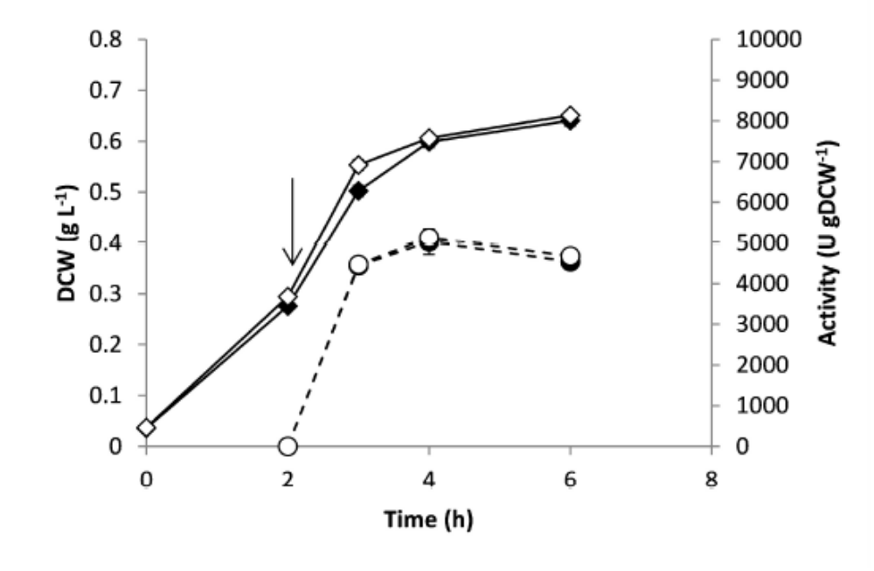

Figure 2
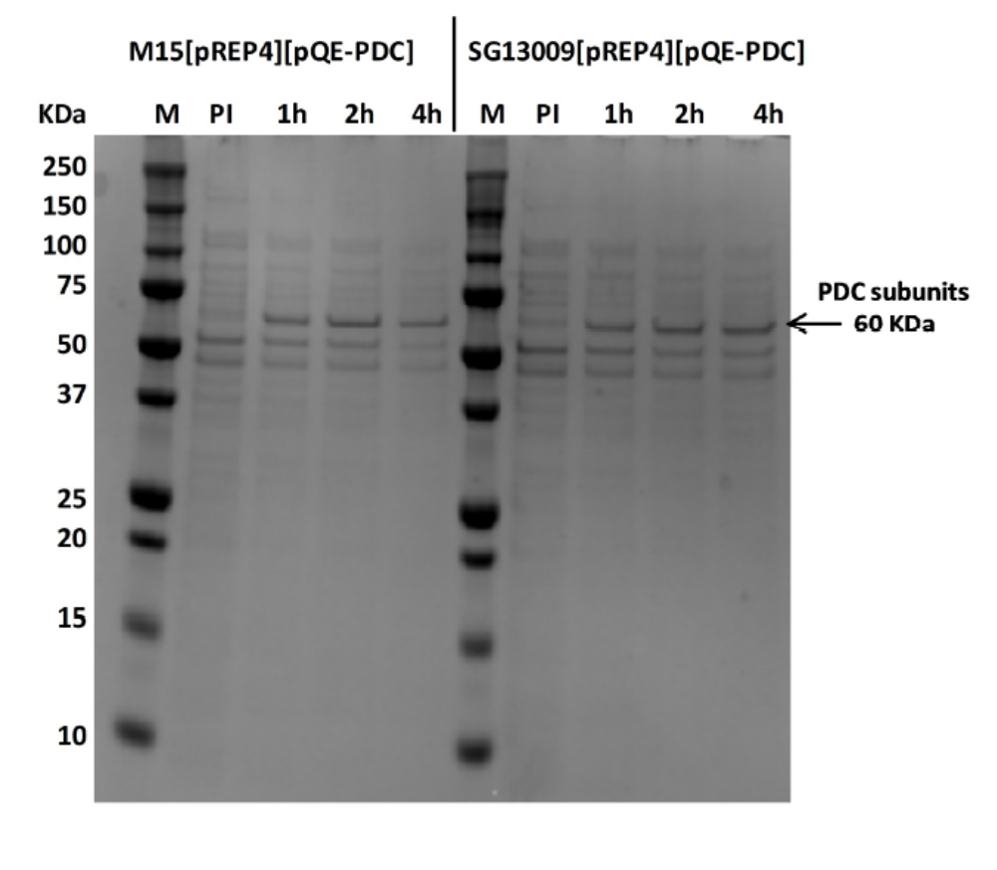

Figure 3
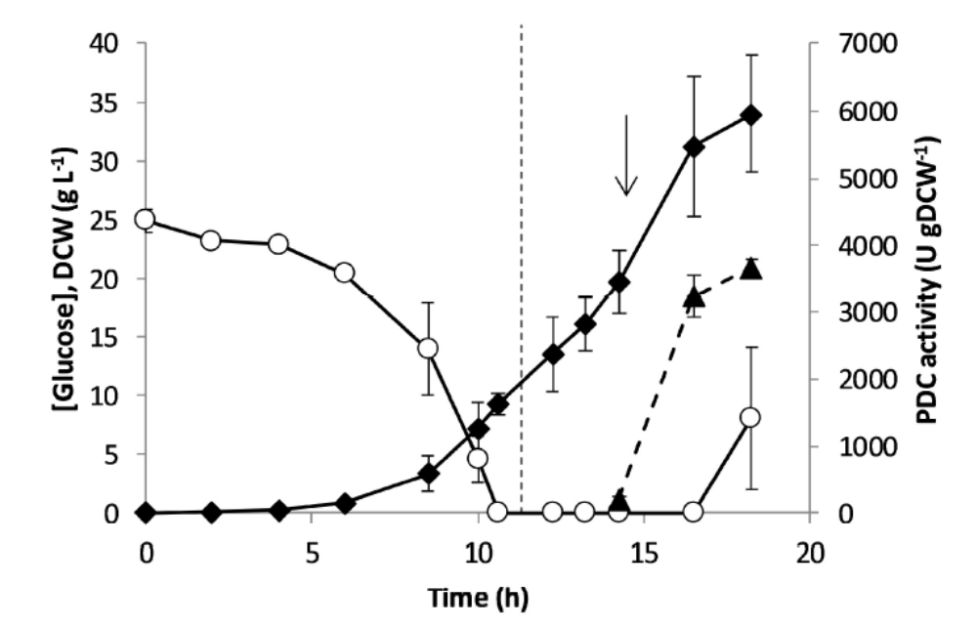

Figure 4
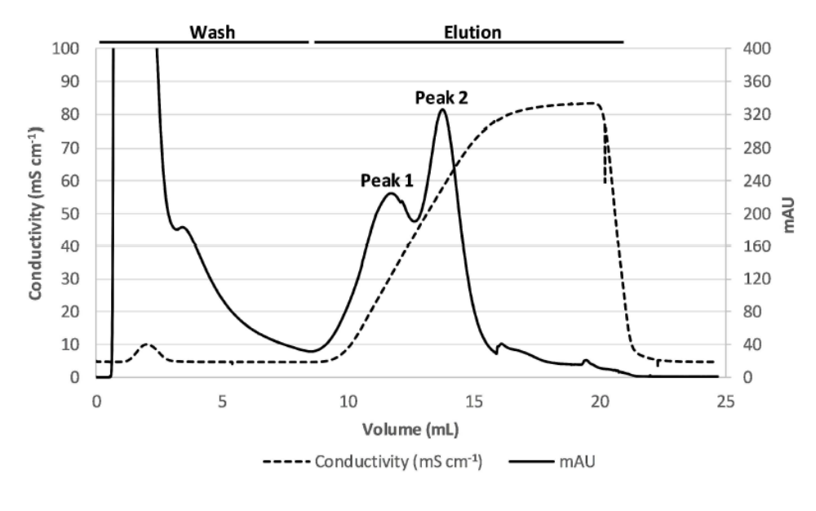

Figure 5
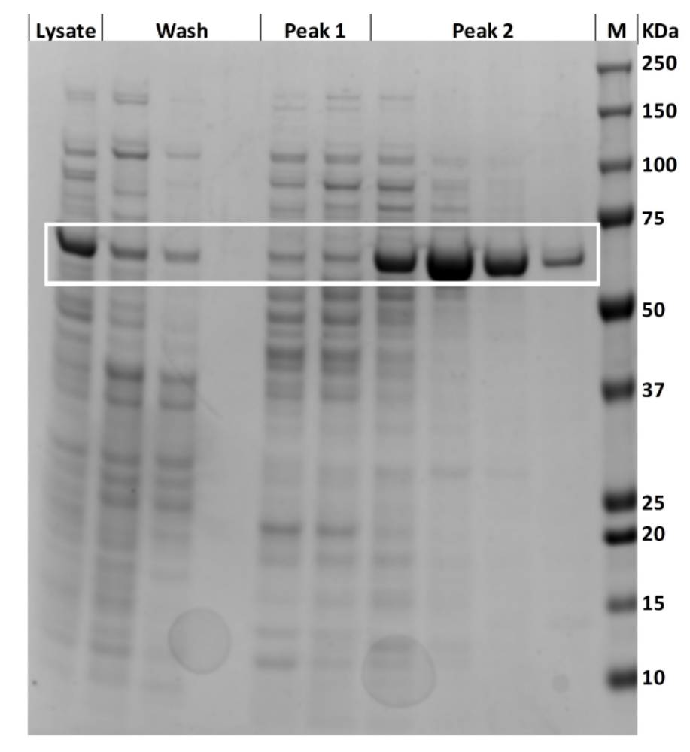

Figure 6
