Enzymatic synthesis of vanillin catalyzed by an eugenol oxidase
Miquel Garcia-Bofill, Marina Guillén¹, Peter W. Sutton¹, Gregorio Álvaro¹,
¹Bioprocess Engineering and Applied Biocatalysis Group, Department of Chemical Biological and Environmental Engineering, Universitat Autònoma de Barcelona, 08193 Bellaterra, Spain.
miquel.garcia.bofill@uab.cat; marina.guillen@uab.cat; peter.sutton@uab.cat; gregorio.alvaro@uab.cat;

Corresponding author:
Gregorio Álvaro
Department of Chemical, Biological and Environmental Engineering, Universitat Autònoma de Barcelona, 08193 Bellaterra, Spain
Telephone: +34 93 581 1806
Fax: +34 93 581 2013
gregorio.alvaro@uab.cat

Abstract

Vanillin is one of the most important flavours produced in the world. Due to its increasing value and its demand, mainly in the food industry, several ways to obtain it at lower prices are under study. One of the routes is based on the oxidation of vanillyl alcohol by Eugenol oxidase (EUGO), which has high potential to be used at industrial scale owing to the high space time yields that can be obtained at lab scale (2.9 g L⁻¹ h⁻¹ of vanillin). Additionally, EUGO can be immobilised efficiently onto different supports (MANA-agarose, Epoxy-agarose and Purolite 8204F) which can be reused several times to perform the oxidation preserving good stability and improving more than 3-fold the biocatalyst yield.

Introduction
Natural vanilla (Vanilla planifolia; V. pompona) is one of the most important flavours harvested in the world [1], with a current volume of almost 8 thousand tonnes per annum. 77% of crop production is concentred in Madagascar, Indonesia and China and its production price over the last 10 years is around 5700 USD T⁻¹ [2]. There are around 180 aromatic compounds in vanilla, and, the one that gives its characteristic flavour is vanillin (4-hydroxy-3-methoxybenzaldehyde) which only represents 2% (w/w) of vanilla [3]. Even though agricultural production is increasing, it is not sufficient to supply demand, which has doubled over the past 20 years. Its high price and widespread use in the food, cosmetic, and pharmaceutical industries triggered the necessity to produce it by other means. It is estimated that less than 1% of total world production of vanillin now comes from the natural beans [4].
Various different ways to produce vanillin using chemical synthesis [5–9], microbial [10–18]/plant cells [19] and enzymatic biotransformation have been described in the literature. [20,21],[22] However, the productivities of the biotransformation approaches are still far from being industrially implementable. Chemical synthesis is used to produce the majority of vanillin production, but it is declining in interest in many markets (chiefly in the food industry) in favour of product produced by microorganisms, plants cells and enzymes, that can be labelled as “natural” [23]. Furthermore, consumers are increasingly willing to pay a premium for products produced using natural means [24].
Biotransformation processes using isolated enzymes can often be more expensive than those using whole cells due to the extra processing required during biocatalyst production, but this can be considerably offset by the reduction in secondary reactions and reduced product purification costs. One of the ways to improve the industrial viability of a bioprocess is to reuse the biocatalyst by immobilisation. Immobilisation does not only permit the reuse and easier recovery of the enzyme, but also allows the utilization of different reactor configurations such as continuous or cross flow in addition to traditional batch formats. It can also improve biocatalyst stability towards various reaction parameters such as pH, temperature, organic solvent or inhibitors. Immobilisation can sometimes also enhance biocatalyst activity, specificity and selectivity [25],[26],[27].
In the present paper, Eugenol oxidase (EUGO) was immobilised covalently onto different supports and used to perform the conversion of vanillyl alcohol to vanillin (Figure 1), reusing the biocatalyst, in order to improve the process metrics compared to reaction using soluble enzyme.
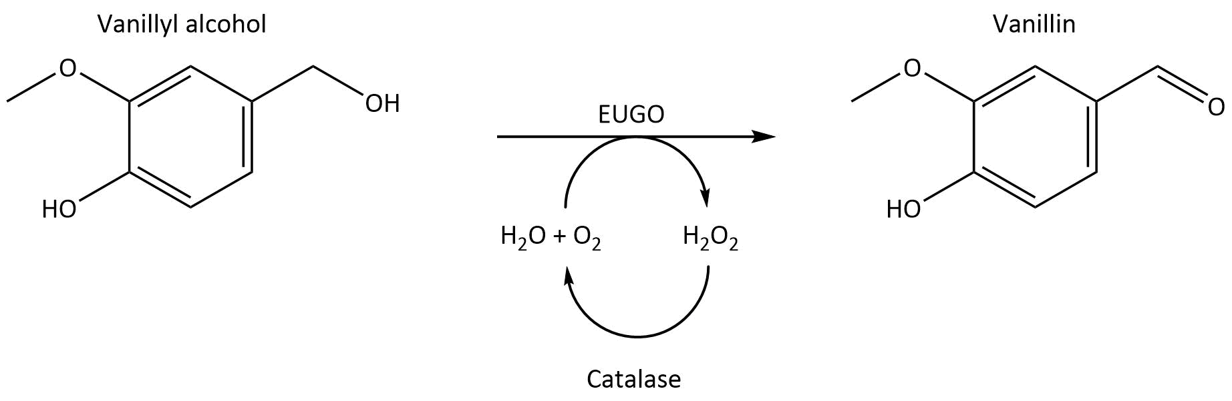
Figure 1: Oxidation of vanillyl alcohol to vanillin catalysed by Eugenol oxidase (EUGO) and catalase.

Materials and methods

Materials
Eugenol oxidase from Rhodococcus jostii (EUGO) was provided by InnoSyn B.V. (The Netherlands) as Escherichia coli lysates. Amino functionalized agarose (AMINO-agarose) and non-functionalised agarose supports, used to obtain epoxy-agarose-UAB, were obtained from Agarose Beads Technology® (ABT®) brands. Purolite® supports, methacrylate matrix activated with amino (ECR8409 and ECR8415, with a pore size of 600-1200Å and 1200-1800 Å, respectively) and epoxy groups (Praesto epoxy 45), were generously donated by Purolite® Life Sciences (Bala Cynwyd, PA, USA). Catalase and all other reagents were supplied by Sigma-Aldrich Chem. Co.

Methods

Protein determination and enzyme content
Total protein content of lysates containing EUGO was analysed using the Bradford method with bovine serum albumin as standard [28].
Enzyme content was determined using the sodium dodecyl sulphate polyacrylamide gel electrophoresis (SDS-PAGE) (NuPage 12%, Invitrogen, USA) run in a Mini-PROTEAN II apparatus (BioRad, USA) following the protocol of Laemmli et al. [29]. Low range protein markers (Biorad, USA) were used for molecular weight determination. Gels were stained using Comassie G250 colloidal stain solution [34% (v/v) ethanol, 2% (v/v) H₃PO₄, 17% (w/v) NH₄SO₄ and 0.066% Comassie G250] and the Image LABTM software (BioRad, USA) was used for image processing.

Enzymatic activity assays
The activity of EUGO was measured spectrophotometrically at 340 nm following the production of vanillin (ɛ= 27 mM⁻¹cm⁻¹) from vanillyl alcohol. A 50 µl aliquot of enzyme sample was added to a cuvette with 950 µl of substrate dissolved in buffer to a final concentration of 0.5 mM vanillyl alcohol in 50 mM glycine-NaOH, pH 9.5 at 30°C. One unit of EUGO activity (U) is defined as the amount of enzyme required to produce 1 µmol of vanillin alcohol per minute at the conditions described above.
Catalase activity was measured spectrophotometrically at 240 nm following the consumption of the substrate, H₂O₂ (ɛ= 0.0383 mM⁻¹cm⁻¹). A 50 µl aliquot of enzyme sample was combined with 950 µl of 20 mM H₂O₂ in 50 mM potassium phosphate buffer, pH 7.0 at 25°C. One unit of catalase activity (U) is defined as the enzyme required to convert 1 µmol of H₂O₂ per minute at the conditions defined previously.
Activity assays were carried out using a Cary 50 Bio UV-visible spectrophotometer (Palo Alto, USA).
Activity assays were carried out using 1.5 mL cuvettes suitable for UV. When the activity of EUGO immobilised derivatives was measured, double of each volume was added and 3 mL cuvettes were used with magnetic stirring to maintain a proper suspension of the derivatives during the measurement.

Stability of EUGO under different pH conditions
The effect of pH on the stability of EUGO was studied by incubating the enzyme at different pHs in the range 5-10. 1 U mL⁻¹ of EUGO was added to in 100 mM buffer solution with a final volume of 10 mL. Samples were incubated on a roller (Movil-Rod Selecta S.A.) for 24 hours at 25°C. The buffers used (100mM) were: sodium acetate (pH 5-5.5), potassium phosphate (pH 6.0-8.0), Tris-HCl (pH 8.5-9), and sodium bicarbonate (pH 10). The activity of the samples was analysed, as described above, at 0, 0.5, 1, 2, 4, 8 and 24 hours. Experiments were carried out in duplicate.

Effect of hydrogen peroxide on EUGO stability
In order to evaluate the effect of the hydrogen peroxide (formed as a by-product in vanillyl alcohol oxidation) on EUGO stability, experiments were performed in presence of hydrogen peroxide. 1 U EUGO mL⁻¹ was incubated under reaction conditions (30% acetone, 50 mM potassium phosphate pH 7.5, mild agitation conditions, 25°C), with different concentrations of hydrogen peroxide (400, 200, 100, 50, 25, 10 and 0 mM) for 24 hours. EUGO activity was analysed, as described above, at different times. Experiments were performed in duplicate.

EUGO immobilisation
All the immobilisation studies shown below were carried out as follows: support was previously hydrated, washed with distilled water several times and two times with immobilisation buffer. Supports were mixed with enzyme preparation in immobilisation buffer in a 1:10 (v/v) support/solution ratio with a final volume of 10 mL. The mixtures were incubated under mild agitation conditions at 25°C for all the immobilisation processes. Experiments were performed in duplicate.
All the experiments were performed using the minimum units of activity per mL of support where there are no diffusional limitations. To determine the limit without diffusional limitations, different low loadings of enzyme (30, 10, 5 and 2.5 U mL⁻¹ support) were immobilised to the supports. When two different loadings show the same immobilisation yields and retained activities, it can be affirmed that there are not diffusional limitations at these loadings.
During the immobilisation process, samples of supernatant and suspension were taken at different times to test EUGO activity during immobilisation course. The blank was prepared by using enzyme preparation in immobilisation buffer with water instead of the support for knowing the behaviour of soluble EUGO under immobilisation conditions.
Once the enzyme was immobilised onto the support, the immobilised derivative was washed and filtered to remove residual water, leaving moist beads.
In order to compare the immobilisations, immobilisation yield and retained activity values were determined, measuring the activity as described above, as:
$Immobilization yield \left(\%\right)=\frac{Initial native enzyme activity -Final suspernatant activity}{Initial suspension activity} x 100$
$Retained activity \left(\%\right)=\frac{Final suspension activity-Final supernatant activity}{Initial native enzyme activity} x 100$
Final supernatant activity: activity of the supernatant when the immobilisation finished.
Final suspension activity: activity of the suspension (supernatant and immobilised derivative) when the immobilisation finished.

Immobilisation of EUGO onto amino functionalized supports
EUGO immobilisation onto amino functionalized support was carried out as follow: 10% (v/v) support/solution mixture was incubated during 30 minutes to adsorb ionically the enzyme to the support. Once the enzyme was ionically adsorbed, 25 mM (N-(3-dimethylaminopropyl)-N-ethyl)carbodiimide (CDI) (final concentration) was then added and the mixture stirred for a further 2 h. Then, 1 h incubation with 1 M NaCl was performed to ensure that the retained activity is attached covalently.

Immobilisation of EUGO onto epoxy functionalised supports
Immobilisation of EUGO onto supports with epoxy groups was performed by incubating the enzyme with the support in a high strength buffer (1 M potassium phosphate buffer at pH 7.5 and 8) for 4 hours at 25˚C. 0.2 M β-Mercaptoethanol was then added and the mixture incubated for a further 4h at 4˚C in order to block epoxy groups that have not formed covalent bounds with the enzyme. Two different epoxy functionalised supports were used: Functionalisation method 1, containing 30 µmol of epoxy groups per g of support (F.M. 1) described by Axarli et al. [30] and functionalisation method 2, containing 80 µmol of epoxy groups per g of support (F.M. 2) described by Sunberg et al. [31].
The immobilised derivatives were washed with the buffer needed and used immediately.

Stability of soluble and immobilised EUGO under reaction and storage conditions
Stability of biocatalyst under reaction conditions (30% acetone in 50 mM potassium phosphate buffer pH 7.5, 25°C, mild agitation conditions) and storage conditions (25 mM potassium phosphate buffer pH 6, 4°C) was studied for free and immobilised EUGO onto the selected supports (10% v/v). The activity of the biocatalyst was analysed over time until the enzyme had lost half of its initial activity. Experiments were performed in duplicate.

Determination of the maximum enzyme loading on the selected supports
The experiments were performed by increasing the offered activity per mL of support following the immobilisation procedures described above for each functionalization type until the activity observed in the supernatant was higher than 10% of initial offered activity. Experiments were performed in duplicate.

Preparative Scale Vanillin Synthesis Reactions with soluble and immobilised EUGO
Reactions with immobilised EUGO were performed using 10% (v/v) of the immobilised derivative in order to ensure efficient mixing. To compare catalyst performance in reactions, both soluble and immobilised EUGO were used with the same units per mL of reaction.
Reactions were carried out at 10 mL scale using the following conditions: 400 mM of vanillyl alcohol, 30% (v/v) acetone in 50 mM potassium phosphate buffer at pH 7.5, 25˚C, 1 vvm air (hydrated with a 30% acetone solution in water), magnetic stirring (500 rpm), and 10 µl antifoam. 9 mg mL⁻¹ (35847 U mL⁻¹ reaction) of catalase were added to the reaction to control the peroxide formed by EUGO in the oxidation. Units of EUGO employed were determined as explained above. Reaction completion time was determined as the moment that no substrate consumption or product production was observed, monitored by GC as described in section 2.2.10.

Reusability of the immobilised derivative
Several cycles of reactions were performed using the same conditions as in section 2.2.8 using immobilised EUGO as catalyst. At the end of each cycle, the immobilised catalyst was washed three times with 20 mL of water and three times with 20 mL of reaction buffer (30% acetone, 50 mM potassium phosphate, pH 7.5). Immediately, the same quantities of fresh reaction components used in the previous cycle were added to the recycled immobilised enzyme to start a new reaction cycle. All the cycles were performed during the same time. The first cycle was ended to reach completion (using fresh biocatalyst) and the conversion was determined by GC as shown in section 2.2.10. The reaction time for the rest cycles was the same as the first one. Error bars correspond to standard deviation.

GC analysis of vanillyl alcohol and vanillin
Vanillyl alcohol and vanillin quantification in preparative scale reactions shown above was carried out by gas chromatography. Samples were extracted with ethyl acetate (1:20 v/v) containing methylbenzoate (5 mM) as internal standard. The organic phase was analysed using a 7890A Agilent gas chromatograph equipped with an Innowax 19095N-123 (30m x 530 µm x 1 µm) column. The column temperature was held at 100 °C for 5 min, then increased to 240 °C at 10°C per minute and maintained at this temperature for a further 2 minutes. The injector was kept at 225 °C; for the flame ionization detector, the temperature was 250 °C. Helium was used as a carrier gas at constant pressure of 10 psi. Retention times were 6.9, 17.7 and 19.6 for internal standard, vanillin and vanillyl alcohol, respectively.

Results

Characterization of EUGO
Cell free extracts (CFE) containing EUGO activity were provided by InnoSyn B.V. These CFE were characterised regarding protein content (42.9 mg mL⁻¹ CFE) and enzymatic activity (180.0 U mL⁻¹ CFE). Aiming to choose the most suitable and appropriate conditions and supports for the immobilisation of EUGO, the effect of pH on stability was studied (Figure 2). EUGO was found to be stable over a wide pH range, preserving more than 90% of its initial activity after 24 hours between pH 5 and 8 (Figure 2). However, at pH’s higher than 8, the stability decreases rapidly. These results are well aligned with a previous publication by Q. Nguyen, et al. [32].
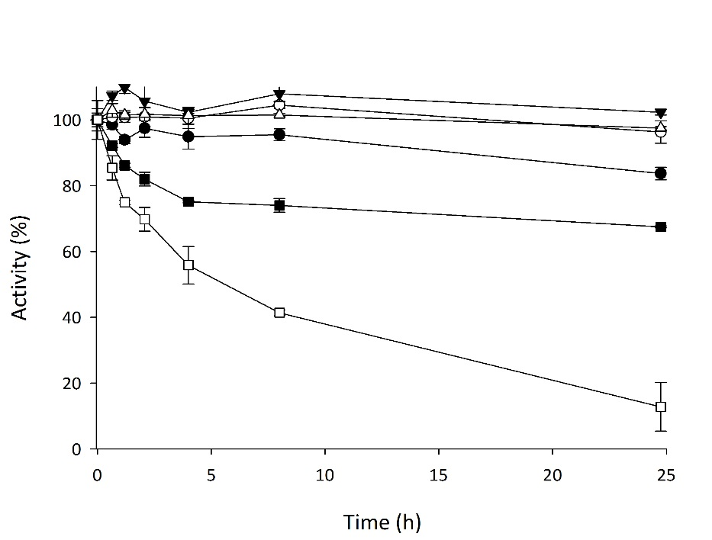
Figure 2: Influence of pH on EUGO stability. Stability was carried out by incubating 1 U mL⁻¹ EUGO in 100 mM buffers: sodium acetate, pH 5 (●); potassium phosphate, pH 6.0 (○), 7.0 (▼), 8.0 (△); Tris-HCl, 9.0 (■), and carbonate-bicarbonate, pH 10.0 (□), 25°C.

Effect of hydrogen peroxide onto EUGO stability
Oxidations catalysed by EUGO produce H₂O₂ (Figure 1) in stoichiometric amounts which could negatively affect the stability of the enzyme [33]. Therefore, the stability of EUGO was studied under reaction conditions at different concentrations of hydrogen peroxide (0-400mM) to analyse the effect of H₂O₂ in EUGO performance. The rank of concentrations was selected taking into account that the initial concentration of substrate used in the target reactions is set at 400mM.
The obtained results are depicted in Figure 3 A. At 10 mM concentration, H₂O₂ had no impact on EUGO stability, whereas, at successively higher concentrations an increasingly negative impact was observed. After 24 hours, less than 50% of initial activity was detected at concentrations higher than 50 mM. Therefore, due to the strong effect of H₂O₂ on EUGO stability, catalase was used in preparative reactions to convert it to water in-situ. Stability studied in the presence of up to 400 mM of H₂O₂ and catalase (9 mg mL⁻¹ (35847 U mL⁻¹)) showed no loss in EUGO activity compared to background (Figure 3 B). Therefore, it was decided to perform the oxidation of vanillyl alcohol in the presence of catalase.
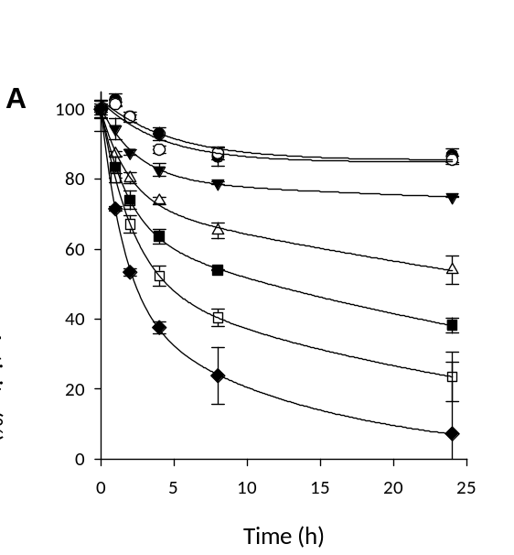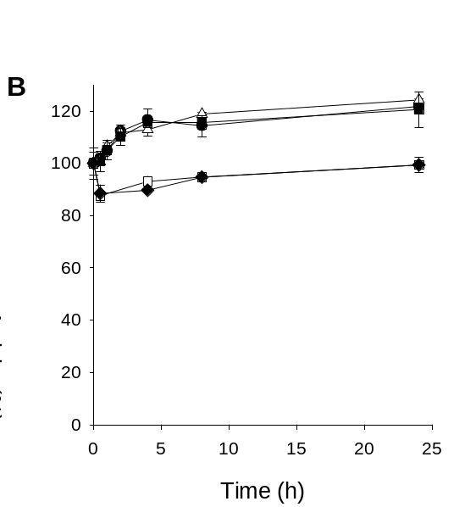
Figure 3: Stability of EUGO under reaction media (30% acetone, 50 mM potassium phosphate pH 7.5, mild agitation conditions, 25°C) at different concentrations of H₂O₂ of 0 mM (●), 10 mM (○), 25 mM (▼),50 mM (Δ), 100 mM (■),200 mM (□) and 400 mM (♦) (A) and with different concentrations of H₂O₂ (0, 50, 100, 200 and 400 mM) and catalase (9 mg ml⁻¹ (35847 U mL⁻¹)) (B)

EUGO immobilisation
The extensive pH range where EUGO is stable allows the use of different immobilisation methods to attach the enzyme covalently onto different supports. Different supports with different matrices (agarose and methacrylate) and different functional groups (amino and epoxy) were selected for the immobilisation screening (Table 1).
Firstly, in order to ensure that the loading of enzyme offered to the supports did not show diffusional limitations, enzyme concentrations of 30, 10, 5 and 2.5 U mL⁻¹ support were selected. Loadings equal or lower than 10 U mL⁻¹ support led to the retained activities showed in table 1. When 10 U mL⁻¹ were used the obtained retained activity were similar:18% (Epoxy-agarose (UAB) F.M.1.; ph 7.5), 35% (Epoxy-agarose (UAB) F.M.1.; pH 8), 38% (Epoxy-agarose (UAB) F.M.2.; pH 8), 29% (Praesto epoxy 45), 44% (Purolite 8204F), 65% (MANA-agarose), 35% (Amino ECR8409) and 21% (Amino ECR8415). Similar values were obtained when 2.5 U mL⁻¹ were immobilised. When 30 U mL⁻¹ were immobilised, retained activity values were lower showing the diffusional limitations. Therefore, loadings equal or lower than 10 U/mL did not show diffusional limitations for all the supports studied. This behave could be because enzyme molecules are being placed forming in a monolayer. Then, 10 U mL⁻¹ support was the loading used in all the experiments to characterise the immobilisations.
Supports functionalised with amino groups (rows 6, 7, 8) behave as expected for ionic exchange resins. The enzyme initially becomes attached by ionic adsorption and in order to provide covalent linkages between carboxyl groups of the enzyme and amino groups of the support, CDI is used. The best result from this support type was obtained using MANA-agarose, with 100% immobilisation yield and 63% retained activity.
Epoxy groups from supports react mainly with amino groups from the enzyme, but also with hydroxyl and thiol groups [34]. Alkaline pH favours this reaction because non protonated NH₂-groups are reactive. Firstly, the effect of pH on immobilization was tested with Epoxy-agarose (UAB) F.M.1. Two pHs (7.5 and 8 (rows 1 and 2)) were selected taking into account the stability decrease suffered by the EUGO at higher pHs (Figure 2). The best results were obtained at pH 8, as expected, reaching 97% and 37% immobilization yield and retained activity respectively. These results represent an increase of 1.5-fold and 2.3-fold, respectively, compared to the experiment performed under pH 7.5.
Regarding the activation grade, 9, 30 and 80 µmols of epoxy groups g ⁻¹ support were tested (row 4, 2 and 3) and the results show that increasing the activation grade from 9 to 30 µmols of epoxy groups g⁻¹ support increase the immobilization yield from 51% to 97% (rows 4 and 2). However, an increase from 30 to 80 did not significantly improve immobilization yield or retained activity (rows 2 and 3). It was also noticed that using a support with similar activation grade but a different matrix did not lead to a variation of the immobilization performance (rows 3 and 5).
Taking into account all the immobilization studies, the best results were obtained with MANA-agarose, Epoxy-agarose (UAB) F.M.2 and Purolite 8204F. They showed 100% immobilisation yield and 63%, 38% and 43% retained activity respectively.
These three supports were pre-selected to perform further experiments, in order to select the best immobilised derivative to perform the vanillyl alcohol oxidation reaction.

Table 1: EUGO immobilisation screening.
Nº | Support | support activation grade (µmols g⁻¹ support) | U of EUGO offered mL⁻¹ support | Matrix | Support functional group | Immobilisation pH | Immobilisation yield (%) | Retained activity (%)
1 | Epoxy-agarose (UAB) F.M. 1 | ≈ 30 | 10 | agarose | epoxy | 7.5 | 64 | 16
2 | Epoxy-agarose (UAB) F.M.1 | ≈ 30 | 10 | agarose | epoxy | 8 | 97 | 37
3 | Epoxy-agarose (UAB) F.M.2 | ≈ 80 | 10 | agarose | epoxy | 8 | 100 | 38
4 | Praesto epoxy 45 (Purolite) | ≈ 9 | 10 | agarose | epoxy | 8 | 51 | 35
5 | Purolite 8204F (purolite) | ≈ 73 | 10 | Methacrylate | epoxy | 8 | 100 | 43
6 | MANA-Agarose (ABT) | 40-60 | 10 | agarose | amino | 6 | 100 | 63
7 | Amino ECR8409 (Purolite) | unknown | 10 | Methacrylate | amino | 6 | 100 | 33
8 | Amino ECR8415 (Purolite) | unknown | 10 | Methacrylate | amino | 6 | 100 | 22

Stability of soluble and immobilised EUGO under reaction and storage conditions
The selected biocatalysts were incubated in reaction media (30% acetone, 50 mM potassium phosphate pH 7.5, mild agitation conditions, 25°C), in order to analyse if immobilisation improved enzyme stability under these conditions compared to the soluble enzyme. Stability under storage conditions was also studied (25 mM potassium phosphate pH 6, 4°C). Under both conditions tested, soluble EUGO was found to be very stable, with a half-life of about 11.5 days under simulated reaction conditions. Similar profiles were observed for EUGO immobilised on MANA-agarose (t_{1/2}: 8.3 days) and Purolite 8204F (t_{1/2}: 17.3 days). In contrast, EUGO immobilised on Epoxy-agarose-UAB showed a 6-fold improvement, with a half-life of 77.5 days (Figure 4 A). Under storage conditions (Figure 4 B), both soluble and immobilised forms preserved more than 70% initial activity after 14 days of storage.
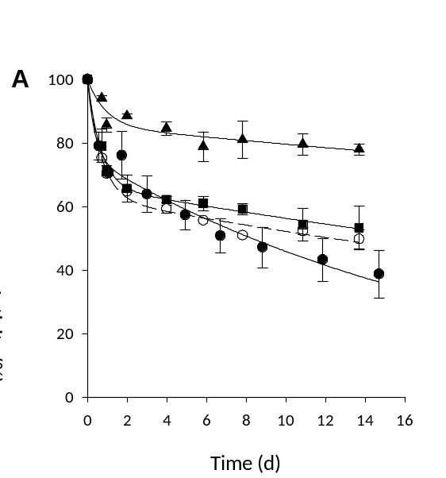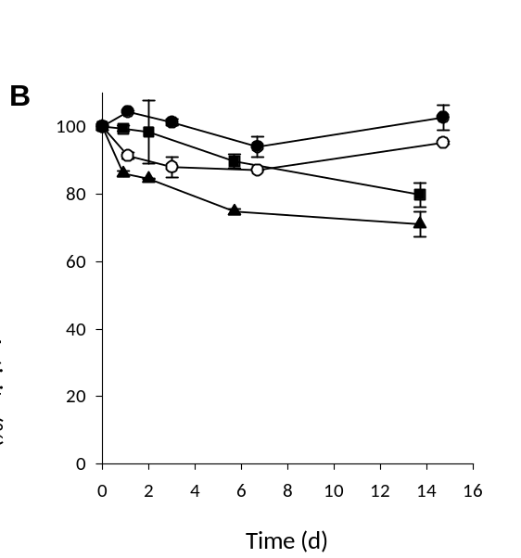
Figure 4: Stability of EUGO, soluble (○) and immobilised onto MANA-agarose (●), Epoxy-agarose (▲) and Purolite 8204F (■) in reaction media (30% acetone, 50 mM Potassium phosphate pH 7.5, 25°C) (A) and in storage conditions (25 mM potassium phosphate pH 6, 4°C) (B).

Maximum loading of enzyme that can be immobilised onto the supports
The maximum quantity of enzyme that can be attached to each selected support was analysed in order to optimise the concentration of enzyme offered to the support without loosening unnecessary amounts of biocatalyst in the supernatant. Different amounts of enzyme were immobilised onto the selected supports in order to determine this value. Results shown in Table 2 determined that EUGO can be immobilised efficiently at high loadings onto MANA-agarose, Epoxy-agarose-UAB and Purolite 8204F. MANA-agarose and Epoxy-agarose-UAB can be loaded up to 75 mg of protein mL⁻¹ support. That equates to 442 and 479 U immobilised mL⁻¹ support respectively. At high loadings of enzyme the activity of immobilised derivatives cannot be analysed due to the presence of diffusional limitations. Then, in order to determine the retained activity, it is supposed that the enzyme retains the same percentage of activity as determined during immobilisation at low enzyme loading (without diffusional limitations). Taking into account the retained activity percentages determined in the characterization (i.e. 63% for MANA-agarose and 38% for Epoxy-agarose) the supports can retain up to 279 and 179 U mL⁻¹ of support. Regarding the Purolite 8204F, the methacrylate-based support could be loaded with up to 50 mg of protein mL⁻¹ support, which corresponds to a retained activity of 130 U mL⁻¹ of support.
As expected, measured activities of the immobilised derivatives at these loadings (39, 32 and 29 U ml⁻¹ support for MANA-agarose, Epoxy-agarose and Purolite 8204F) were lower than the theoretical values, probably due to diffusional limitations.
Table 2: Results of maximum loading enzyme study.
Support | Offered mg protein mL⁻¹ support | U offered mL⁻¹ support | % Immobilisation | Theoretical U immobilised mL⁻¹ support | Theoretical* retained activity (U mL⁻¹ support) | Measuredactivity of the immobilised derivative (U mL⁻¹)
MANA-agarose | 75 | 456 | 97 | 442 | 279 | 39
Epoxy-agarose | 75 | 509 | 94 | 479 | 179 | 32
Purolite 8204F | 50 | 340 | 88 | 300 | 131 | 29
*Thereoretical retained activity in the absence of diffusional limitations.

Vanillyl alcohol oxidation using soluble and immobilised EUGO
Preparative scale vanillin synthesis reactions were performed on a 10 mL scale with 400 mM vanillyl alcohol, as shown in the experimental section, using 10% v/v of immobilised enzyme onto MANA-agarose (279 U mL⁻¹ of support), Epoxy-agarose (179 U mL⁻¹ of support) and Purolite 8204F (131 U mL⁻¹ of support). For comparative purposes the same overall number of units of soluble enzyme to compare the obtained process metrics. All reactions also contained 35847 U of catalase mL⁻¹ of reaction media to eliminate the peroxide formed by EUGO. Reactions with 28, 18 and 13 U mL⁻¹ of soluble EUGO gave high conversions of 86.2, 85.7 and 83.8% after 30, 41 and 37 hours respectively.
Reactions with immobilised EUGO gave comparable conversions to that of the free enzyme when using similar overall number of units activity under similar reaction conditions. Similar space-time yields were obtained for both forms of Epoxy-agarose (immobilised and soluble) (1.8 and 1.6 g P L⁻¹h⁻¹, respectively) and Purolite 8204F (1.2 and 1.4 g P L⁻¹h⁻¹, respectively) were used as immobilisation support, but a 50% increase was observed with EUGO immobilised into MANA-agarose (2.9 g P L⁻¹h⁻¹). This variation was produced because the reaction time was lower in the reaction with immobilised derivative. This behave maybe could be produced because the immobilised enzyme is protected from the gas interphase which has been demonstrated that can deactivate enzymes [35]. Soluble EUGO gave a space-time yield of 1.9 g P L⁻¹h⁻¹. These high values, compared with other biotechnological ways to produce vanillin [10,12,17,18,22,36], make EUGO a promising enzyme to perform the vanillyl alcohol oxidation at industrial scale.

Reusability of immobilised EUGO for vanillyl alcohol oxidation
Immobilised derivatives were each reused over 5 reaction cycles and the results are shown in Table 3 and Figure 5. Purolite 8204F displayed lowest recyclability, retaining less than 65% conversion and less than 15% yield by the last cycle. EUGO immobilised onto Epoxy-agarose-UAB and MANA-agarose showed better operational stability with conversions higher than 80%, for both derivatives and yields higher than 50% and 30% in the last cycle, respectively. The biocatalyst yield improved more than 2 fold compared to soluble enzyme, with a maximum obtained using the Epoxy-agarose immobilised derivative (7.3 mg vanillin U⁻¹ EUGO). It should be mentioned that the particles were abraded by magnetic stirring during the re-cycles and, therefore, the particle size was reduced during the experiments. This effect can produce a decrease on diffusional limitations which would increase the initial reaction rate. However, this effect would be counteracted by the activity decrease due to enzyme stability.
Only one study was found in the literature that reported vanillin production with an immobilised enzyme (oxygenase Cso2) [22]. Although a different pathway (from isoeugenol) was used, they obtained 0.68 mg of vanillin per mL over ten cycles. We could produce 45 mg of vanillin mL⁻¹ in 5 cycles, when MANA-agarose was used as immobilisation carrier, which represents an increase of 66-fold over the alternative literature procedure.

Table 3: Process metrics obtained in the vanillyl oxidation using soluble and immobilised EUGO. 400 mM of vanillyl alcohol, 30% (v/v) acetone in 50 mM potassium phosphate buffer at pH 7.5, 25˚C, 1 vvm air (hydrated with a 30% acetone solution), magnetic stirring (500 rpm), and 10 µl antifoam. 9 mg mL⁻¹ reaction (35847 U mL⁻¹ reaction) of catalase.
Biocatalyst | Form | U mL⁻¹ reaction | Reaction time (h) | % conversion | Total vanillin (g) | Biocatalyst* yield (mg P U⁻¹ of biocatalyst offered)
MANA-agarose | Soluble | 28 | 30 | 86 | 0.4 | 1.4
MANA-agarose | Immobilised | 28 | 18 | 87** | 1.1 | 4.1
Epoxy-agarose | Soluble | 18 | 41 | 86 | 0.4 | 2.3
Epoxy-agarose | Immobilised | 18 | 30 | 90** | 1.3 | 7.3
Purolite 8204F | Soluble | 13 | 37 | 84 | 0.3 | 2.7
Purolite 8204F | Immobilised | 13 | 36 | 76** | 0.7 | 5.6
*Determined when the reaction finished.
** Overall conversion.

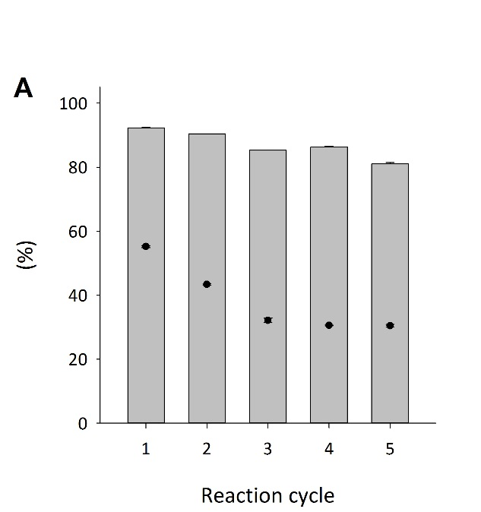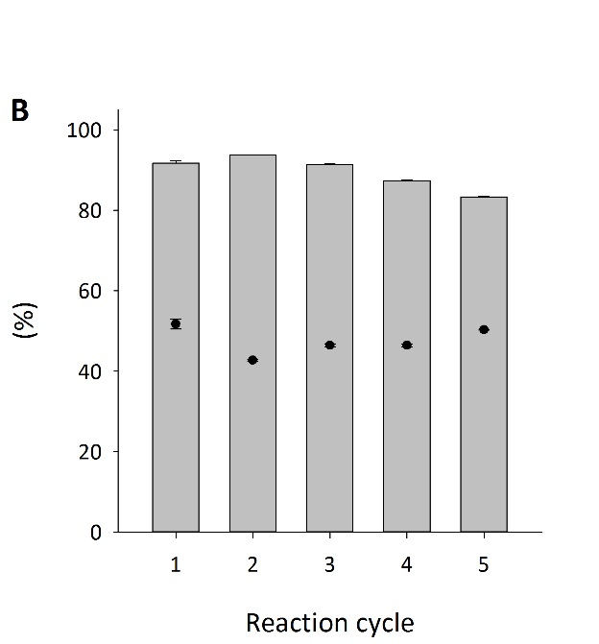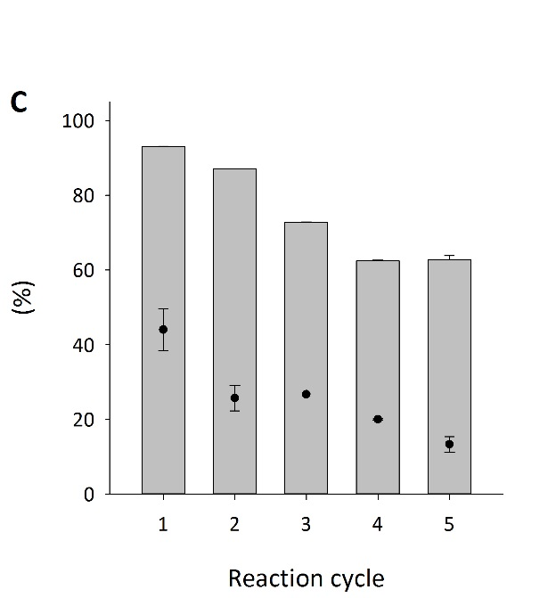
Figure 5: Conversion (bars) and Yield (●) of the reaction cycles MANA-agarose 283.5 U mL⁻¹ support (A), Epoxy agarose 182.8 U mL⁻¹ support (B) and Purolite 8204F 124 U mL⁻¹ support (C), and Catalase (35847 U mL⁻¹ reaction). Reaction conditions: 10 mL, 25˚C, magnetic stirring (500 rpm), 1 vvm, 400 mM Vanillyl alcohol/50 mM Potassium phosphate pH 7.5.

Conclusions
Eugenol oxidase is an active and stable enzyme over a wide range of pH. It can be immobilised efficiently into different supports (MANA-agarose, Epoxy-agarose and Purolite 8204F) at high enzyme loadings (279, 179 and 131 U EUGO mL⁻¹ support, respectively). Immobilised derivatives showed high stability under the reaction conditions used with a 6-fold improvement in half-time for EUGO immobilised onto Epoxy-agarose compared with the soluble form. High conversions (more than 90%) and space-time yield of 2.9 g vanillin L⁻¹ h⁻¹ could be obtained in the vanillyl alcohol oxidation with soluble and immobilised forms. The immobilised derivatives could be reused satisfactorily for more than 5 cycles, with EUGO immobilised into Epoxy-agarose being the operationally most stable biocatalyst tested, retaining more than 80% of conversion in the last cycle, which represents 90% of retained activity compared to fresh biocatalyst. It presented the highest biocatalyst yield of 7.3 mg vanillin U⁻¹ EUGO which is 3-fold more than the soluble form.

Acknowledgements
The research for this work has received funding from the European Union project ROBOX (grant agreement n° 635734) under EU’s Horizon 2020 Programme Research and Innovation actions H2020-LEIT BIO-2014-1. This document reflects only the author's view and the Agency is not responsible for any use that may be made of the information it contains. The Department of Chemical, Biological and Environmental Engineering of Universitat Autònoma de Barcelona constitutes the Biochemical Engineering Unit of the Reference Network in Biotechnology and the research group 2017 SGR 1462, Generalitat de Catalunya. Authors also thank COST Action CM 1303–Systems Biocatalysis for financial support and Purolite Life Sciences® for the supports given. Miquel García acknowledges also UAB for funding his Ph.D. grant.
PS would like to acknowledge the the European Union for his current funding: “This project has received funding from the European Union’s Horizon 2020 research and innovation programme under Marie Skłodowska-Curie grant agreement No 665919”.

Bibliography
[1] A. Lomascolo, C. Stentelaire, M. Asther, L. Lesage-Meessen, Trends Biotechnol. 17 (1999) 282–289.
[2] Food and Agriculure Organization-FAO site, (2018).
[3] S. Ramachandra Rao, G. Ravishankar, J. Sci. Food Agric. 80 (2000) 289–304.
[4] M.M. Bomgardner, Chem. Eng. News (2016) 38–42.
[5] A.L. Mathias, A.E. Rodrigues, Holzforschung 49 (1995) 273–278.
[6] C. Qu, M. Kaneko, K. Kashimura, K. Tanaka, S. Ozawa, T. Watanabe, ACS Sustain. Chem. Eng. 5 (2017) 11551–11557.
[7] J.D.P. Araújo, C.A. Grande, A.E. Rodrigues, Chem. Eng. Res. Des. 88 (2010) 1024–1032.
[8] J.D.P. Araújo, C.A. Grande, A.E. Rodrigues, Catal. Today 147 (2009) 330–335.
[9] E.A.B. da Silva, M. Zabkova, J.D. Araújo, C.A. Cateto, M.F. Barreiro, M.N. Belgacem, A.E. Rodrigues, Chem. Eng. Res. Des. 87 (2009) 1276–1292.
[10] A. Muheim, K. Lerch, Appl. Microbiol. Biotechnol. 51 (1999) 456–461.
[11] S.-H. Yoon, C. Li, J.-E. Kim, S.-H. Lee, J.-Y. Yoon, M.-S. Choi, W.-T. Seo, J.-K. Yang, J.-Y. Kim, S.-W. Kim, Biotechnol. Lett. 27 (2005) 1829–1832.
[12] S.H. Yoon, C. Li, Y.M. Lee, S.H. Lee, S.H. Kim, M.S. Choi, W.T. Seo, J.K. Yang, J.Y. Kim, S.W. Kim, Biotechnol. Bioprocess Eng. 10 (2005) 378–384.
[13] D. Di Gioia, L. Sciubba, L. Setti, F. Luziatelli, M. Ruzzi, D. Zanichelli, F. Fava, Enzyme Microb. Technol. 41 (2007) 498–505.
[14] J. Ni, F. Tao, H. Du, P. Xu, Sci. Rep. 5 (2015) 1–12.
[15] A. Paz, D. Outeiriño, R. Pinheiro de Souza Oliveira, J.M. Domínguez, N. Biotechnol. 40 (2018) 186–191.
[16] E.H. Hansen, B.L. Møller, G.R. Kock, C.M. Bünner, C. Kristensen, O.R. Jensen, F.T. Okkels, C.E. Olsen, M.S. Motawia, J. Hansen, Appl. Environ. Microbiol. 75 (2009) 2765–2774.
[17] L. Zheng, P. Zheng, Z. Sun, Y. Bai, J. Wang, X. Guo, Bioresour. Technol. 98 (2007) 1115–1119.
[18] W. Yang, H. Tang, J. Ni, Q. Wu, D. Hua, F. Tao, P. Xu, PLoS One 8 (2013).
[19] B. Suresh, G.A. Ravishankar, Plant Physiol. Biochem. 43 (2005) 125–131.
[20] J. Jin, H. Mazon, R.H.H. Van Den Heuvel, D.B. Janssen, M.W. Fraaije, FEBS J. 274 (2007) 2311–2321.
[21] R.H.H. Van Den Heuvel, M.W. Fraaije, C. Laane, W.J.H. van Berkel, J. Agric. Food Chem. 49 (2001) 2954–2958.
[22] T. Furuya, M. Kuroiwa, K. Kino, J. Biotechnol. 243 (2016) 25–28.
[23] E.L.P. Europeo, E.L. Consejo, D.E.L.A. Uni, P. Europeo, P. Europeo, (2008) 34–50.
[24] S. Román, L.M. Sánchez-Siles, M. Siegrist, Trends Food Sci. Technol. 67 (2017) 44–57.
[25] C. Mateo, J.M. Palomo, G. Fernandez-Lorente, J.M. Guisan, R. Fernandez-Lafuente, Enzyme Microb. Technol. 40 (2007) 1451–1463.
[26] U. Guzik, K. Hupert-Kocurek, D. Wojcieszynska, Molecules 19 (2014) 8995–9018.
[27] R. Di Cosimo, J. Mc Auliffe, A.J. Poulose, G. Bohlmann, Chem. Soc. Rev. 42 (2013) 6437–6474.
[28] M.M. Bradford, Anal. Biochem. 72 (1976) 248–254.
[29] U.K. Laemmli, Nature 227 (1970) 680–685.
[30] I. Axarli, A. Prigipaki, N.E. Labrou, Biomol. Eng. 22 (2005) 81–88.
[31] L. Sunberg, J. Porath, J. Chromatogr. 90 (1974) 87–98.
[32] Q.T. Nguyen, G. de Gonzalo, C. Binda, A. Rioz-Martínez, A. Mattevi, M.W. Fraaije, ChemBioChem 17 (2016) 1359–1366.
[33] K. Hernandez, A. Berenguer-murcia, R.C. Rodrigues, R. Fernandez-lafuente, Curr. Org. Chem. 16 (2012) 2652–2672.
[34] E. Katchalski-katzir, D.M. Kraemer, J. Mol. Catal. B Enzym. 10 (2000) 157–176.
[35] A.S. Bommarius, A. Karau, Biotechnol. Prog. 21 (2005) 1663–1672.
[36] T. Furuya, M. Miura, M. Kuroiwa, K. Kino, N. Biotechnol. 32 (2015) 335–339.

