The role of climate, foliar stoichiometry and plant diversity on ecosystem carbon balance
Running head: Nutrient and diversity effects on C balance
Authors: Marcos Fernández-Martínez^{*1}, Jordi Sardans^{2,3}, Talie Musavi⁴, Mirco Migliavacca⁴, Maitane Iturrate-Garcia⁷, Robert J. Scholes⁸ Josep Peñuelas^{2,3}, Ivan A. Janssens¹.

Affiliations:
¹ PLECO (Plants and Ecosystems), Department of Biology, University of Antwerp, 2610 Wilrijk, Belgium.
² CSIC, Global Ecology Unit, CREAF-CSIC-UAB, Cerdanyola del Vallès, 08193 Barcelona, Catalonia, Spain

³ CREAF, Cerdanyola del Vallès, 08193 Barcelona, Catalonia, Spain

⁴ Department Biogeochemical Integration, Max Planck Institute for Biogeochemistry, Jena, Germany
⁷ Department of Chemical and Biological Metrology, Federal Institute of Metrology, 3003 Bern-Wabern, Switzerland
⁸ Global Change Institute, University of the Witwatersrand, Johannesburg, South Africa
*Correspondence to: M. Fernández-Martínez, marcos.fernandez-martinez@uantwerpen.be
Length of the main text: 4752 words
Figures and tables: 4 figures, 0 tables
Length of the captions: 387 words
References: 82
ORCID iDs:
Marcos Fernández-Martínez: 0000-0002-5661-3610
Jordi Sardans: 0000-0003-2478-0219
Mirco Migliavacca: 0000-0003-3546-8407
Robert J. Scholes: 0000-0001-5537-6935
Josep Peñuelas: 0000-0002-7215-0150
Ivan A Janssens: 0000-0002-5707-1787

Abstract
Global change is affecting terrestrial carbon balances. The effect of climate on ecosystem carbon balance has been largely explored, but the roles of other concurrently changing factors, such as diversity and nutrient availability, remain elusive. We used eddy-covariance carbon-flux measurements from 62 ecosystems from which we compiled information on climate, ecosystem type, stand age, species abundance and foliar concentrations of N and P of the main species, to assess their importance in the ecosystem carbon balance. Climate and productivity were the main determinants of ecosystem C balance and its stability. In P-rich sites, increasing N was related with increased gross primary production and respiration and vice versa, but reduced net C uptake. Our analyses did not provide evidence for a strong relation between ecosystem diversity and their productivity and stability. Nonetheless, these results suggest that nutrient imbalances and, potentially, diversity loss may alter future global carbon balance.
Keywords: Elemental composition, ecosystem functioning, nitrogen, phosphorus, nutrients, biodiversity.

Main

Anthropogenic activities, and their consequent global change, are altering ecosystems worldwide. Climate change, the alteration of global biogeochemical cycles and biodiversity loss are amongst the most important impacts of global change (Rockström et al., 2009; Steffen et al., 2015). Firstly, climate change is characterized by increasing mean global temperatures and altering precipitation regimes (Ciais et al., 2013), causing dramatic changes in ecosystem functioning (Fernández-Martínez et al., 2019). Secondly, the extensive use of fossil fuels (emitting CO₂ and NO_{x}, amongst others) and the production of fertilisers have triggered unprecedented rates of atmospheric nitrogen (N) deposition (Galloway et al., 2004), completely modifying global biogeochemical cycles (Peñuelas et al., 2020). These changes can induce elemental stoichiometric shifts (Penuelas et al., 2020) which can produce imbalances between essential elements for life, such as nitrogen and phosphorus (Peñuelas et al., 2012, 2013). Thirdly, biodiversity loss, caused by habitat destruction, climate change and altered biogeochemical cycles, can entail important changes in species composition and functionality of ecosystems (Hooper et al., 2012) and the ecosystem services they provide (Gamfeldt et al., 2013). The large repercussions of all these impacts on the Earth system and, therefore, on human societies (Cardinale et al., 2012; Peñuelas et al., 2013), have triggered intensive research into the effects of global change on ecosystems. One of the most important features of ecosystems, given the current climate emergency, is their carbon (C) balance, this is: gross primary production (GPP), ecosystem respiration (Re) and net ecosystem production (NEP = GPP – Re). The ecosystem-level C-use efficiency (CUEe), defined as the NEP:GPP ratio, is another important feature to understand how C is used in ecosystems (Fernández-Martínez et al., 2014a).

While the role of climate and the alteration of the N cycle (i.e., N deposition) on ecosystem C balance has been intensively investigated (van Dijk et al., 2005; Luyssaert et al., 2007a; Janssens et al., 2010; de Vries et al., 2014; Fernández-Martínez et al., 2014b, 2017), we barely have any evidence regarding the role of diversity and elemental composition of ecosystems on C balance. Filling in this knowledge gap is crucial given that different facets of the global change are currently reducing biodiversity and, therefore, directly (altering species elemental concentrations) and indirectly (changing species pools) shifting the elemental composition of ecosystems. On the other hand, both diversity and elemental composition of organisms have been demonstrated to play an important role on ecosystem functioning (Sterner & Elser, 2002; Hooper et al., 2012), thus entailing ecosystem changes if species are lost or stoichiometric imbalances occur.

It is now widely accepted that ecosystems with higher diversity also present higher productivity (often biomass production) and lower temporal variability (Cardinale et al., 2012; Musavi et al., 2017; Oehri et al., 2017) in both, aquatic and terrestrial environments, across the globe (Liang et al., 2016). However, despite the fact that decomposition rates have also been suggested to increase with diversity of decomposers and plant litter (Handa et al., 2014), it is not well understood how diversity relates to respiration of entire ecosystems, and, hence, to net C uptake. It is, therefore, imperative to understand the role of diversity on the ecosystem net C balance. On the other hand, there is evidence pointing towards an important role of nutrients on biomass production (Vicca et al., 2012) and ecosystem net C balance (Fernández-Martínez et al., 2014b). These findings suggest higher productivity and net C uptake in nutrient-rich ecosystems, where concentrations of foliar N and P of primary producers are also often higher (Sardans et al., 2016; Van Sundert et al., 2018; Firn et al., 2019), potentially leading to enhanced photosynthesis (Field et al., 1983; Wright et al., 2004; Domingues et al., 2010) and lower C losses by the emission of volatile organic compounds (Fernández-Martínez et al., 2018a). However, the direct link between community-weighted elemental composition and C balance still remains elusive.

Hence, the goal of this study was to assess the importance, for the first time, of the effects of climate, endogenous factors (i.e., ecosystem type , productivity and stand age), diversity and elemental stoichiometry on ecosystem C balances. We here hypothesised that, once the effect of climate and endogenous factors are accounted for, larger and less interannually variable C fluxes (GPP, Re, NEP, their interannual variabilites: GPP_{IAV}, Re_{IAV} and NEP_{IAV}, and CUEe) will be found in sites with higher diversity (species and phylogenetic diversity). Similarly, we hypothesised that larger and less variable C fluxes will be associated with higher foliar concentrations of N and P at the community level. To test these hypotheses, we used 62 eddy-covariance sites included in the FLUXNET 2015 database, comprising forest, shrubland, savanna and grassland ecosystems (Fig. S1, Table S1). For all 62 sites we compiled information regarding their species abundance and their community-weighted foliar N and P concentrations, either measured or inferred for the species present.

Materials and methods

Datasets

Carbon fluxes and climate data

We downloaded monthly weather and C flux (GPP, Re and NEP) data from eddy-covariance towers from the FLUXNET 2015 dataset (Tier 2), (http://fluxnet.fluxdata.org/data/download-data) (Pastorello et al., 2020). From the total of 93 sites for which we could gather species abundance data, croplands excluded, (see section Species composition data below), only 62 sites met the conditions for data quality (NEE_VUT_REF_QC ≥ 0.5, following Bond-Lamberty et al. (2018)), had data for at least 60 months – five years, and did not experienced strong management or disturbances (Fig. S1, Table S1). The 62 sites that were selected included boreal, temperate, and Mediterranean biomes and ten different vegetation types according the IGBP-DISCover classification (Bonan et al., 2002): evergreen needle-leaved forests [19 sites], evergreen broad-leaved forests [3], deciduous broad-leaved forests [13], mixed forests [6], savannas [2], woody savannas [3], open shrublands [3], closed shrublands [1], wetlands [2] and grasslands [10]. We grouped these vegetation types into three categories in order to facilitate statistical analyses, being forests (evergreen and deciduous, needle-leaved and broadleaved, and mixed forests), shrublands and savannas (savannas and woody savannas, open and closed shrublands and wetlands) and grasslands. We used all monthly values of GPP and Re estimated with the daytime partitioning method. We then calculated annual values of the C fluxes as the sum of GPP, Re and NEP average monthly values. Additionally, we calculated average CUEe (Fernández-Martínez et al., 2014a) as the ratio of mean NEP and GPP per site. We also calculated mean annual temperature (MAT) and precipitation (MAP) per site to control for climate effects in our statistical models. Interannual variability of C fluxes per site was estimated using the proportional variability index (Heath, 2006; Fernández-Martínez et al., 2018b) (PV), as the average of the interannual PV for each month (e.g., ${GPP}_{IAV}= \frac{{GPP}_{IAV,January}+ \left[...\right]+ {GPP}_{IAV,December}}{12}$). We calculated PV as following (Heath, 2006; Fernández-Martínez et al., 2018b):

$$PV= \frac{2 \sum{z}}{n\left(n-1\right)}$$

Where z is calculated as:

$$z=1- \frac{\min\left(z_{i },z_{j }\right)}{\max\left(z_{i },z_{j }\right)}$$

“n” is the number of values in a time series, and “z” is the list of individual values from which to calculate the pairwise comparisons.

Interannual variability of climate variables (MAT_{IAV} and MAP_{IAV}) was estimated using the same method. We collected stand age of forests from ancillary data and a global forest database (Luyssaert et al., 2007b; Campioli et al., 2015).

Species composition data

Information on species abundance per site was extracted from (Musavi et al., 2016, 2017), ancillary data for each site, published literature containing information about the selected sites and information provided after contacting the PI’s of the sites. To avoid underestimation of species richness in sites where inventories were not very accurate, we only used those species that accounted for up to 95% of the abundance of the site, similar to (Musavi et al., 2017). Abundances were estimated as the fraction of leaf area occupied by each species in the sites for which this information was available. The relative density of individuals or direct reports of relative abundance were used in the rest of sites. When abundances per species were not reported, we assigned equal abundances to each species within their strata (e.g., overstory or understory) based on the average percentage of over- and understory of each vegetation type (e.g., evergreen needle-leaved forests have 85% overstory and 15% understory, so if a site would have two species in the overstory, they both would have 42.5% relative abundance). When only vague indications about species abundance was reported we assigned differential abundances accordingly. Species per site and their abundances can be found in Supplementary Material (online only – spec_abund_full.csv). Vascular plants, ferns and bryophytes were used in our analyses given that in some sites non-vascular plants could account for a considerable proportion of the species present (>10%).

Elemental composition data

We collected all available information about foliar N and P concentration per species at each of the selected sites, including data from previous compilations (Musavi et al., 2016). We searched for that information in the main literature of the sites and by directly requesting this information to the PI’s of each site. Overall, we gathered data of N and P foliar concentrations for, respectively, 21 and 18% of the relative abundance of species per site in our database (see specs_abund_full.csv file in Supplementary Information). For the rest of the species for which we did not find any information on foliar N and P concentrations, we attributed values of foliar N and P based on average values of the species. To that aim, we used N and P data per species from (Tian et al., 2019). For the purpose of this study, we calculated median concentrations of N and P per species. We used the Rphylopars (Goolsby et al., 2016) R package to estimate the elemental composition of N and P from phylogenetic information (Penone et al., 2014) for those species for which we did not find literature data on their foliar N and P concentrations. Imputation of N and P for missing species was performed based on the phylogenetic tree of all species present in the selected sites and in our database of elemental composition. We used the plant megaphylogeny provided by Qian & Jin (Qian & Jin, 2016). Species not found in the base phylogeny were included into our phylogenetic tree using the V.PhyloMaker (Jin & Qian, 2019) R package. Correlation between imputed and observed values (in the selected sites) was very good for both N and P (respectively, R = 0.91 and 0.83; 100 and 94 replicates, P < 0.001) indicating low uncertainty in our estimates of foliar N and P concentrations. All species names were checked and corrected using The Plant List database, using the R package Taxonstand (Cayuela & Oksanen, 2016). We finally calculated the community weighted mean N and P concentrations based on the species abundance per site and their corresponding N and P concentrations.

Statistical analyses

Diversity indices

We first calculated three different metrics of phylogenetic diversity per site using the PhyloMeasures package in R (Tsirogiannis & Sandel, 2016, 2017). We estimated phylogenetic diversity (PD), mean pairwise distance (MPD) and mean nearest taxon distance (MNTD) per site, we standardised (mean = 0, sd = 1) all three variables and calculated their average as a measure of phylogenetic diversity. PD measures phylogenetic diversity as the total branch length in the minimum spanning subtree for a given set of species (Faith, 1992), MPD measures the mean pairwise distance along the tree between all species in a given set, and MNTD measures the mean distance from each taxon to its nearest neighbour in the set of selected species (Webb, 2000; Tsirogiannis & Sandel, 2016). We also estimated species diversity as the average of the standardised values of species richness per site, Shannon, Simpson, inverse Simpson, unbiased Simpson and evenness indices (Hurlbert, 1971; Hill, 1973; Daly et al., 2018). All these indices, except species richness per site, were calculated using the vegan (Oksanen et al., 2018) package in R.

Statistical models

We used a model averaging approach based on linear models to investigate the effects of endogenous factors, climate, diversity and foliar nutrient concentrations on annual C fluxes (GPP, Re and NEP), their interannual variability (GPP_{IAV}, Re_{IAV} and NEP_{IAV}) and CUEe. Model averaging is a statistical technique based on multimodel inference that computes an average model from the estimates of a set of models including different predictors and weighting their relative importance according to the difference of the second-order AIC (AICc) between each model and the best model (Burnham & Anderson, 2004). For annual fluxes, we fitted models containing ecosystem type (forest, shrublands-savannas or grasslands), MAT, MAP and their interaction (MAT × MAP), species and phylogenetic diversity, community weighted foliar N and P and their interaction. For Re and NEP, we also included GPP as a predictor to control for the productivity of the site as an endogenous factor. Models explaining variability in CUEe included the same predictors but without including C fluxes. For interannual variability we repeated the same models as for C fluxes described above but including also the GPP, Re and NEP as predictors. For GPP_{IAV} only GPP was included, for Re_{IAV} we included GPP and Re and for NEP_{IAV} we included GPP, Re and NEP. Diversity and foliar nutrient variables were log-transformed to account for non-linear relationships.

We then estimated all possible models nested within the saturated (see above) models using the dredge function in MuMin (Burnham, 2004; Barton, 2018) R package. Models including both MAT and MAT_{IAV} were discarded from the set of models because of the high collinearity between these two predictors (variance inflation factor > 10). We selected those models with ΔAICc < 4 to estimate the conditional average model and calculate the relative importance of each predictor. For each of these models we also calculated the variance explained by each of the predictors with the “lmg” metric in the R package “relaimpo” (Grömping, 2006). We then calculated the average variance explained by all predictors weighting by the relative importance of each of the models with ΔAICc < 4. We finally used models with ΔAICc < 4 to visualise the relationships between response and predictor variables using partial residual plots by means of the visreg (Breheny & Burchett, 2015) package in R.

We repeated all statistical analyses using i) all sites (N=62), ii) only forests (N=41), and iii) only savannas, shrublands and grasslands (N=21). In models using only forests, we also included stand age (log-transformed) and its interaction with C fluxes as a predictor (see models described above). All analyses were performed in R statistical software v. 3.6.2 (R Core Team, 2019).

Results

Main controls of C fluxes and their temporal variability

Our results indicated that climate was the main factor explaining variability in GPP across sites (Fig. 1). Ecosystems with higher MAP and MAT and less variable climate (MAT_{IAV} and MAP_{IAV}) had generally higher GPP. The main climatic effect on GPP propagated into Re and NEP, for which the direct climate effect was very low (and potentially negative for Re) once site productivity (GPP) was taken into account. Similarly happened with interannual variability in C fluxes, that was strongly negatively related to the annual C fluxes (Fig. 2). Across all ecosystem types, warmer sites presented higher Re_{IAV} and NEP_{IAV}, while across forests MAP was positively related to higher Re_{IAV} and NEP_{IAV} (Fig. S2). Instead, MAT_{IAV} often presented a negative relationship with variability in C fluxes, especially in savannas and grasslands (Fig. S3).

Community-weighted foliar N and P explained a relatively large proportion of the spatial variability in GPP and NEP annual sums and their interannual variability. We found a statistically significant interaction between community-weighted foliar N and P concentrations explaining variability in GPP, Re and NEP (Fig. 3). Our results showed that increasing foliar N translated into increases in GPP only in sites with higher concentrations of foliar P. On the other hand, increasing foliar P had a positive effect on GPP in sites with high foliar N concentration, while the opposite relationship was found across sites with low foliar N. Similarly, Re only increased with increasing foliar N and P when their counterpart nutrient was also high. As a result of these interactions between nutrients, GPP and Re, we found a negative interaction between foliar N and P explaining variability in NEP. Our analyses indicate that increasing foliar N and P is only slightly related to increased NEP in sites with low foliar N and P concentrations. These interactions, however, were either lost or had a very low importance in the average model when forest and non-forest ecosystems were analysed separately (Fig. 1, Fig. S2, Fig. S3). We also found that variability in C fluxes was positively related to the interaction between foliar N and P, pointing towards higher variability when both nutrients were high. Across non-forest ecosystems those findings remained only for foliar P.

Instead, the role of diversity was very small on annual C fluxes and their interannual variability when comparing all ecosystems (Fig. 1). Across all ecosystem types and across forests, sites with higher species diversity tended to present higher GPP and Re but lower NEP and higher GPP_{IAV}. Across forests, instead, diversity did not seem to affect C fluxes nor their variability (Fig. S2). Phylogenetic diversity, however, was found to be negatively related to temporal variability in NEP across non-forest ecosystems (Fig. S3). We additionally found that stand age was an important predictor of GPP across forests. Older stands are more productive (GPP) and exhibit more temporarily stable net C uptake (lower NEP_{IAV}) (Fig. S2, Fig. S4).

Controls of carbon-use efficiency at the ecosystem level

Across sites, CUEe, defined as the NEP:GPP ratio, was mainly explained by climate and the type of ecosystem (Fig. 4). On average, CUEe was higher in forests than in grasslands, but neither were statistically different from shrublands and savannas. Higher CUEe was consistently found in sites with higher MAP but low MAT and viceversa, especially across forests. Species diversity was negatively related to CUEe in non-forest ecosystems. Foliar N was mainly positively correlated to higher CUEe, but showed a strong negative correlation across non-forest ecosystems.

Discussion

Mechanisms behind the effects of foliar elemental composition on ecosystem C balance

As hypothesised, and consistent with findings in the literature (Field et al., 1983; Wright et al., 2004; Reich et al., 2009; Domingues et al., 2010; Fleischer et al., 2013) our results show that high concentrations of foliar N and P are associated with larger C fluxes (both GPP and Re), but only when both elements were found in high concentrations (Fig. 3). This result may emerge because of the inability of plants to increase their growth when one nutrient is limiting (Peng et al., 2019). Growth is, therefore, often boosted by a synergistic effect of both N and P. However, the effect is stronger on Re than GPP, and as a result net C uptake (NEP) presented the opposite behaviour. This is unexpected considering the previously reported positive effect of nutrients on C sinks (Fernández-Martínez et al., 2014a). Differences in these results, however, may emerge from the different approaches used: foliar nutrients in the present study and site fertility (mainly soil) in the previous one (Fernández-Martínez et al., 2014a). Adaptations to take up and retain nutrients shown by different plant species often mask the relationships between site fertility and foliar elemental concentrations (Van Sundert et al., 2019). In this sense, we did not find a direct statistical relationship between foliar N and P and site fertility used in previous studies (Fernández-Martínez et al., 2014a, 2016) across the 33 shared forest sites included in both studies. On the other hand, the observed decrease in GPP with increasing foliar P in sites with low foliar N may appear because of increasing limitation of N with respect to P. Hence, our results suggest that GPP constraints due to nutrient imbalances may be stronger for N limitation than for P.

Increased decomposition rates (heterotrophic respiration) may be driven by lower leaf nutrient resorption from nutrient-rich communities and, therefore, organic matter of better quality (Enríquez et al., 1993; Kozovits et al., 2007). The hypothesis that nutrient imbalances (C:N:P) and retarded decomposition may increase C sink capacity has actually also been suggested as one of the potential explanations for the recent increases in NEP in Asia (Fernández-Martínez et al., 2019) given the higher positive effect of the declining sulphur (S) deposition on Re than GPP found in forests (Fernández-Martínez et al., 2017). However, our results indicated that foliar nutrients played a very limited role explaining CUEe, presenting a negative relationship between foliar N and CUEe across shrublands, savannas and grasslands once MAP and species diversity were taken into account (Fig. 4). These results are counterintuitive considering the positive effect that foliar N generally has on GPP (Fleischer et al., 2013) for which they could only be explained because of a proportionally higher increase in Re than in GPP due to higher N availability in the litter (Norby et al., 2001), albeit that was not found in our analyses (Fig. S3). Across forests, however, we found weak evidence suggesting that increasing foliar N translates into higher CUEe. Further research is therefore needed to corroborate these findings and identify the mechanisms driving them.

Despite the fact that temporal variability in C fluxes are negatively related to C fluxes themselves (Fig. 2) and the latter tend to be larger when both foliar N and P are high, our initial hypothesis stating that higher foliar nutrients would be related to more stable C fluxes was not confirmed by our results. Contrary to our expectations, when controlling for the magnitude of the C flux, we found evidence for a positive effect of foliar N and P on interannual variability of C fluxes (Fig. 1, Fig. S2, Fig. S3). These positive relationships could emerge as a result of a stronger link between C fluxes and environmental variability in sites with higher foliar nutrient concentrations. Fluctuating environmental conditions (i.e., temperature, water availability) could then be one of the few metabolic constraints, allowing larger peaks of photosynthesis and decomposition when nutrient requirements are satisfied, but we have no evidence in support of this mechanism.

The influence of plant diversity on ecosystem C balance

Our results provided weak evidence that higher plant species diversity is associated with higher GPP and Re (Fig. 1). Thus, our initial hypothesis stating that larger and less variable C fluxes are found at sites with larger diversity finds insufficient support from this dataset. The small effect of diversity on NEP and CUEe was even found to be negative (Fig. 4, Fig. S2, Fig. S3). This suggests that any positive effect of diversity on GPP is being overcompensated by an increase in Re. Nonetheless, the positive relationship between species diversity and C fluxes (GPP and Re) may emerge because of selection and complementarity effects (Cardinale et al., 2012). The selection effect refers to the higher probability of diverse communities to include one or more highly productive species. The complementarity effects contribute to the increased productivity and lower variability over time by promoting temporal asynchrony in the productivity of the species of a community (Gessner et al., 2010; Cardinale et al., 2012; Loreau & de Mazancourt, 2013; Ammer, 2019). Larger diversity of plant species may then entail a larger diversity of decomposers, which would hence contribute to a positive effect on decomposition of organic matter and, therefore, respiration. Instead, the negative relationship between phylogenetic diversity and temporal variability in NEP across non-forest ecosystems was stronger and in agreement with our initial hypotheses. These results may also indicate that complementary effects and niche partitioning may be more relevant in non-forest ecosystems because the usual inference is that the larger the phylogenetic diversity at a site, the more likely it is that the species are functionally different. Temporal asynchrony is then easier to achieve if species are phylogenetically, and thereby likely, functionally distant, because they are more likely to respond differently to environmental variability amongst each other.

Climate and stand age effects on ecosystem C balance

Climate played a much more important role in controlling annual C fluxes and their temporal variability than either elemental composition or diversity (Fig. 1, Fig. 4, Fig. S2, Fig. S3). We found a general trend of increasing variability in C fluxes in warmer climates and a very interesting negative effect of climate variability on GPP and Re. The latter relationship may be indicative of lower performance under periods of stress due to too high or too low temperatures or precipitation. In forest ecosystems, stand age also presented a relevant role on the C balance (Fig. S4), supporting previous research (Carey et al., 2001; Luyssaert et al., 2008; Fernández-Martínez et al., 2014b; Musavi et al., 2017). We found that GPP increases and C sinks become more stable as forests age, suggesting that an increase in ecosystem complexity may dampen the effects of environmental fluctuations by making ecosystems more resistant.

Implications for the global carbon balance

Our results provide a first assessment of the combined role of climate, endogenous factors, diversity and ecosystem foliar stoichiometry on terrestrial ecosystem C balances. We found an important effect of climate and endogenous factors on ecosystem C balance, similar to what was found in previous studies (Luyssaert et al., 2007b; Fernández-Martínez et al., 2014b). Furthermore, our analyses also found a negative effect of climate interannual variability on GPP and Re (Fig. 1, Fig. 2), a facet of climate barely explored in C balance studies. Variability in precipitation was also likely to increase variability in C fluxes. These findings suggest that increasing climate variability, as predicted for some regions, will alter C fluxes and potentially increase their temporal variability. The important effect of climate variability on ecosystem C balance highlights the need to take into account the temporal variability of climate in addition to average values, when exploring the impacts on biological processes.

We found that foliar stoichiometry and especially plant species diversity explain a relatively low amount of the spatial variability in C fluxes and their variability over time, compared with the variance explained by climate. The effect of diversity found here seems to be lower than that shown in previous studies on small and artificial plots (Cardinale et al., 2004; Gross et al., 2014) or using forest inventories (Liang et al., 2016). The effect of the ecosystem foliar stoichiometry may also seem to be slightly lower than those in previous studies using proxy metrics of soil fertility (Vicca et al., 2012; Fernández-Martínez et al., 2014a). There may be several explanations for the relatively low effects of diversity and foliar nutrients that we found on ecosystem C balance.

First, C fluxes estimated by eddy-covariance towers inherently contain a rather large uncertainty themselves, estimated to be in the order of 30% of the total annual flux (Luyssaert et al., 2007b). This uncertainty may disproportionally mask relatively small effects, operating at small scales and short gradients, such as those of diversity or elemental composition, compared to strong effects at much larger scales, such as climate. Second, our assessment of species abundance was based on literature research and contact with the principal investigators of the sites because data from standardised protocols do not exist yet. Therefore, species abundance used here is far, in terms of quality, from the information that standardised botanical surveys would provide. Openly available standardised botanical surveys at each site would definitely help to better elucidate the role of diversity on ecosystem C balances and flux networks should promote their broad implementation. Third, the elemental composition of the species within a site was reconstructed based on species identity for the majority of the sites. For several species we had to use elemental composition data inferred from phylogeny, because foliar chemistry for the target species were not present in our database. The fact that differences in elemental composition is higher amongst species than within-species (Peñuelas et al., 2019), however, supports the validity of our approach. Additionally, all these abovementioned uncertainties in our data are systematic across sites, which means that it would be very unlikely that any of our findings emerge as a result of them. Despite these limitations, we found statistically significant differences in ecosystem fluxes and their interannual variability in response to differences in diversity and ecosystem elemental composition. Hence, we hypothesise that the effect of biodiversity and foliar elemental composition on ecosystem C balance may be stronger than the one that we report here. Our results, point out that global change is affecting the global C cycle, not only through climate change, but also through shifts in foliar stoichiometry of autotrophs, such as increasing N and decreasing P concentrations (Peñuelas et al., 2013; Penuelas et al., 2020). Whether diversity loss will have a strong impact on global C balance still deserves further attention.

Acknowledgements
This work used eddy-covariance data acquired and shared by the FLUXNET community, including the networks AmeriFlux, AfriFlux, AsiaFlux, CarboAfrica, CarboEuropeIP, CarboItaly, CarboMont, ChinaFlux, Fluxnet-Canada, GreenGrass, ICOS, KoFlux, LBA, NECC, OzFlux-TERN, TCOS-Siberia, and USCCC. The data from the ERA-Interim reanalysis were provided by ECMWF and processed by LSCE. The FLUXNET eddy-covariance data were processed and harmonised by the European Fluxes Database Cluster, AmeriFlux Management Project, and Fluxdata project of FLUXNET, with the support of CDIAC, the ICOS Ecosystem Thematic Center, and the offices of OzFlux, ChinaFlux, and AsiaFlux. We thank Gabriela Schaepman-Strub and Derek Eamus for contributing with data. We thank Julia Boike, Bob Scholes and Lars Kutzbach for their comments on the manuscript. This research was funded by the Spanish Government project CGL2016-79835-P (FERTWARM), the European Research Council Synergy grant ERC-2013-726 SyG-610028 IMBALANCE-P, and the Catalan Government project SGR 2017-1005. M.F-M. is a postdoctoral fellow of the Research Foundation-Flanders (FWO).
Competing interests
The authors declare no competing interests.
Author contributions
MFM, JP, and IAJ planned and designed the research. MFM analysed the data. TM, MM, MI and RJS provided data. All authors contributed substantially to the writing of the manuscript.
Data availability statement
The data that support the findings of this study are openly available in Figshare at: https://doi.org/10.6084/m9.figshare.13047956.v1.

References
Ammer C (2019) Diversity and forest productivity in a changing climate. New Phytologist, 221, 50–66.
Andrews M, Sprent JI, Raven JA, Eady PE (1999) Relationships between shoot to root ratio, growth and leaf soluble protein concentration of Pisum sativum, Phaseolus vulgaris and Triticum aestivum under different nutrient deficiencies. Plant, Cell and Environment, 22, 949–958.
Barton K (2018) MuMIn: Multi-Model Inference. -R package version 1.40.4.
Bonan GB, Levis S, Kergoat L, Oleson KW (2002) Landscapes as patches of plant functional types: An integrating concept for climate and ecosystem models. Global Biogeochemical Cycles, 16, 5-1-5–23.
Bond-Lamberty B, Bailey VL, Chen M, Gough CM, Vargas R (2018) Globally rising soil heterotrophic respiration over recent decades. Nature, 560, 80–83.
Breheny P, Burchett W (2015) Visualization of Regression Models Using visreg, R package version 2.2-0.
Burnham KP (2004) Multimodel Inference: Understanding AIC and BIC in Model Selection. Sociological Methods & Research, 33, 261–304.
Burnham KP, Anderson DR (2004) Model Selection and Multimodel Inference: A Practical Information-Theoretic Approach. Springer, New York.
Campioli M, Vicca S, Luyssaert S et al. (2015) Biomass production efficiency controlled by management in temperate and boreal ecosystems. Nature Geoscience, 8, 843–846.
Cardinale BJ, Ives AR, Inchausti P (2004) Effects of species diversity on the primary productivity of ecosystems: Extending our spatial and temporal scales of inference. Oikos, 104, 437–450.
Cardinale BJ, Duffy JE, Gonzalez A et al. (2012) Biodiversity loss and its impact on humanity. Nature, 489, 326–326.
Carey E V., Sala A, Keane R, Callaway RM (2001) Are old forests underestimated as global carbon sinks? Global Change Biology, 7, 339–344.
Cayuela L, Oksanen J (2016) Taxonstand: Taxonomic Standardization of Plant Species Names.
Ciais P, Sabine C, Bala G et al. (2013) The physical science basis. Contribution of working group I to the fifth assessment report of the intergovernmental panel on climate change. Change, IPCC Climate, 465–570.
Daly AJ, Baetens JM, De Baets B (2018) Ecological diversity: Measuring the unmeasurable. Mathematics, 6.
van Dijk AIJM, Dolman AJ, Schulze ED (2005) Radiation, temperature, and leaf area explain ecosystem carbon fluxes in boreal and temperate European forests. Global Biogeochemical Cycles, 19, 1–15.
Domingues TF, Meir P, Feldpausch TR et al. (2010) Co-limitation of photosynthetic capacity by nitrogen and phosphorus in West Africa woodlands. Plant, Cell and Environment, 33, 959–980.
Enríquez S, Duarte CM, Sand-Jensen K (1993) Patterns in decomposition rates among photosynthetic organisms: the importance of detritus C:N:P content. Oecologia, 94, 457–471.
Faith DP (1992) Conservation evaluation and phylogenetic diversity. Biological Conservation, 61, 1–10.
Fernández-Martínez M, Vicca S, Janssens IA et al. (2014a) Nutrient availability as the key regulator of global forest carbon balance. Nature Climate Change, 4, 471–476.
Fernández-Martínez M, Vicca S, Janssens IA et al. (2014b) Spatial variability and controls over biomass stocks, carbon fluxes and resource-use efficiencies in forest ecosystems. Trees, structure and function, 28, 597–611.
Fernández-Martínez M, Vicca S, Janssens IA, Campioli M, Peñuelas J (2016) Nutrient availability and climate as the main determinants of the ratio of biomass to NPP in woody and non-woody forest compartments. Trees, structure and function, 30, 775–783.
Fernández-Martínez M, Vicca S, Janssens IA et al. (2017) Atmospheric deposition, CO2, and change in the land carbon sink. Scientific Reports, 7:9632, 1–13.
Fernández-Martínez M, Llusià J, Filella I et al. (2018a) Nutrient-rich plants emit a less intense blend of volatile isoprenoids. New Phytologist, 220, 773–784.
Fernández-Martínez M, Vicca S, Janssens IA, Martín-Vide J, Peñuelas J (2018b) The consecutive disparity index, D, as measure of temporal variability in ecological studies. Ecosphere, 9, e02527.
Fernández-Martínez M, Sardans J, Chevallier F et al. (2019) Global trends in carbon sinks and their relationships with CO2 and temperature. Nature Climate Change, 9, 73–79.
Field C, Merino J, Mooney HA (1983) Compromises between water-use efficiency and nitrogen-use efficiency in five species of California evergreens. Oecologia, 60, 384–389.
Firn J, McGree JM, Harvey E et al. (2019) Leaf nutrients, not specific leaf area, are consistent indicators of elevated nutrient inputs. Nature Ecology & Evolution, 3, 400–406.
Fleischer K, Rebel KT, Van Der Molen MK et al. (2013) The contribution of nitrogen deposition to the photosynthetic capacity of forests. Global Biogeochemical Cycles, 27, 187–199.
Galloway JN, Dentener FJ, Capone DG et al. (2004) Nitrogen Cycles: Past, Present, and Future. Biogeochemistry, 70, 153–226.
Gamfeldt L, Snäll T, Bagchi R et al. (2013) Higher levels of multiple ecosystem services are found in forests with more tree species. Nature Communications, 4.
Gessner MO, Swan CM, Dang CK, McKie BG, Bardgett RD, Wall DH, Hättenschwiler S (2010) Diversity meets decomposition. Trends in Ecology and Evolution, 25, 372–380.
Goolsby EW, Bruggeman J, Ane C (2016) Rphylopars: Phylogenetic Comparative Tools for Missing Data and Within-Species Variation.
Grömping U (2006) Relative importance for linear regression in R: the package relaimpo. Journal of Statistical Software, 17, 1–27.
De Groot CC, Marcelis LFM, Van Den Boogaard R, Kaiser WM, Lambers H (2003) Interaction of nitrogen and phosphorus nutrition in determining growth. Plant and Soil, 248, 257–268.
Gross K, Cardinale BJ, Fox JW et al. (2014) Species Richness and the Temporal Stability of Biomass Production: A New Analysis of Recent Biodiversity Experiments. The American Naturalist, 183, 1–12.
Güsewell S (2004) N:P ratios in terrestrial plants: Variation and functional significance. New Phytologist, 164, 243–266.
Güsewell S, Bollens U (2003) Composition of plant species mixtures grown at various N:P ratios and levels of nutrient supply. Basic and Applied Ecology, 4, 453–466.
Handa IT, Aerts R, Berendse F et al. (2014) Consequences of biodiversity loss for litter decomposition across biomes. Nature, 509, 218–21.
Heath JP (2006) Quantifying temporal variability in population abundances. Oikos, 115, 573–581.
Hill MO (1973) Diversity and Evenness: A Unifying Notation and Its Consequences. Ecology, 54, 427–432.
Hooper DU, Adair EC, Cardinale BJ et al. (2012) A global synthesis reveals biodiversity loss as a major driver of ecosystem change. Nature, 486, 105–108.
Hurlbert SH (1971) The nonconcept of species diversity: a critique and alternative parameters. Ecology, 52, 577–586.
Janssens IA, Dieleman W, Luyssaert S et al. (2010) Reduction of forest soil respiration in response to nitrogen deposition. Nature Geoscience, 3, 315–322.
Jin Y, Qian H (2019) V.PhyloMaker: an R package that can generate very large phylogenies for vascular plants. Ecography, ecog.04434.
Kozovits AR, Bustamante MMC, Garofalo CR, Bucci S, Franco AC, Goldstein G, Meinzer FC (2007) Nutrient resorption and patterns of litter production and decomposition in a Neotropical Savanna. Functional Ecology, 21, 1034–1043.
Li W, Jin C, Guan D, Wang Q, Wang A, Yuan F, Wu J (2015) The effects of simulated nitrogen deposition on plant root traits: A meta-analysis. Soil Biology and Biochemistry, 82, 112–118.
Liang J, Crowther TW, Picard N et al. (2016) Positive biodiversity-productivity relationship predominant in global forests. Science, 354, aaf8957–aaf8957.
Loreau M, de Mazancourt C (2013) Biodiversity and ecosystem stability: A synthesis of underlying mechanisms. Ecology Letters, 16, 106–115.
Luyssaert S, Janssens IA, Sulkava M et al. (2007a) Photosynthesis drives anomalies in net carbon-exchange of pine forests at different latitudes. Global Change Biology, 13, 2110–2127.
Luyssaert S, Inglima I, Jung M et al. (2007b) CO 2 balance of boreal, temperate, and tropical forests derived from a global database. Global Change Biology, 13, 2509–2537.
Luyssaert S, Schulze E-D, Börner A et al. (2008) Old-growth forests as global carbon sinks. Nature, 455, 213–5.
Musavi T, Migliavacca M, van de Weg MJ et al. (2016) Potential and limitations of inferring ecosystem photosynthetic capacity from leaf functional traits. Ecology and Evolution, 6, 7352–7366.
Musavi T, Migliavacca M, Reichstein M et al. (2017) Stand age and species richness dampen interannual variation of ecosystem-level photosynthetic capacity. Nature Ecology & Evolution, 1, 0048.
Norby RJ, Cotrufo MF, Ineson P, O’Neill EG, Canadell JG (2001) Elevated CO2, litter chemistry, and decomposition: a synthesis. Oecologia, 127, 153–65.
Oehri J, Schmid B, Schaepman-Strub G, Niklaus PA (2017) Biodiversity promotes primary productivity and growing season lengthening at the landscape scale. Proceedings of the National Academy of Sciences of the United States of America, 114, 10160–10165.
Oksanen J, Guillaume Blanchet F, Friendly M et al. (2018) vegan: Community Ecology Package. R package version 2.4-6.
Pastorello G, Trotta C, Canfora E et al. (2020) The FLUXNET2015 dataset and the ONEFlux processing pipeline for eddy covariance data. Scientific Data, 7, 225.
Peng Y, Peng Z, Zeng X, Houx JH (2019) Effects of nitrogen-phosphorus imbalance on plant biomass production: a global perspective. Plant and Soil, 436, 245–252.
Penone C, Davidson AD, Shoemaker KT et al. (2014) Imputation of missing data in life-history trait datasets: Which approach performs the best? Methods in Ecology and Evolution, 5, 1–10.
Penuelas J, Fernández-Martínez M, Vallicrosa H et al. (2020) Increasing atmospheric CO2 concentrations correlate with declining nutritional status of European forests. Communications Biology, 3, 125.
Peñuelas J, Sardans J, Rivas-Ubach A, Janssens IA (2012) The human-induced imbalance between C, N and P in Earth’s life system. Global Change Biology, 18, 3–6.
Peñuelas J, Poulter B, Sardans J et al. (2013) Human-induced nitrogen-phosphorus imbalances alter natural and managed ecosystems across the globe. Nature communications, 4, 2934.
Peñuelas J, Fernández‐Martínez M, Ciais P et al. (2019) The bioelements, the elementome, and the biogeochemical niche. Ecology, 100, e02652.
Peñuelas J, Janssens IA, Ciais P, Obersteiner M, Sardans J (2020) Anthropogenic global shifts in biospheric N and P concentrations and ratios and their impacts on biodiversity, ecosystem productivity, food security, and human health. Global Change Biology, gcb.14981.
Qian H, Jin Y (2016) An updated megaphylogeny of plants, a tool for generating plant phylogenies and an analysis of phylogenetic community structure. Journal of Plant Ecology, 9, 233–239.
R Core Team (2019) R: A Language and Environment for Statistical Computing.
Reich PB, Oleksyn J, Wright IJ (2009) Leaf phosphorus influences the photosynthesis-nitrogen relation: A cross-biome analysis of 314 species. Oecologia, 160, 207–212.
Rockström J, Steffen W, Noone K et al. (2009) A safe operating space for humanity. Nature, 461, 472–475.
Sardans J, Alonso R, Janssens I et al. (2016) Foliar and soil concentrations and stoichiometry of nitrogen and phosphorous across European Pinus sylvestris forests: relationships with climate, N deposition and tree growth. Functional Ecology, 30, 676–689.
Steffen W, Richardson K, Rockstrom J et al. (2015) Planetary boundaries: Guiding human development on a changing planet. Science, 347, 1259855–1259855.
Sterner RW, Elser JJ (2002) Ecological stoichiometry : the biology of elements from molecules to the biosphere. Princeton University Press, 439 pp.
Van Sundert K, Horemans JA, Stendahl J, Vicca S (2018) The influence of soil properties and nutrients on conifer forest growth in Sweden, and the first steps in developing a nutrient availability metric. Biogeosciences, 15, 3475–3496.
Van Sundert K, Radujković D, Cools N et al. (2019) Towards comparable assessment of the soil nutrient status across scales – review and development of nutrient metrics. Global Change Biology, gcb.14802.
Tian D, Kattge J, Chen Y et al. (2019) A global database of paired leaf nitrogen and phosphorus concentrations of terrestrial plants. Ecology, ecy.2812.
Tsirogiannis C, Sandel B (2016) PhyloMeasures: a package for computing phylogenetic biodiversity measures and their statistical moments. Ecography, 39, 709–714.
Tsirogiannis C, Sandel B (2017) PhyloMeasures: Fast and Exact Algorithms for Computing Phylogenetic Biodiversity Measures.
Vicca S, Luyssaert S, Peñuelas J et al. (2012) Fertile forests produce biomass more efficiently. Ecology letters, 15, 520–6.
de Vries W, Du E, Butterbach-Bahl K (2014) Short and long-term impacts of nitrogen deposition on carbon sequestration by forest ecosystems. Current Opinion in Environmental Sustainability, 9–10, 90–104.
Webb (2000) Exploring the Phylogenetic Structure of Ecological Communities: An Example for Rain Forest Trees. The American Naturalist, 156, 145.
Wright IJ, Reich PB, Westoby M et al. (2004) The worldwide leaf economics spectrum. Nature, 428, 821–7.
Yuan ZY, Chen HYH (2012) A global analysis of fine root production as affected by soil nitrogen and phosphorus. Proceedings of the Royal Society B: Biological Sciences, 279, 3796–3802.

Figure captions

Figure 1: Contribution of climate, endogenous factors, community-weighted foliar nutrients and diversity on terrestrial C balance. Panel a shows the relative (R, within each model) and absolute (A) variance explained by four different type of variables (climate, endogenous [site type, productivity], nutrients and diversity) for models with ΔAICc < 4. Panel b shows the relative importance of the most relevant variables selected by the models (at least one relationship with relative importance > 0.5) and the direction of their effect. Empty and filled dots indicate, respectively, P<0.1 and P<0.05 in the average model (see Supplementary Information – Models). Acronyms: gross primary production (GPP), ecosystem respiration (Re), net primary production (NEP), mean annual precipitation (MAP), mean annual temperature (MAT), interannual variability (IAV) and species diversity (Diversity_{Sp}).

Figure 2: Partial residuals plots showing the predictors of interannual variability in annual fluxes. Y-axes in panels a and d show GPP_{IAV}, panels b and e show Re_{IAV}, and panels c and f show NEP_{IAV}. Acronyms: gross primary production (GPP), ecosystem respiration (Re), net primary production (NEP), proportional variability (PV), mean annual temperature (MAT), mean annual precipitation (MAP), interannual variability (IAV), proportional variability (PV).

Figure 3: Partial residual plots showing the effect of the interaction between foliar N and P concentrations on C fluxes. Models can be found in Supplementary Information. Nutrient levels that are compared correspond to percentiles 20 and 80 in the nutrient concentration ranges. Acronyms: gross primary production (GPP), ecosystem respiration (Re), net primary production (NEP) and dry weight (DW).

Figure 4: Contribution of climate, endogenous factors, community-weighted foliar nutrients and diversity on ecosystem carbon-use efficiency (CUEe). Panel a shows the relative (R, within each model) and absolute (A) variance explained by four different type of variables (climate, endogenous [site type, productivity], nutrients and diversity) for models with ΔAICc < 4. Panel b shows the relative importance of the most relevant variables selected by the models (at least one relationship with relative importance > 0.5) and the direction of their effect. Empty and filled dots indicate, respectively, P<0.1 and P<0.05 in the average model (see Supplementary Information – Models). Panel c show partial residuals plots showing differences in CUEe amongst ecosystem types. Acronyms: gross primary production (GPP), ecosystem respiration (Re), net primary production (NEP), mean annual precipitation (MAP), mean annual temperature (MAT), interannual variability (IAV) and savannas, shrublands and grasslands (SSG).

Figure 1

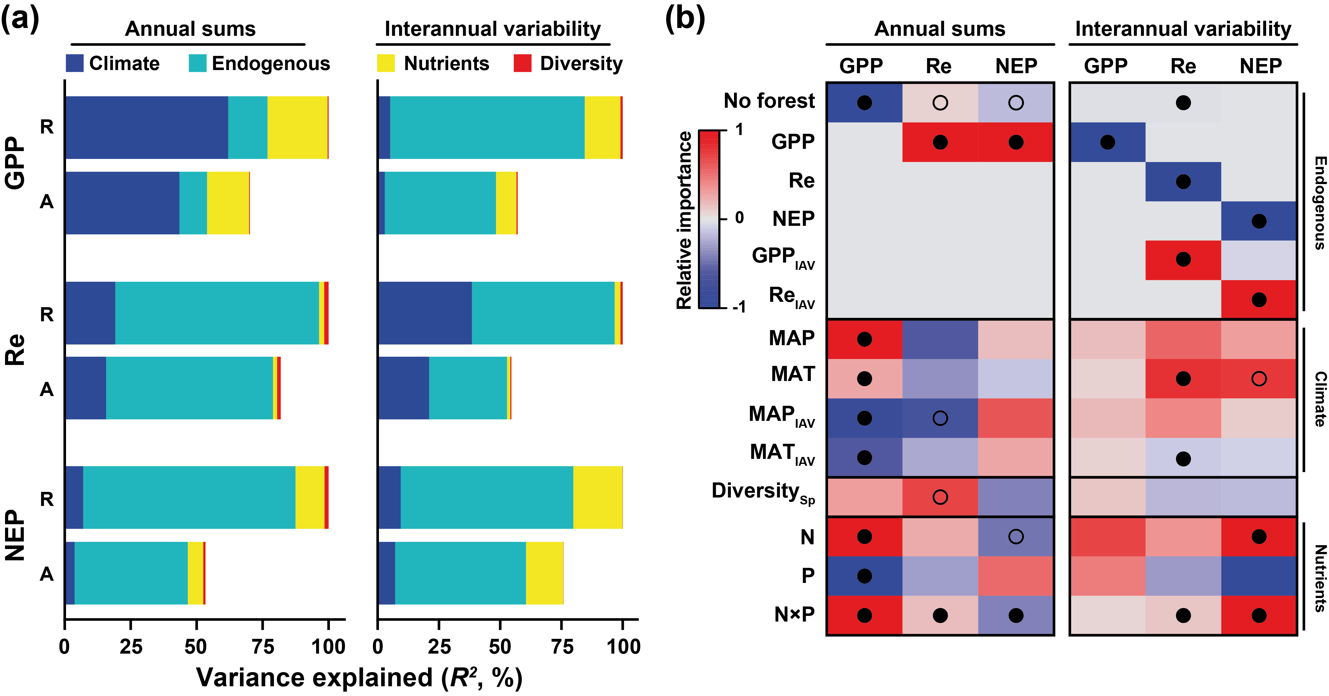

Figure 2
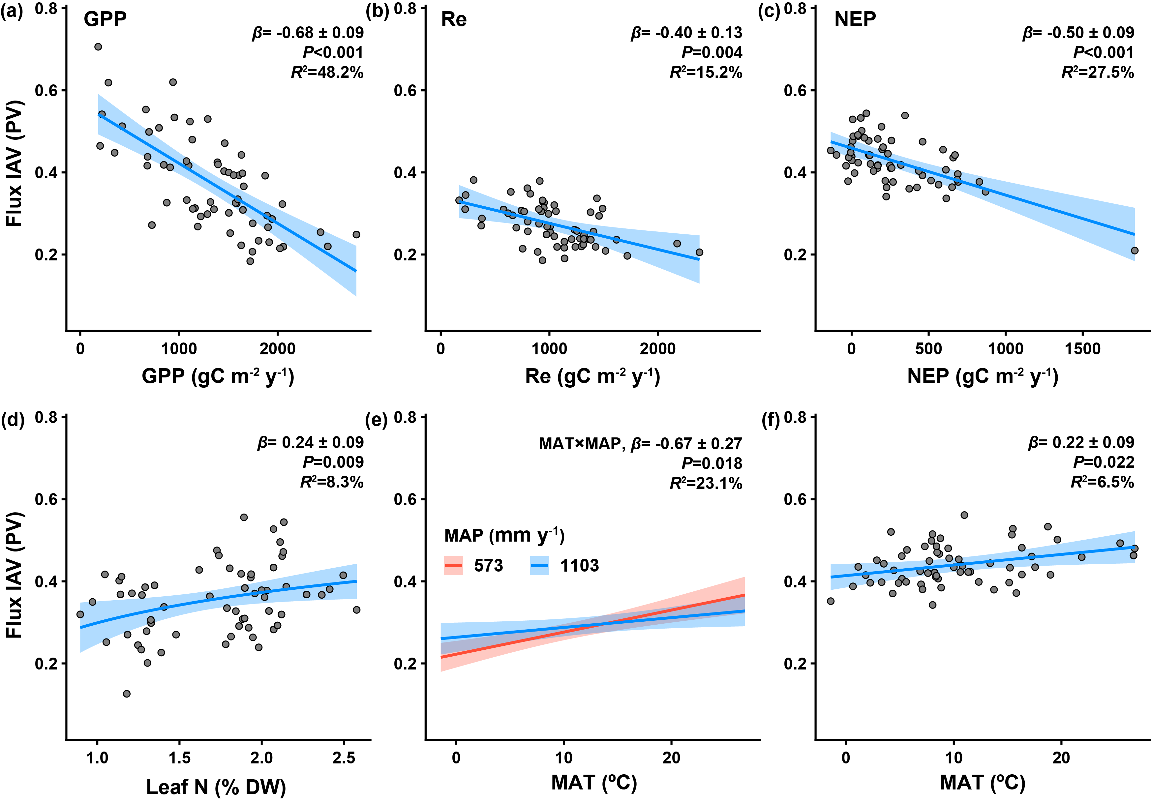

Figure 3

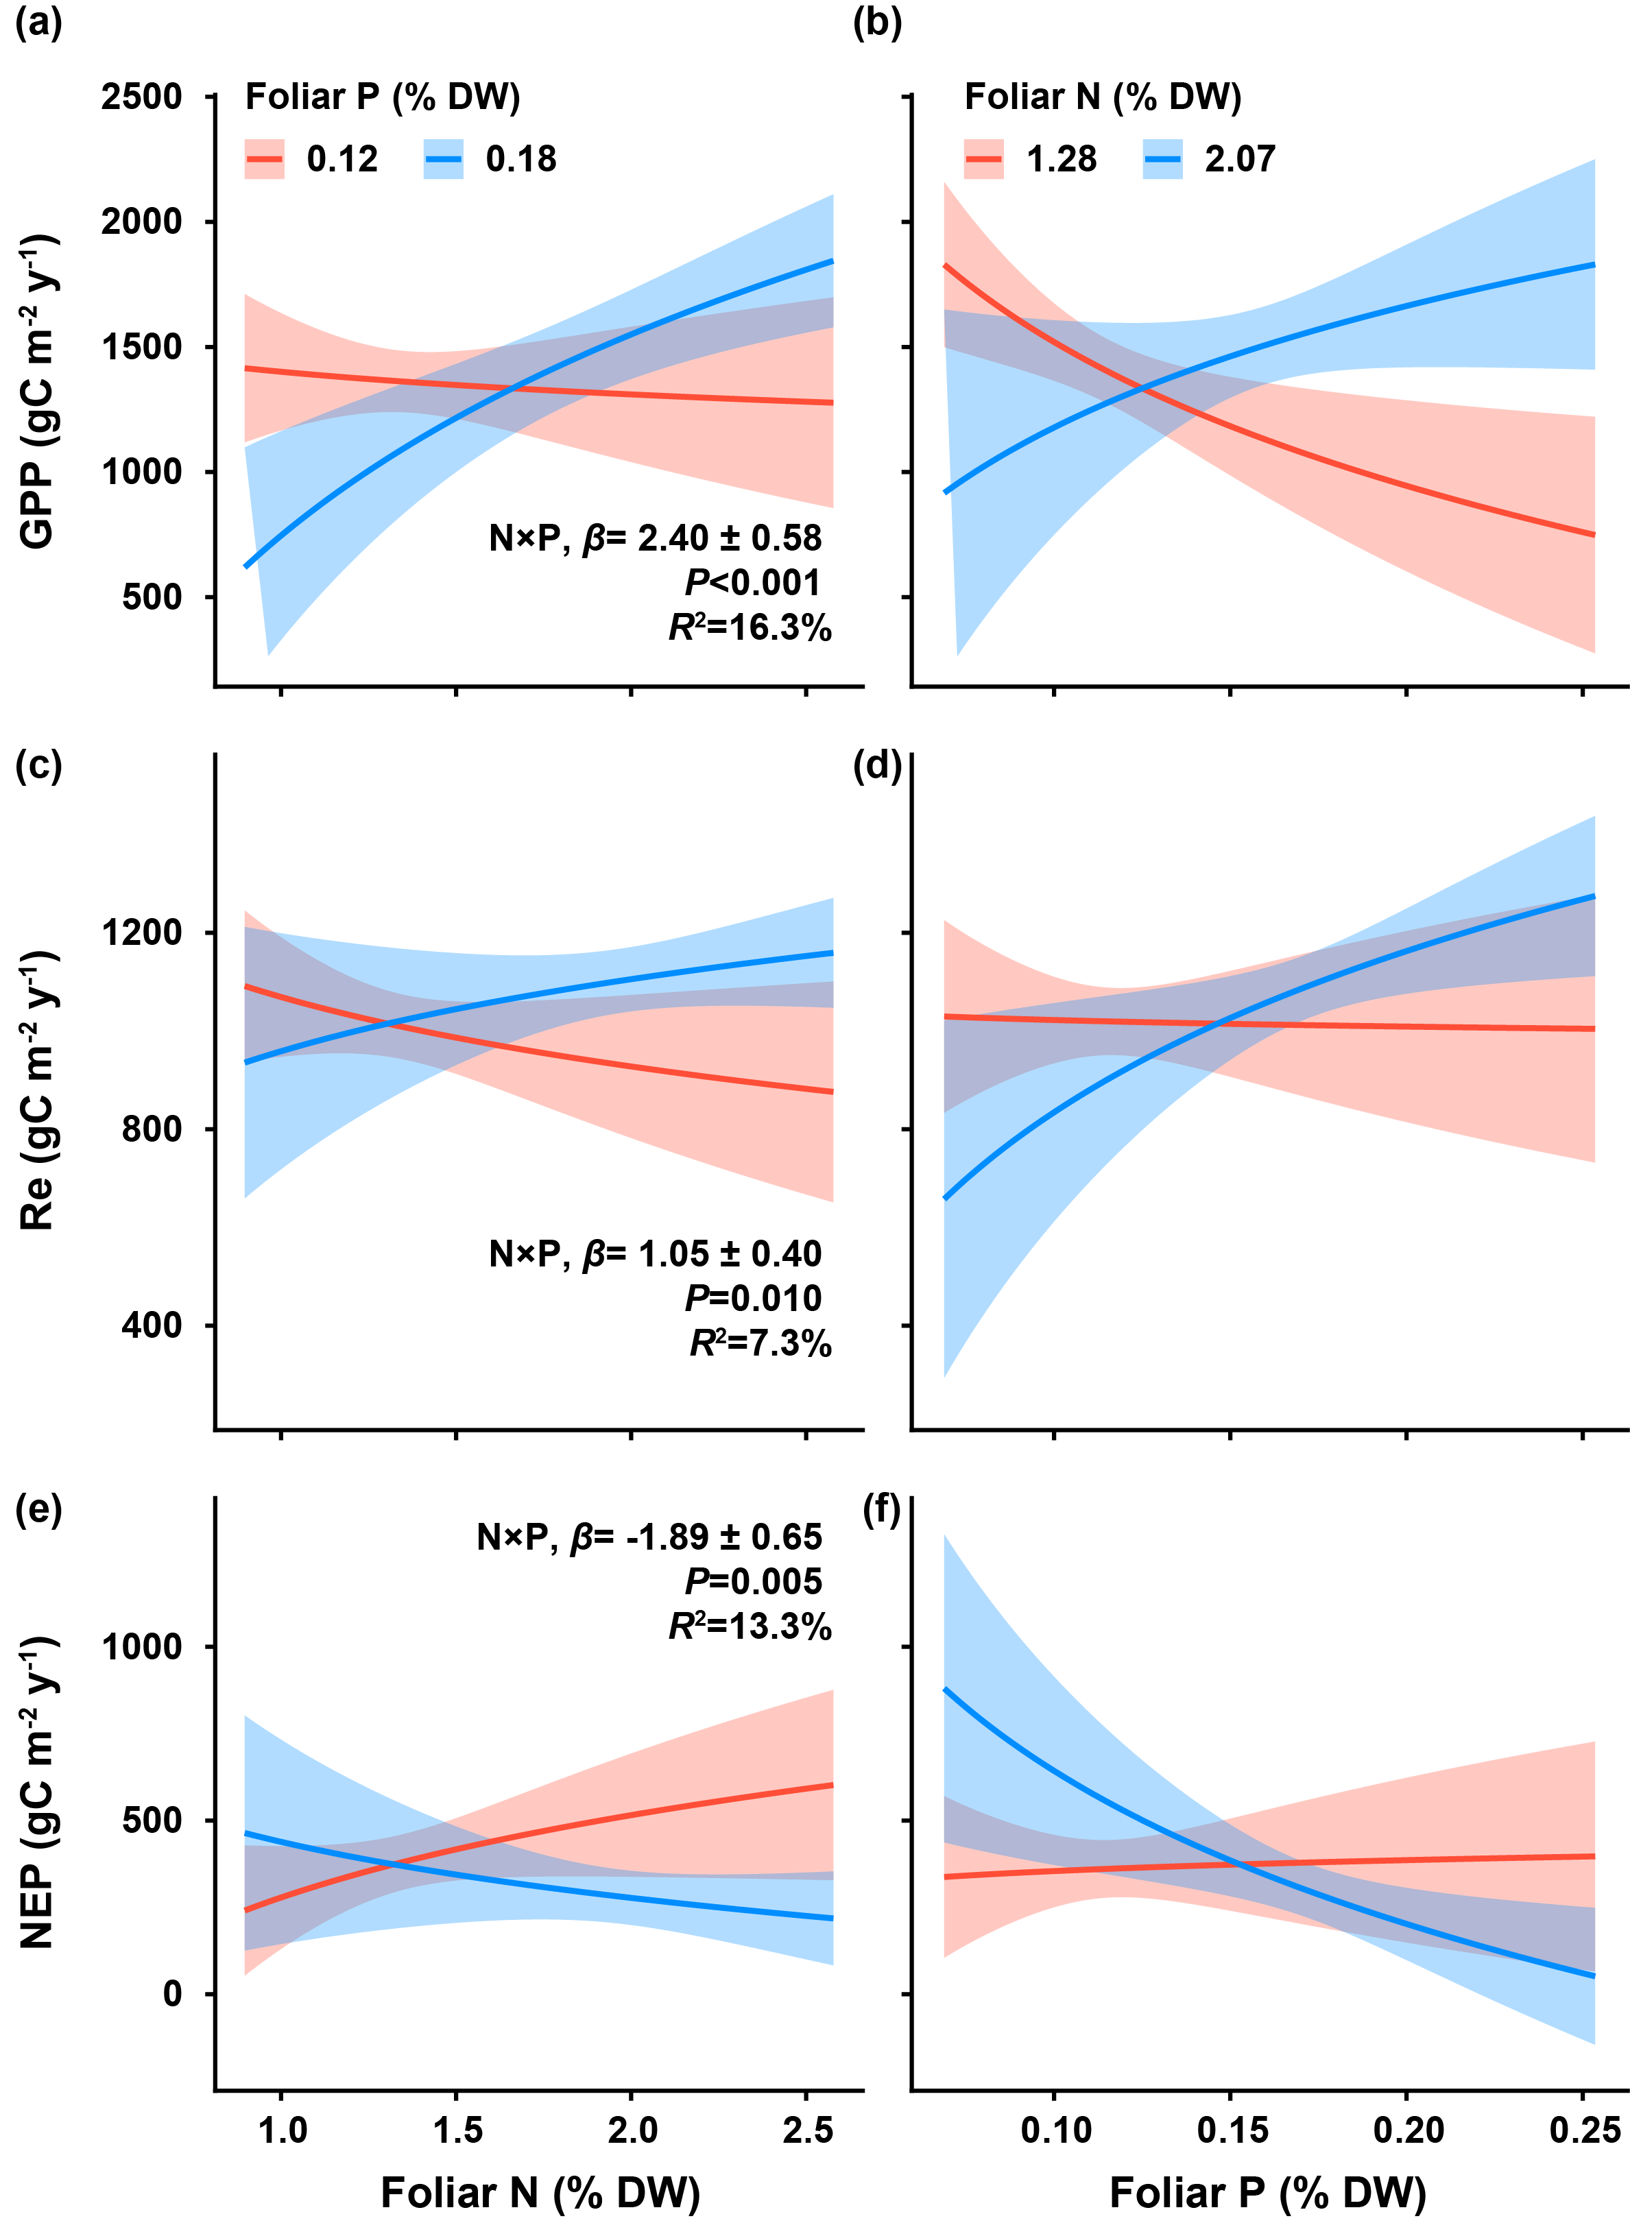

Figure 4

