Comparison of regulatory pathways for advanced therapies approved in the European Union and the United States
Iglesias-Lopez C¹, Obach M², Vallano A^{1,2}, Agustí A^{1,3}
¹Department of Pharmacology, Therapeutics and Toxicology. Universitat Autònoma de Barcelona, Bellaterra, Cerdanyola del Vallès, 08193, Spain.
²Medicines Department. Catalan Healthcare Service, Travessera de les Corts 131-159, 08028, Barcelona, Spain.
³Clinical Pharmacology Service. Vall d’Hebron University Hospital, Passeig Vall d’Hebron 119-129, 08035, Barcelona, Spain.

Email addresses:

Carolina Iglesias-Lopez: carolina.iglesias.lopez.uab@gmail.com
Mercè Obach: mobach@catsalut.cat
Antoni Vallano: avallano@catsalut.cat
Antònia Agustí: ag@icf.uab.cat; aagustí@vhebron.net

* Correspondence:
Vallano, Antoni: Medicines Department. Catalan Healthcare Service, Travessera de les Corts 131-159, 08028, Barcelona, Spain.
Phone: 34 93 403 86 94 Fax: Not available; Email: avallano@catsalut.cat

ABSTRACT
Regulatory agencies in the European Union (EU) and in the United States (US) have adapted and launched regulatory pathways to accelerate the patient access to innovative therapies, such as advanced therapy medicinal products (ATMPs). The aim of this study is to analyse similarities and differences between regulatory pathways followed by the approved ATMPs in both regions.
Methods: A retrospective analysis of the approved ATMPs by the EU and US regulatory agencies was carried out until 31st May 2020. Data was collected on the features and timing for the orphan drug designation (ODD), scientific advices (SA), expedited programs designations (EP) and marketing authorisation application (MAA) and authorisation for both regions.
Results: In the EU a total of 15 ATMPs were approved (8 gene therapies, 3 somatic cell therapies, 3 tissue engineered products, and 1 combined ATMP), while in the US a total of 9 were approved (5 gene therapies and 4 cell therapies); 7 of those were authorised in both regions. No statistical differences were found on the mean time between having the ODD or EP granted to the start of pivotal clinical trial or to the MAA among EU and US, although US required less time for the MAA assessment than EU (5.44 difference; p=0.012); specifically, for those therapies with EP and an expedited MAA assessment. Our results also showed no differences in the number and percentage of ATMPs with expedited MAA assessment between the EU and the US (5 ATMPs; 33.3% vs 55.5%, respectively; p=0.285). More than half of the approved ATMPs (67% and 55.55% in the EU and US, respectively) were granted with an ODD, 70% by submitting preliminary clinical data in the EU. The mean number of SA and protocol assistance conducted by the European Medicines Agency was 1.71 and 3.75, respectively, and only 13% included a parallel advice with the Health Technology Assessment bodies. 53.33% of the products conducted the first SA after the pivotal clinical study had started. Finally, of the 7 ATMPs authorised in both regions, only for 2 ATMPs (28.6%) the type of MA differed and 4 out of 8 products non-commercialised in the US had a non-standard MA in the EU.
Conclusion: The current approved ATMPs mainly target orphan diseases. Although the EU and the US regulatory procedures may differ, the main regulatory milestones obtained for the approved ATMPs are similar in both regions, with the exception of the time for MAA evaluation, the number of authorised products among regions and the type of authorisation for some products. More global regulatory convergence might imply to simplify and expedite even more the current ATMP development among regions.
Keywords: Genetic therapy, Cell- and Tissue-based therapy, Europe, United States Food and Drug Administration, Drug Approval, Legislation & Jurisprudence.

Highlights
- Currently, few ATMPs have been approved in the EU and the US.
- Less than half of approved ATMPs are marketed simultaneously in the EU and the US.
- More than half of the approved ATMPs obtained orphan drug designation in the EU and the US.
- The time required for the assessment of the marketing authorisation application is different between regions.

INTRODUCTION
Advanced therapy medicinal products (ATMPs) feature cells, genes, or tissues. In the last decade, the first advanced therapies have been launched into the market and, as a result of their recent increase in research and development, the regulatory agencies have adapted and launched new regulatory pathways compatible with the novelty, complexity and technical specificity of these products. It has been recognised by the European Medicines Agency (EMA) and the Food and Drug Administration (FDA) that the evaluation of ATMPs requires specific expertise, which goes beyond the traditional pharmaceutical field (1).
There are several optional and mandatory regulatory procedures to be followed throughout drug development (Figure 1). No studies have been conducted so far to analyse the regulatory steps taken in the European Union (EU) and the United States of America (US) for the approved ATMPs; thus, the aim of this study is to analyse and compare the regulatory pathways followed by these therapies in both regions.

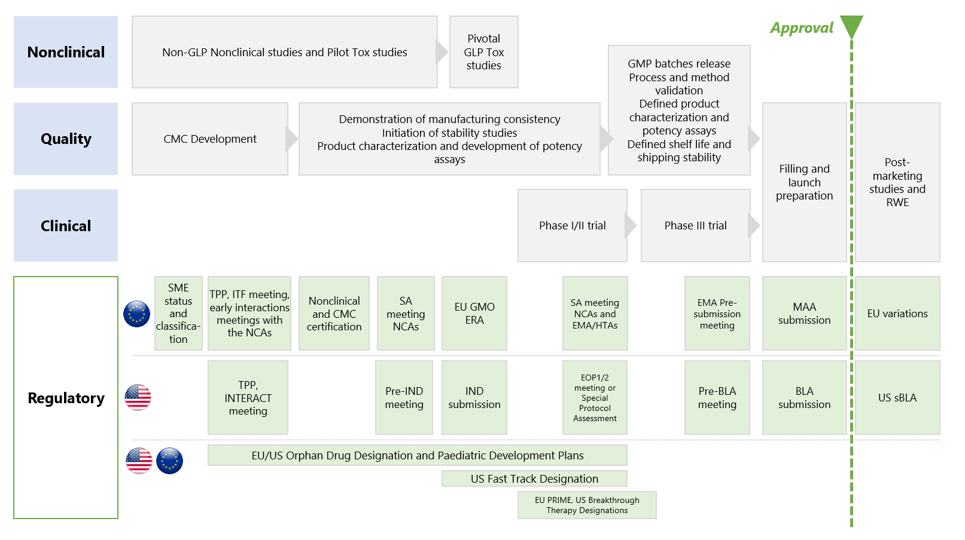
Figure 1. Overview of the EU and the US regulatory steps for advanced therapies during development. CMC: Controls Manufacturing Chemical; EOP1/2: End-of-Phase 1 or 2; EU: European Union; GLP: Good Laboratory Practices; GMO: Genetically Modified Organism; GMP: Good Manufacturing Practices; IND: Investigational New Drug; ITF: Innovative Task Force Meeting; INTERACT: Initial Targeted Engagement for Regulatory Advice; NCAs: National Competent Authorities; PD: Pharmacodynamic; SA: Scientific Advice; sBLA: Supplemental Biologics License Application; SME: Small and Medium Enterprise; Tox: toxicity; TPP: target product profile; RWE: Real World Evidence; US: United States of America. In the US, the current good manufacturing practice (CGMP) for Phase 1 Investigational Drugs, which include biological drugs, are exempt from complying with 21 CFR part 211 (CGMP for finished pharmaceuticals) under 21 CFR 210.2(c) (referred to as phase 1 investigational drugs). However, this exemption does not apply to an investigational drug for use in a phase 1 study once the investigational drug has been made available for use by or for the sponsor in a phase 2 or phase 3 study, as described in § 312.21(b) and (c), or the drug has been lawfully marketed. In the EU, cGMP requirements are detailed in EudraLex The Rules Governing Medicinal Products in the European Union Volume 4 Good Manufacturing Practice - Guidelines on Good Manufacturing Practice specific to Advanced Therapy Medicinal Products.

METHODS
To perform the retrospective study of the approved ATMPs in the EU and the US the following approach has been used:
Search strategy: Data collection was primarily extracted from the EMA and FDA websites (www.ema.europa.eu; www.fda.gov). European data was gathered from European Public Assessment Reports, orphan designations product reports and publicly available EMA agendas, minutes and highlights. The US data were collected mainly from FDA drug summaries reports and “Summary Basis of Regulatory Action” documents and other approval history related documents published for the approved cellular and gene therapy products. The search was carried out until 31st May 2020. In addition, a search for the main clinical trials of the approved ATMPs was conducted using ClinicalTrials.gov database.
Eligibility criteria: The medicine products classified as ATMPs according to the EMA criteria and those classified as cellular and gene therapy products in the US were included in the study (2)(3). In order to compare only those products that are considered ATMPs in both regions, the approved hematopoietic progenitor cell cord blood products in the US have been discarded from this analysis since are not considered ATMPs products in the EU but under the transplantation laws. In addition, only product under centralised procedure in the EU have been considered, excluding those ATMPs approved under ¨hospital exemption”, since these products are non-industrial manufactured and tailor-made for a single patient.
Data extraction and collected variables: We designed specific data extraction forms using Microsoft Excel 2019 to collect the information related to the approved ATMPs regulatory development: i) scientific advice (SA) number and timing in the EU and US pre-investigational new drug applications (pre-IND) and pre-biological license applications (pre-BLA) meetings, along with Special Protocol Assessment procedures, ii) timing and features for the European and the US orphan drug designations (ODD) including significant benefit for the EU, iii) timing and features of expedited programs, marketing authorisation application (MAA) and type of approval for the approved ATMPs in both regions. The expedited programs were classified as Priority Medicines Designation (PRIME) in the EU, and Breakthrough designation, Fast Track, Regenerative Medicine Advanced Therapy (RMAT) in the US. Information on the expedited programs for other chemical and biological drugs was also collected. The types of marketing authorisation were classified as standard approval, conditional approval, and exceptional circumstances in the EU, and standard approval and accelerated approval program in the US. The date for the EU approval was based on the CHMP positive opinion. Finally, the issues raised to the scientific advisory groups meetings during the MAA evaluation were collected for both regions, and its categorisation approach were sourced and adapted from Barkholt et al. (4). ATMP classification and certification procedures have been exclude from the analysis since are European specific, as well as the Environmental Risk Assessment procedures as they differ among regions (5).
Statistical analysis: Statistical analysis of categorical and continuous variables was made by means of the distribution of frequencies, proportions, confidence intervals (CI) 95%, means, standard deviation (SD), median, interquartile range (IQR), and range (minimum and maximum). Statistical differences were evaluated using the chi-square test for categorical variables and paired student’s t-test for continuous variables. Comparison of temporal variables were only made for common ATMPs approved in both regions. A two-tailed significance was set at a level of 0.05. The statistical analysis was performed using SAS® 9.4 (SAS Institute Inc., Cary, NC, USA).

RESULTS
In the EU a total of fifteen ATMPs were approved for sixteen different clinical indications, while in the US a total of nine therapies were approved for ten clinical indications. The ATMPs approved in both regions, the year of submission and approval, and the clinical indications authorised are shown in Table 1. A total of seven of these ATMPs were approved in both EU and US regions (five being gene therapy medicinal products (GTMPs)), eight therapies were only approved in the EU, and two were only approved in the US. In the EU, eight (53.33%) ATMPs were GTMPs, three (20%) were somatic cell therapy medicinal products (SCTMPs), three were tissue engineered products (TEP) (20%), and one (6.66%) was a combined ATMP. In the US, five (55.55%) were GTMPs and four (44.44%) were cell therapies.

Table 1. Overview of the approved advanced therapy medicinal products in the EU and the US (until May 2020)
Product | Product description | EU Indication¹ |  | US Indication¹
Axicabtagene ciloleucel (Yescarta®) | Cell-based GTMP. Autologous T cells transduced gamma retroviral vector | - Treatment of adult patients with relapsed or refractory diffuse large B-cell lymphoma (DLBCL)  - Treatment of primary mediastinal large B-cell lymphoma (PMBCL), after two or more lines of systemic therapy |  | - Treatment of adult patients with relapsed or refractory large B-cell lymphoma after two or more lines of systemic therapy, including diffuse large B-cell lymphoma (DLBCL) not otherwise specified, primary mediastinal large B-cell lymphoma, high grade B-cell lymphoma, and DLBCL arising from follicular lymphoma
Axicabtagene ciloleucel (Yescarta®) |  | Submitted: 29 Jul 2017  CHMP PO: 28 Jun 2018 | Status: Authorised | Submitted: 31 Mar 2017  Approved: 18 Oct 2017 | Status: Authorised
Tisagenlecleucel  (Kymriah®) | Cell-based GTMP. Autologous T cells transduced with lentiviral vector | - Treatment of paediatric and young adult patients up to and including 25 years of age with B-cell acute lymphoblastic leukaemia (ALL) that is refractory, in relapse post-transplant or in second or later relapse  - Treatment of adult patients with relapsed or refractory diffuse large B-cell lymphoma (DLBCL) after two or more lines of systemic therapy. |  | - (1) Treatment of patients up to 25 years of age with B-cell precursor acute lymphoblastic leukemia (ALL) that is refractory or in second or later relapse  - (2) Treatment of adult patients with relapsed or refractory (r/r) large B-cell lymphoma after two or more lines of systemic therapy including diffuse large B-cell lymphoma (DLBCL) not otherwise specified, high grade B-cell lymphoma and DLBCL arising from follicular lymphoma
Tisagenlecleucel  (Kymriah®) |  | Submitted: 02 Nov 2017  CHMP PO: 28 Jun 2018 | Status: Authorised | (1) Submitted: 27 Oct 2017  Approved: 01 May 2018 | (2) Submitted: 02 Feb 2017  Approved: 30 Aug 2017
 |  |  |  | Status: Authorised
Voritegene meparvovec (Luxturna®) | Non cell- based GTMP. AAV-2 | - Treatment of adult and paediatric patients with vision loss due to inherited retinal dystrophy caused by confirmed biallelic RPE65 mutations and who have sufficient viable retinal cells. |  | - Treatment of patients with confirmed biallelic RPE65 mutation-associated retinal dystrophy. Patients must have viable retinal cells.
Voritegene meparvovec (Luxturna®) | Non cell- based GTMP. AAV-2 | Submitted: 29 July 2017  CHMP PO: 20 Sep 2018 | Status: Authorised | Submitted: 16 May 2017 Approved: 19 Dec 2017 | Status: Authorised
Spheroids of human autologous matrix-associated chondrocytes  (Spherox®) | TEP. Spheroids of human autologous matrix associated chondrocytes | - Repair of symptomatic articular cartilage defects of the femoral condyle and the patella of the knee (International Cartilage Regeneration & Joint Preservation Society [ICRS] grade III or IV) with defect sizes up to 10 cm² in adults. |  | Not approved in the US
 |  | Submitted 03 Dec 2012  CHMP PO: 18 May 2017 | Status: Authorised
Darvadstrocel  (Alofisel®) | SCTP. Expanded human allogeneic mesenchymal adult stem cells extracted from adipose  tissue | - Treatment of complex perianal fistulas in adult patients with non-active/mildly active luminal Crohn’s disease, when fistulas have shown an inadequate response to at least one conventional or biologic therapy |  | Not approved in the US
Darvadstrocel  (Alofisel®) |  | Submitted: 2 Mar 2016 CHMP PO: 14 Dec 2017 | Status: Authorised
Allogeneic T cells genetically modified with a retroviral vector encoding for a truncated form of the human low affinity nerve growth factor receptor (ΔLNGFR) and the herpes simplex I virus thymidine kinase (HSV-TK Mut2)  (Zalmoxis®) | Cell-based GTMP. Allogeneic T cells genetically modified with a retroviral vector | - Adjunctive treatment in hematopoietic cell transplantation |  | Not approved in the US
 |  | Submitted: 05 Mar 2014  CHMP PO: 23 Jun 2016 | Status: Withdrawn
An autologous CD34+ enriched cell fraction that contains CD34+ cells transduced with retroviral vector that encodes for the human adenosine deaminase (ADA) cDNA sequence from human haematopoietic stem/progenitor (CD34+ ) cells  (Strimvelis®) | Cell-based GTMP. Autologous CD34+ cells transduced with retroviral vector | - Treatment of severe combined immunodeficiency (SCID) due to adenosine deaminase (ADA) deficiency |  | Not approved in the US
 |  | Submitted: 01 May 2015  CHMP PO: 01 Abr 2016 | Status: Authorised
Talimogene laherparepvec (Imlygic®) | Non cell-based GTMP. rHSV-1 | - Treatment of adults with unresectable melanoma that is regionally or distantly metastatic (Stage IIIB, IIIC and IVM1a) with no bone, brain, lung or other visceral disease |  | - Indicated for the local treatment of unresectable cutaneous, subcutaneous, and nodal lesions in patients with melanoma recurrent after initial surgery
Talimogene laherparepvec (Imlygic®) | Non cell-based GTMP. rHSV-1 | Submitted: 28 Aug 2014 CHMP PO: 22 Oct 2015 | Status: Authorised | Submitted: 28 Jul 2014  Approved: 27 Oct 2015 | Status: Authorised
Ex vivo expanded autologous human corneal epithelial cells containing stem cells  (Holoclar®) | TEP. Ex vivo expanded autologous human corneal epithelial cells containing stem cells | - Treatment of adult patients with moderate to severe limbal stem cell deficiency, unilateral or bilateral, due to physical or chemical ocular burns |  | Not approved in the US
 |  | Submitted: 06 Mar 2013 CHMP PO: 18 Dec 2014 | Status: Authorised
Sipuleucel-T  (Provenge®) | SCTP. Autologous peripheral-blood mononuclear cells activated with prostatic acid phosphatase granulocyte-macrophage colony-stimulating factor | - Treatment of asymptomatic or minimally symptomatic metastatic (non-visceral) castrate resistant prostate cancer in male adults in whom chemotherapy is not yet clinically indicated |  | - Treatment of asymptomatic or minimally symptomatic metastatic castrate resistant (hormone refractory) prostate cancer
Sipuleucel-T  (Provenge®) |  | Submitted: 30 Dec 2011  CHMP PO: 27 Jun 2013 | Status: Withdrawn | Submitted: 30 Oct 2009  Approved: 29 Apr 2010 | Status: Authorised
Autologous cultured chondrocytes on porcine collagen membrane  (MACI®) | TEP. Autologous chondrocytes expanded ex vivo expressing chondrocyte-specific marker  genes, seeded onto a CE marked porcine derived Type I/III collagen membrane | - Repair of symptomatic, full-thickness cartilage defects of the knee (grade III and IV of the Modified Outerbridge Scale) of 3-20 cm² in skeletally mature adult patients |  | - Repair of symptomatic, single or multiple full-thickness cartilage defects of the knee with or without bone involvement in adults
 |  | Submitted: 01 Sep 2011  CHMP PO: 25 April 2013 | Status: Withdrawn | Submitted: 04 Jan 2016  Approved: 13 Dec 2016 | Status: Authorised
Alipogene tiparvovec  (Glybera®) | Non cell-based GTMP. AAV-1/2 | - Indicated for adult patients diagnosed with familial lipoprotein lipase deficiency and suffering from severe or multiple pancreatitis attacks despite dietary fat restrictions. The indication is restricted to patients with detectable levels of LPL protein |  | Not approved in the US
Alipogene tiparvovec  (Glybera®) | Non cell-based GTMP. AAV-1/2 | Submitted: 23 Dec 2009  CHMP PO: 23 Jun 2011 | Status: Withdrawn
Characterised viable autologous cartilage cells expanded ex vivo expressing specific marker proteins  (ChondroCelect®) | TEP. Characterised viable autologous cartilage cells expanded ex vivo expressing specific marker proteins | - Repair of single symptomatic cartilage defects of the femoral condyle of the knee (International Cartilage Repair Society [ICRS] grade III or IV) in adults. Concomitant asymptomatic cartilage lesions (ICRS grade I or II) might be present |  | Not approved in US
 |  | Submitted: 01 Jun 2007  CHMP PO: 25 June 2009 | Status: Withdrawn
Betibeglogen autotemcel (Zynteglo®) | Cell based GTMP. Genetically modified autologous CD34+ cell enriched population that contains haematopoietic stem cells transduced with lentiviral vector | - Treatment of patients 12 years and older with transfusion-dependent β-thalassaemia who do not have a β0/β0 genotype, for whom haematopoietic stem cell transplantation is appropriate but a human leukocyte antigen (HLA)-matched related HSC donor is not available |  | Not approved in the US
Betibeglogen autotemcel (Zynteglo®) |  | Submitted: 21 Aug 2018  CHMP PO: 26 Apr 2019 | Status: Authorised
Azficel-T  (Laviv®) | Autologous cellular product | Not approved in the EU |  | - Indicated for improvement of the appearance of moderate to severe nasolabial fold wrinkles in adults
Azficel-T  (Laviv®) | Autologous cellular product |  |  | Submitted: 22 Dec 2010  Approved: 21 June 2011 | Status: Authorised
Onasemnogene abeparvovec-xioi  (Zolgensma®) | Non cell-based GTMP. AAV-9 | - Treatment of patients with 5q spinal muscular atrophy (SMA) with a bi-allelic mutation in the survival motor neuron 1 (SMN1) gene and a clinical diagnosis of SMA Type 1, or patients with 5q SMA with a bi-allelic mutation in the SMN1 gene and up to 3 copies of the SMN2 gene |  | - Treatment of pediatric patients less than 2 years of age with spinal muscular atrophy with bi-allelic mutations in the survival motor neuron 1 gene
Onasemnogene abeparvovec-xioi  (Zolgensma®) | Non cell-based GTMP. AAV-9 | Submitted: 09 Oct 2018  CHMP PO: 26 Mar 2020 | Status: Authorised | Submitted: 01 Oct 2018 Approved: 24 May 2019 | Status: Authorised
Allogenic cultured keratinocytes and fibroblast in bovine collagen  (Gintuit®) | Allogeneic Cultured Keratinocytes and Fibroblasts in Bovine Collagen | Not approved in the EU |  | - Indicated for topical (non-submerged) application to a surgically created vascular wound bed in the treatment of mucogingival conditions in adults
 |  |  |  | Submitted: 13 Mar 2011  Approved: 09 Mar 2002 | Status: Authorised
*Indications according to labelling of each region. Date of EU marketing authorisation application submission corresponds to the date where the application was received by the EMA. AAV: Adeno Associated Viral Vector; CHMP PO: The Committee for Medicinal Products for Human Use Positive Opinion; EU: European Union; GTMP: Gene Therapy Medicinal Product; SCTP: Somatic Cell Therapy Medicinal Product; TEP: Tissue Engineered Product

Orphan Drug designation
Ten out of fifteen approved therapies in the EU (67%) were granted with an ODD during their development (seven were GTMPs, two SCTMPs and one TEP), while in the US five GTMPs out of nine approved ATMPs (55.55%) obtained this designation. In the EU, Yescarta®, Kymriah® and Luxturna® received two ODD each product, while in the US Yescarta® received three ODD and Kymriah two (Table 2). For those seven products that were developed both in the EU and the US, four of them obtained an orphan designation in both regions (57.14%).

Table 2. Summary of ODD granted in the EU and the US to the approved advanced therapies
Product | Orphan indication |  | ODD at MA |  | EU prevalence of disease to support the ODD | Data available to support the ODD* | Significant benefit criterion in the European Union
Product | EU | US | EU | US | EU prevalence of disease to support the ODD | Data available to support the ODD* | No satisfactory treatment that has been authorised in the European Union | Designated with the need to justify significant benefit
Yescarta® | Treatment of diffuse large B cell lymphoma | Treatment of diffuse large B cell lymphoma | Yes. COMP adopted a LoQ and required an OE | Yes | 2.4 in 10,000 | Preliminary clinical data showing a favourable response in patients with progressive disease who are refractory to previous treatments. | NA | Yes
Yescarta® | Treatment of primary mediastinal large B-cell lymphoma | Treatment of primary mediastinal large B-cell lymphoma | Yes. COMP adopted a LoQ and required an OE | Yes | 0.3 in 10,000 | Preliminary clinical data in patients affected by the condition who  responded to treatment with the product as assessed by imaging | NA | Yes
Yescarta® | NA | Treatment of follicular lymphoma | NA | Yes | NA | NA | NA | NA
Kymriah® | Treatment of diffuse large B-cell lymphoma | Treatment of diffuse large B-cell lymphoma | Yes | Yes | 4.5 in 10,000 | Preclinical data and preliminary clinical data showing antitumor  activity of the proposed product | NA | Yes
Kymriah® | Treatment of B-lymphoblastic leukaemia/lymphoma | Treatment of acute lymphoblastic leukaemia | Yes | Yes | 1 in 10,000 | Preliminary clinical data in patients | NA | Yes
Luxturna® | Treatment of Leber’s congenital amaurosis | Treatment of inherited retinal dystrophy due to biallelic RPE65 gene mutations | Yes. COMP adopted a LoQ and required an OE | Yes | 1 in 10,000 | Preclinical data supporting improvements in visual function | Yes | NA
Luxturna® | Treatment of retinitis pigmentosa |  | Yes. COMP adopted a LoQ and required an OE | Yes | 3.7 in 10,000 | Preclinical data supporting improvements in visual function | Yes | NA
Alofisel® | Treatment of anal fistula | NA | Positive COMP opinion after appealing a negative opinion | NA | 2.3 in 10,000 | Not known | Yes | NA
Zalmoxis® | Adjunctive treatment in hematopoietic cell transplantation | NA | Yes | NA | 0.32 in 10,000 | Clinical trials in patients were ongoing | NA | Yes
Strimvelis® | Treatment of severe combined immunodeficiency due to adenosine deaminase deficiency | NA | Yes | NA | 0.02 in 10,000 | Clinical trials in patients were ongoing | Yes | NA
Imlygic® | Not orphan drug in the EU | Treatment of stage IIb-stage IV melanoma | NA | Yes | NA | NA | NA | NA
Holoclar® | Treatment of corneal lesions, with associated corneal (limbal) stem cell deficiency, due to ocular burns | NA | Yes | NA | 0.3 in 10,000 | Clinical trials in patients were ongoing | NA | Yes
Glybera® | Treatment of lipoprotein lipase deficiency | NA | Yes | NA | 0.02 in 10,000 | The evaluation of the effects of adeno-associated viral vector expressing LPL in experimental models was on-going. At the time of submission of the application for orphan designation, no clinical trials in patients with LPL deficiency were initiated. | Yes | NA
Zynteglo® | Treatment of ß-thalassaemia intermedia and major | NA | Yes | NA | 1 in 10,000 | Preclinical results in a model of betathalassaemia intermedia | NA | Yes
Zolgensma® | Treatment of spinal muscular atrophy | Treatment of spinal muscular atrophy | Yes | Yes | 0.4 in 10,000 | Clinical trials with the medicine in patients with spinal muscular atrophy were ongoing | Yes | NA
COMP: Committee for Orphan Medicinal Products; EU: European Union; LoQ: list of questions; LPL: lipoprotein lipase deficiency; NA: not applicable; OE: oral explanation; US: United States of America

In the EU significant benefit did not need to be demonstrated for five medicinal products at the time of designation, as they targeted rare conditions lacking any approved therapies in the EU (33.3% of all approved ATMPs and 50% of those with an ODD). Only three ATMPs approved (30% of the approved products with an ODD) obtained the designation supported only by preclinical data (Glybera®, Luxturna® and Zynteglo®), for Alofisel® this information was not known, while the rest submitted preliminary clinical data (70%) (Table 2).
The mean (SD) time between having the ODD granted to the start of pivotal clinical trial in the EU was 3.16 (26.93) months (median -2.50; IQR -15.75, 30.25; Range -34, 41) and -7.57 (28.72) months for the US (median -15; IQR -25, 14; Range -49, 36), meaning that the main clinical trial started before having the ODD granted (Figure 2). When analysing the four ATMPs with an orphan designation in both regions, the mean (SD) time between having the ODD granted to start de pivotal clinical trial in the EU was 1.50 (16.37) months (median -2.50; IQR -11.25, 15.25; Range -15, 28) and -5 (30.57) months for the US (median -3; IQR -31, 19.50; Range -49, 36). This difference was not statistically significant (difference = 6.5 months; CI 95% -20.14, 33.14; p=0.558).
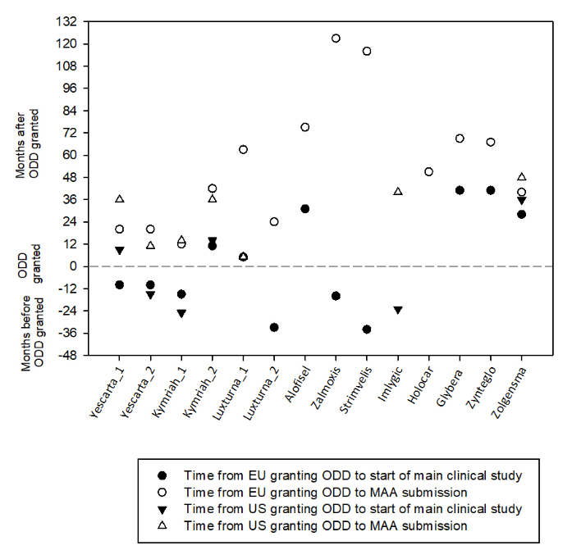
Figure 2. Relationship between date of granted ODD and start of main clinical study and MAA submission. No prospective clinical trials were conducted in support of Holoclar MAA. Yescarta_1 and Kymriah_1: Treatment of diffuse large B cell lymphoma indication in the EU and the US; Yescarta_2: Treatment of primary mediastinal large B-cell lymphoma indication in the EU and the US; Kymriah_2: Treatment of B-lymphoblastic leukaemia/lymphoma in the EU and the US; Luxturna_1: Treatment of Leber’s congenital amaurosis in the EU and treatment of inherited retinal dystrophy due to biallelic RPE65 gene mutations in the US; Luxturna_2: Treatment of retinitis pigmentosa in the EU. Yescarta received three ODD in the US: i) treatment of diffuse large B-cell lymphoma, ii) treatment of primary mediastinal B-cell lymphoma and iii) treatment of follicular lymphoma. The two latest indications have been clustered (Yescarta_2), since were granted almost at the same time. EU: European Union; MAA: Marketing Authorisation Application; ODD: Orphan Drug Designation; US: United States of America.
The mean (SD) time between having the ODD granted to the MAA submission in the EU was 55.53 (35.13) months (median 51; IQR 22, 72; Range 12, 123) and 27.14 (16.73) months for the US (median 36; IQR 11, 40; Range 5, 48) (Figure 2). When analysing the four ATMPs with an orphan designation in both regions, the mean (SD) time between having the ODD granted to MAA was 32.83 (19.02) months in the EU (median 30; IQR 20, 47.25; Range 12, 63) and 28.3 (14.29) months for the US (median 30.50; IQR 13.25, 39; Range 11, 48). This difference was not statistically significant (difference = 4.50 months; CI 95% -15.21, 24.21; p=0.583).
Of those therapies that were granted with an ODD, none of them lost the designation after their marketing authorisation (MA) and only Alofisel® needed an oral explanation during the EU MAA procedure to maintain the designation. Finally, Kymriah® and Zolgensma® (13.33% of the approved products) required the submission of a critical report addressing the possible similarity with authorised orphan medicinal products in the EU.

Scientific advice procedures
In the EU, all authorized ATMPs followed a SA or a protocol assistance (in case of an orphan medicinal product). The mean (SD) number of SA conducted with the EMA was 1.71 (0.75) for product (median 2; IQR 1, 2; Range 1, 3) and the mean (SD) number of protocol assistances was 3.75 (1.05) for product (median 4; IQR 3, 4.75; Range 2, 5). The questions for all products pertained to quality, nonclinical and clinical development. A total of 6 (40%) of the approved therapies had the first EU SA before the start of pivotal clinical study, while a total of 8 products (53.33%) had it later (Figure 3A). The mean (SD) time from the first SA to the conduct of the pivotal study was -2.50 (41.34) months (median 6; IQR –35, 15.5; Range -74, 85). The mean (SD) number of reported protocol amendments to the pivotal study for those products that had the SA after starting this main study was 5.60 (1.67) (median 6; IQR 4, 7; Range 3, 7), while for those products that had the SA before starting the main study was 3.75 (1.67) (median 4; IQR 2.25, 5; Range 1, 6). The mean (SD) time from the first SA to the MAA was 55.86 (33.23) months (median 46; IQR 40, 70; Range 10, 129). Only Zynteglo® conducted a parallel advice with the Health Technology Assessment bodies, whereas Kymriah® benefited from the pilot version of this program (13.33% of the ATMPs approved products in the EU).
For the US, Kymriah®, Yescarta®, Luxturna® and Zolgensma® had pre-BLA meetings. The mean (SD) time from the pre-BLA meeting to the MAA was 7.40 (5.68) months (median 5; IQR 2.5, 13.5; Range 2, 14). Kymriah®, Luxturna® and Zolgensma® also had reported pre-IND meetings with a mean (SD) time from these meetings to the conduct of the pivotal study of 47.50 (34.78) months (median 46.50; IQR 15.50, 80.50; Range 13, 84) and 74.75 (47.30) months (median 63; IQR 36.75, 124.50; Range 34, 139) from the meeting to the MAA. Kymriah® and Imlygic® applied for the Special Protocol Assessment procedure one year before the conduct of the main trial (Figure 3B).

- (B)
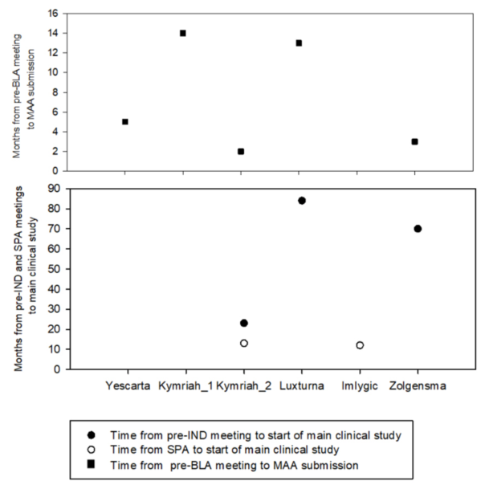
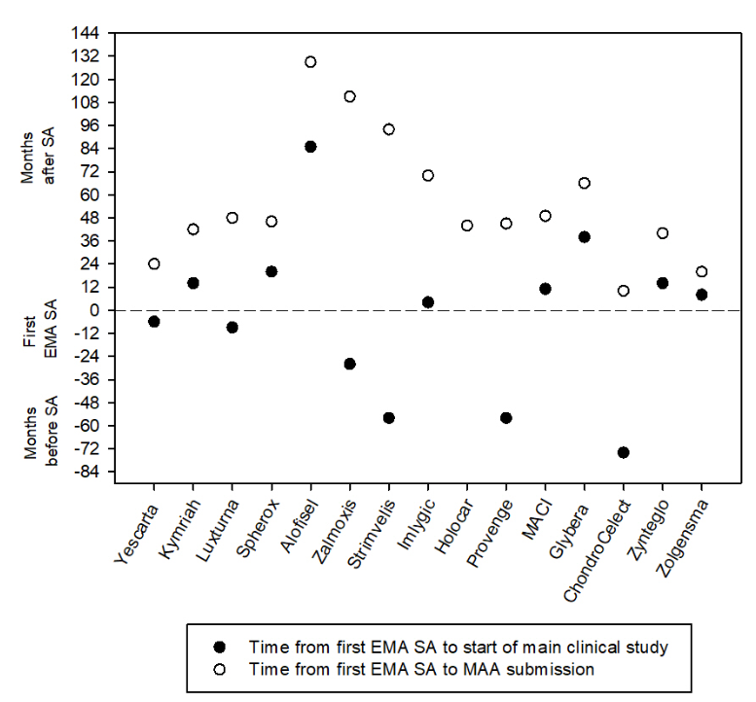

Figure 3. (A) Relationship between date of first EMA Scientific Advice and start of main clinical study and MAA submission. (B) Relationship between the reported meetings with the FDA and start of main clinical study and MAA submission. No prospective clinical trials were conducted in support of Holoclar MAA. Kymriah_1: Treatment of diffuse large B cell lymphoma indication; Kymriah_2: Treatment of B-lymphoblastic leukaemia/lymphoma. EMA: European Medicines Agency; MAA: Marketing Authorisation Application; pre-IND: pre-Investigational New Drug; SA: Scientific Advice; SPA: Special Protocol Assessment.

Expedited programs designations
In the EU four approved ATMPs obtained the Priority Medicines (PRIME) designation (26.67%), three of them the same year that the scheme was launched, Kymriah®, Yescarta® and Zynteglo®, and the following year for Zolgensma®. All the therapies, except for Zolgensma®, obtained the PRIME designation after having started the main clinical trial that was the base of the submission. The mean (SD) time from the start of the pivotal clinical trial to the PRIME designation was 5.25 (10.56) months (median 6.50; IQR -5.50, 14.75; Range -8, 16) (Figure 4A). The mean (SD) time from obtaining the PRIME designation to the MAA submission was 18.66 (4.46) months (median 20.28; IQR 14.61, 23.19; Range 14.04, 24.24). Both Kymriah® and Yescarta® obtained the designation just over a year before the MAA submission, and around two years before for Zynteglo® and Zolgensma® (Figure 4B). Although CAR-T products share the “relapsed or refractory diffuse large B-cell lymphoma (DLBCL)” indication, Kymriah® obtained the PRIME designation for the treatment of paediatric patients with relapsed or refractory B cell acute lymphoblastic leukaemia while Yescarta® did for the shared indication.
In the US, four out of nine ATMPs approved were granted with the Breakthrough designation (44.44%), being these ones the latest approved products (Kymriah®, Yescarta®, Luxturna® and Zolgensma®). All these therapies obtained the Breakthrough designation after having started the main clinical trial that was the base of the submission, except for Zolgensma®. Kymriah® obtained two Breakthrough designations, one for the B-cell precursor acute lymphoblastic leukaemia (ALL) indication and the other for DLBCL. The mean (SD) time from the start of the main clinical trial to obtain the Breakthrough designation was 10 (15.13) months (median 11; IQR -2.50, 22; Range -15, 23) (Figure 4A). The mean (SD) time from obtaining the Breakthrough designation to the MAA submission was 20.2 (8.14) months (median 19.56; IQR 13.02, 28.50; Range 11.04, 30.96). Like in the EU, both Kymriah® and Yescarta® obtained the designation just over a year before the MAA submission, and over two years before for Luxturna® and Zolgensma® (Figure 4B). Three approved products (33.33%) received the Fast Track designation (Provenge®, Imlygic® and Zolgensma®). Zolgensma® obtained both Fast Track and Breakthrough designations consecutively. The mean (SD) time from the start of the main clinical trial to obtain the Fast Track designation was -8.33 (35.64) months (median 2; Range -48, 21). The mean (SD) time from obtaining the Fast Track designation to the MAA submission was 58.96 (15.57) months (median 60.12; Range 42.84, 73.92). None of the approved ATMPs have been granted with a RMAT designation and no product with this designation has been launched yet to the US market.
- (B)
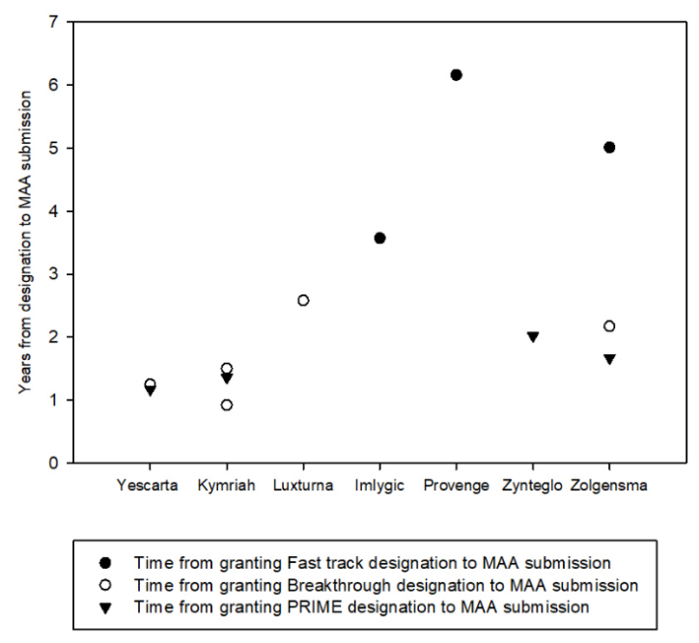
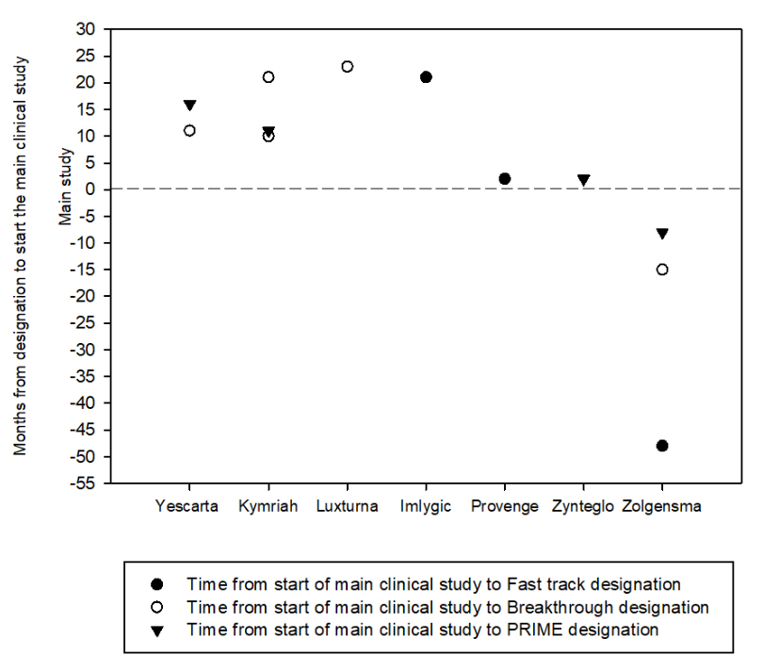
Figure 4. (A) Relationship between date of granting expedited programs and start of main clinical study. (B) Relationship between date of granting expedited programs and MAA submission. (A)(B). Kymriah obtained the Breakthrough designation for the two following indications: i) treatment of adult patients with diffuse large B-cell lymphoma (DLBCL), and ii) treatment of patients up to 25 years of age with B-cell precursor acute lymphoblastic leukaemia (ALL) that is refractory or in second or later relapse. MAA: Marketing Authorisation Application; PRIME: PRIority Medicines designation.
When analysing the three common ATMPs approved in the EU and the US, the mean (SD) time between having the expedited designation granted to start de pivotal clinical trial in the EU was 6.33 (12.66) months (median 11; Range -15, 28) and 5.66 (18.58) months for the US (median 11; Range -15, 21). This difference was not statistically significant (difference = -0.66 months; CI 95% -23.75, 22.42; p=0.912). The mean (SD) time between having the expedited designation granted to MAA in the EU was 16.80 (3.02) months (median 18; Range 14.04, 20.04) and 19.68 (5.70) months for the US (median 18; Range 15, 26.04). This difference was not statistically significant (difference = 0.24 months; CI 95% -0.32, 0.80; p=0.209).
The cumulative PRIME designations granted from May 2016 to May 2020 for ATMPs was 32 out of 76 (42.10%) designations requested, while for other chemical and biological drugs was 36 out of 199 (18.09%) requested (p<0.0001) (Figure 5). No cumulative data is reported for the Breakthrough designation. The reported cumulative RMAT requests received from December 2016 until May 2020 add up to a total of 139, and of those 48 were granted (34.5%), 76 were declined (54.67%) and 6 were withdrawn (4.3%). Since both RMAT and PRIME were launched in 2016, the cumulative data indicates that slightly more PRIME designations are granted than RMAT for ATMPs (42.1% vs 34.5%, respectively).
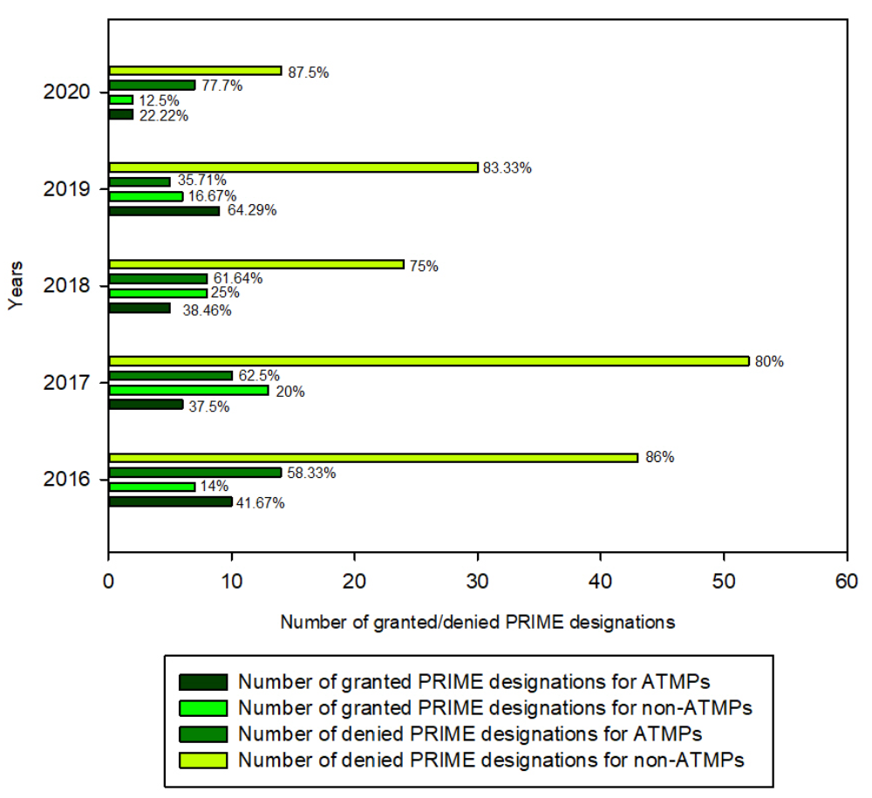
Figure 5. Number of PRIME designations granted and denied for ATMPs vs non-ATMPs (from May 2016 to May 2020). ATMPs: Advanced Therapies Medicinal Products; PRIME: PRIority Medicines designation.

Marketing authorization application
The mean (SD) time required from submission of the MAA to its final approval in the EU was 17.96 (10.97) months (median 17.55; IQR 10.78, 21.42; Range 7.69, 53.49) and 10.96 (4.62) months for those therapies with a PRIME designation (median 9.30; IQR 7.72, 15.86; Range 7.69, 17.55). The mean (SD) time of the first clock stop at Day 120 for all approved ATMPs was 6.56 (9.81) months (median 3.65; IQR 2.16, 6.19; Range 0.85, 43.70), while for therapies with the PRIME designation was 1.59 (0.63) months (median 1.66; IQR 0.95, 2.16; Range 0.85, 2.20). The mean (SD) time for the second clock stop at Day 180 of the procedure was 2.03 (2.22) months (median 1.05; IQR 0.64, 2.38; Range 0.03, 7.75). There were second rounds of outstanding issues for nine of the approved ATMPs analysed (60%), and even third and fourth rounds for ChondroCelect® and Zalmoxis® respectively (13.33% of the approved products). For Zynteglo®, at Day 180 there were no outstanding issues, although the European Commission requested clarifications on the label after the Committee for Advanced Therapies (CAT)/Committee for Medicinal Products for Human Use (CHMP) positive opinion. Finally, nine of the approved products required an oral explanation (60%).
In the US, the mean (SD) time required from submission of the MAA to its final approval was 8.16 (3.05) months (median 6.98; IQR 5.95, 10.31; Range 5.13, 14.98) and 6.85 (1.10) for those with a Breakthrough designation (median 6.63; IQR 5.49, 7.56; Range 5.13, 7.72). It took 7 months for Yescarta® and Luxturna® to obtain the approval through a rolling submission.

The mean (SD) time required from submission of the MAA to its final approval between approved ATMPs in both regions was 13.64 (4.58) months in the EU (median 13.76; IQR 8.56, 17.81, Range 7.82, 19.78) and 8.20 (3.29) months for the US (median 6.98; IQR 6.11, 10.40; Range 5.13, 14.98). The difference was statistically significant (difference = 5.44 months; CI 95% 1.63, 9.25; p=0.012).

A total of seven products (46.67%) in the EU and six products (66.66%) in the US required an Advisory Committee (AC) during the MAA. Regarding the issues that were posed to these ACs, do not coincide between both agencies and the most common questions are related with the target population, the evidence of clinical efficacy and clinical pharmacology (including dose and route of administration) (Table 3).

Table 3. Comparison of the issues discussed in the Scientific Advisory Groups meetings during the Marketing Authorisation procedure for the approved advanced therapies in the EU and the US
 | Kymriah® |  | Luxturna® |  | Imlygic® |  | Provenge®
 | EU | US | EU | US | EU | US | EU | US
Product potency |  |  |  |  |  |  |  | ①
Pharmacology (including dosing and route of administration) |  |  |  |  |  | ① |  | ①
Pharmacokinetics (biodistribution) |  |  | ①
Target population and indication | ② |  | ③ |  | ② | ① | ①
Choice of endpoints |  |  |  | ① | ①
Sufficient clinical package to support the MA |  |  |  |  |  | ①
Clinical efficacy results | ④ |  |  |  | ① |  | ① | ①
Clinical benefit | ① |  | ②
Clinical safety |  |  |  |  |  |  | ①
Safety with regards to product administration |  | ① |  | ①
Limited S&E follow-up, RM, and post-marketing | ① |  |  | ① |  |  | ①
Risk benefit assessment |  | ① |  | ① |  | ①
Regulatory pathway for approval |  |  |  |  |  | ①
Total | ⑧ | ② | ⑥ | ④ | ④ | ⑤ | ④ | ③
Categorisation approach were sourced and adapted from Barkholt et al. (4). EU: European Union; MA: marketing authorisation; RM: risk management; S&E: safety and efficacy; US: United States of America. Laviv® and Gintuit® were only approved in the US. Issues discussed in the Scientific Advisory Groups (SAG) meeting during the MA procedure for Laviv® were pharmacology (1), clinical safety (5), limited S&E follow-up and RM and post marketing (1); and for Gintuit® were validation process and assays (1), impurities, microbiological contamination (2), and comparability and consistency issues (1). Glybera® was only approved in the EU. Issues discussed in the SAG meeting during the MA procedure for Glybera® were: choice of endpoints (1), pharmacodynamics and drug interactions (1), target population and indication (1). Zolgensma® required a SAG meeting in the EU. The issues discussed included: pharmacology (including dosing and route of administration) (1), target population and indication (1) and clinical benefit (1). For Zolgensma® no advisory committee meeting was held in the US because initial review of information submitted did not raise concerns or controversial issues that would have benefited from an advisory committee discussion.

Expedited MAA assessments
Strimvelis®, Yescarta®, Kymriah®, Zynteglo® and Zolgensma® MAA were reviewed under an accelerate assessment (AA) (33.33% of the approved products), being the mean (SD) time from submission to final approval 10.96 (4) months in the EU (median 10.78; IQR 7.75, 14.29; Range 7.69, 17.55). Only Zynteglo® could keep the AA until the end of the procedure.
A total of 5 (55.55%) of the approved products obtained the priority review in the US, including all of the approved therapies that were granted the Breakthrough designation (Yescarta®, Kymriah®, Luxturna® and Zolgensma®). Provenge® was granted with a Fast Track designation, also obtaining the priority review, since at the time of its development the breakthrough designation was not available. The mean (SD) time for approval under priority review was 6.56 (0.91) months (median 6.73; IQR 5.74, 7.25; Range 5.13, 7.72). LaViv® was the first and only personalized aesthetic cell therapy approved by the FDA under standard review within only 6 months.
There was not differences in the percentage of ATMPs with an expedited MAA assessment between the EU (33,3%; CI 95%: 15%, 58.5%) and the US (55.5%; CI 95% 26.6%, 81.2%) (p=0.285).
Kymriah®, Yescarta® and Zolgensma® obtained expedited MAA review in both regions (42.86% of ATMPs authorised in both regions). The mean (SD) time from submission to final approval of these products was 10.99 (4.58) months in the EU (median 9.3; IQR 7.82, 15.85; Range 7.82, 17.55) and 6.58 (1.07) months in the US (median 6.73; IQR 5.49, 7.50; Range 5.13, 7.72). The difference was not statistically significant (difference = 4.41; CI 95% -1.70, 10.53; p=0.105).

Types of marketing authorisation
In EU, ten (66.7%) ATMPs have been authorised under a standard approval, four (26.7%) under conditional approval and one (6.7%) under exceptional circumstances. In US, six (66.7%) have been authorised under standard approval and three (33.3%) under an accelerated approval program (Table S2). Of the seven ATMPs authorised in both regions, only for two ATMPs (28.6%) the type of MA differed; Yescarta® and Kymriah® have been authorised under standard approval in the EU but under an accelerated approval program in the US. Four out of eight products non-commercialised in the US had a non-standard MA in the EU. Five therapies were withdrawn in the EU, while two of those are still authorised in the US (Table 1).

DISCUSSION
The major finding of the current study is that the main regulatory milestones are similar between regions although some differences have become apparent (Figure 6).
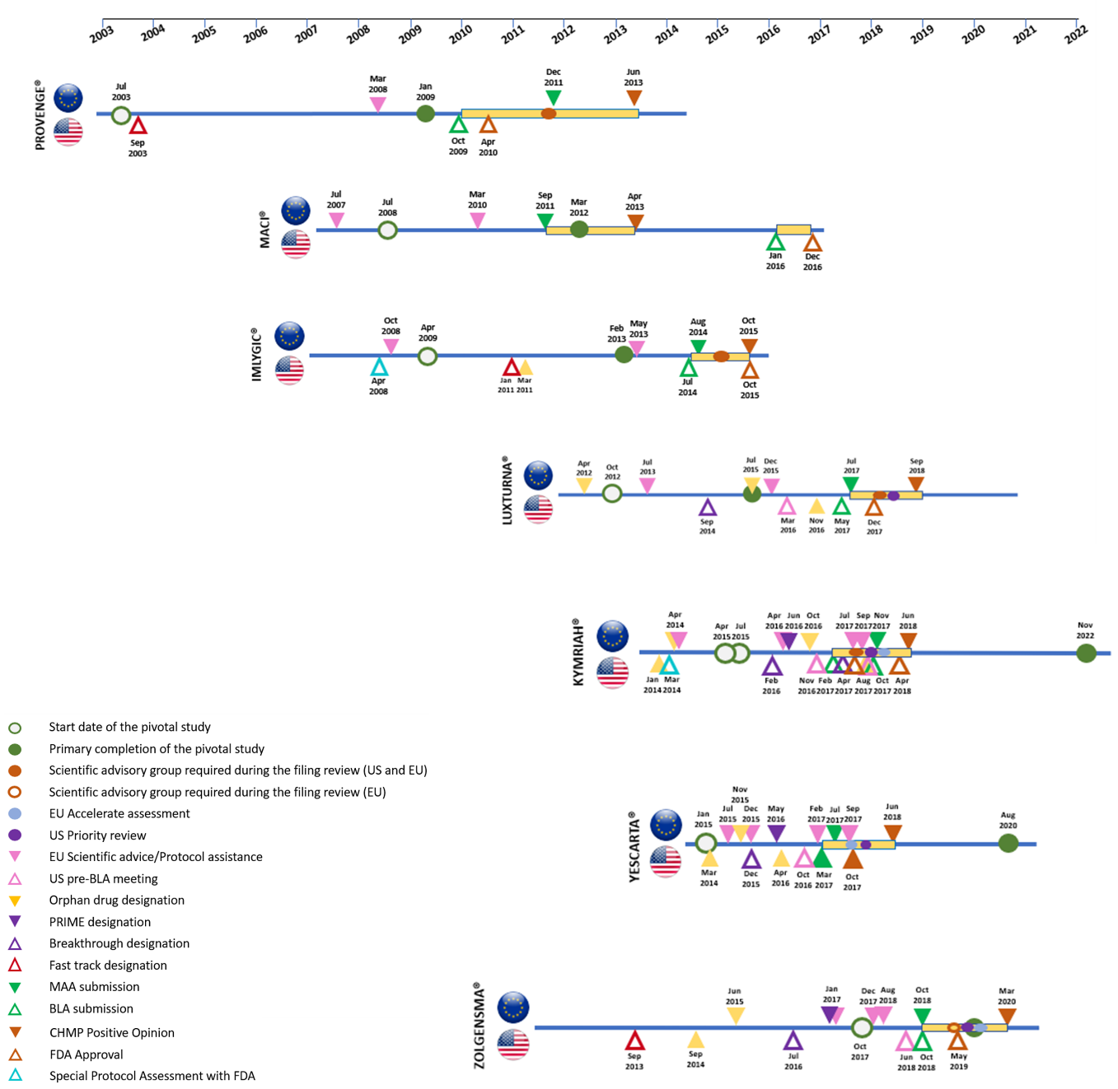
Figure 6. Comparison of regulatory pathways followed by ATMPs that were authorised in both regions.

Over the last years a constant effort has been made to develop ATMPs mainly focused on orphan conditions. Almost 2,100 clinical trials studying ATMPs were initiated between 2014 and June 2019 worldwide, most of them cell and gene therapies in phase I or II of clinical development (6). Interestingly, three times more of these interventional clinical trials were located in North America than in Europe. However, only 15 ATMPs in the EU and 9 in the US have achieved MA until May 2020, representing 1.6% of overall approved products in Europe from 2009. This data reveals the necessity to understand the gap between the large number of investigational products and the approved ATMPs, and whether specific regulatory mechanisms were used to achieve their current status in the EU and the US.
When analyzing all the steps involved in the procedure to achieve MA, we have seen that more than half of the approved ATMPs obtained the orphan status. For the European and US ODD programs the medical plausibility needs to be demonstrated, as well as the prevalence of the disease. However, unlike the EU, in the US there is no need to proof significant benefit over standard of care. (7)(8). Our study indicates that in the EU, half of the approved ATMPs with an ODD targeted unmet medical needs, avoiding significant benefit demonstration and in part contributing to an open label clinical designs. Moreover, the time analysis related to achieve orphan designation exhibits that there is no representative mean time to apply for the ODD and it is mainly product-specific and dependant on the duration of the clinical development. Most of the approved therapies applied to the ODD once preliminary clinical data in patients was available, maybe due to the fact that the conventional nonclinical toxicological packages are not applicable to these therapies because of their patient-specificity and the lack of preclinical models (9). On the other hand, the therapies that have a short period between the ODD granted status and the MAA submission might be in part due to the abbreviated clinical development, while those products with prolonged periods were probably attributed to recruitment issues, common in the case of rare diseases.
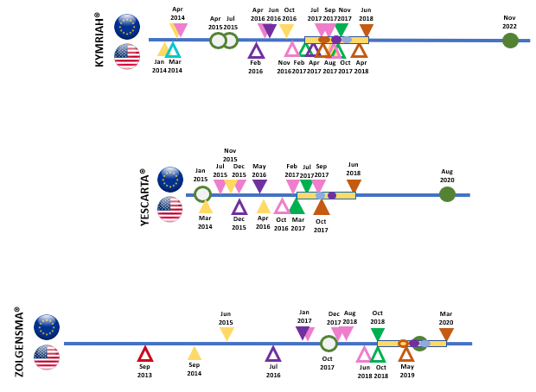
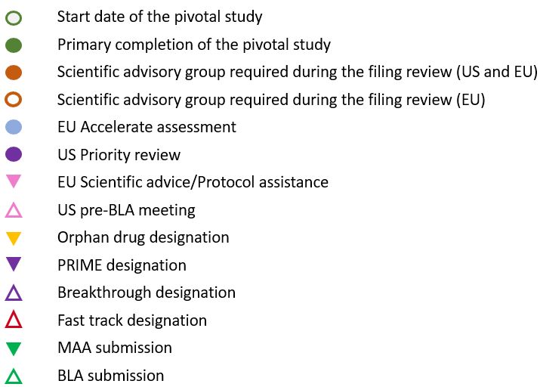
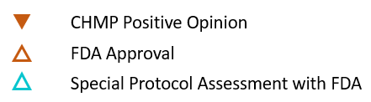
SA is a non-binding regulatory procedure offered to the sponsors at any stage of the ATMP development program. Although SA is not mandatory, it has been previously shown that products following SA recommendations at early stages of the clinical development are more prone to achieve MA (10). In the EU, an advice can be provided by the EMA or the National Competent Authorities (NCAs). The NCAs SA are related to the suitability of early clinical development, whereas the EMA SA will usually focus towards the pivotal clinical trials that will support the MAA. Interestingly, half of the approved products did not seek advice with the EMA before starting the main study and this did not imply an impact on approval success but a mean of two additional amendments to the protocol of the main study were observed. The fact that these therapies target unmet medical needs and the lack of clinical regulatory guidelines for specific medical conditions might increase the need for this procedure. In 2020, the EMA has promoted a new pilot program to facilitate multiple SA with the NCAs (11). It should be noted that the review will be independent among the NCAs and diverging opinion may still occur. Other options prior to a formal SA include informal meetings with the NCAs in the EU focused on innovative therapies (12)(13)(14) or the called “ITF” or “INTERACT” meetings with the EMA and FDA, respectively (15)(16).
On the other hand, the early development strategy should include discussions with the authorities regarding evidence generation. The abbreviated clinical developments and non-controlled trials that follow most of ATMPs, brings in uncertainty about long-term efficacy and safety, being the main constraint for obtaining product´s reimbursement (17). Although approved through a standard authorisation, Provenge®, MACI® and ChondroCelect® were withdrawn due to poor commercial performance and/or lack of reimbursement in EU countries (18)(19)(20). Despite the importance of this point, only 13% of the products conducted a parallel advice with the EMA and with the European Network for Health Technology Assessment bodies (21).
In the US, limited information about meetings conducted with the Agency is available. Interestingly, in the case of ATMPs, Special Protocol Assessment procedure were also reported, where the sponsors might reach an agreement with the FDA on the design and size of a single clinical trial to support the MA (22). End-of-phase 2 meetings with the FDA are aimed to obtain advice on pivotal study design and would be similar to the EMA SA when is conducted with the same purpose. No comparisons among regions can be done for these SA procedures since there is not publicly information about when End-of-phase meetings were conducted with the FDA for the approved ATMP products.
Another milestone of the regulatory pathway in the EU and the US is the possibility to apply for an expedited program (Table S1). These programs offer a continuous support and guidance from the agencies during the clinical development so as to optimise and speed up the drug development plans and evaluation. Expedited programs are mainly aimed for those products that target unmet medical needs, serious conditions or bring a major therapeutic advantage to patients without treatment options. The FDA has created three type of expedited programs: the Fast Track designation in 1997, the Breakthrough Therapy designation in 2012 and the RMAT in 2016, while the EMA launched the PRIME designation scheme in 2016 (23)(24)(25).
The present data points that more Breakthrough designations have been granted than PRIMEs for the approved ATMPs (44.4% vs 26.7%). Although a low number of approved ATMPs obtained PRIME designation, almost all of the ATMPs that were under development when these programs were launched benefited from them except for Luxturna® in the EU. Our results also demonstrate that the mean time from the start of the main clinical trial to obtain PRIME or Breakthrough designation or the mean time from obtaining these designations to the MAA submission was similar for both regions. However, the time for obtaining PRIME designation might be not representative, since it might have been granted earlier for these therapies based on exploratory clinical data, if this program was available at that time. Further analysis is required to conclude the mean timing to apply for this program, although for the current approved therapies was requested after the main clinical trial started. The fact that the Breakthrough designation was available but obtained later during the development, might be attributed to the qualifying criteria of this program, where clinical evidence that demonstrate substantial improvement over available therapies is required.
For Kymriah®, Yescarta® and Zolgensma®, both PRIME and Breakthrough designations were obtained consecutively from each other. Although the Breakthrough Therapy and the PRIME designations would be equivalent among regions the development requirements and the regulatory guidance may differ. However, our data displays that the access of ATMPs to expedited programs are either approved or rejected similarly in both agencies.
In the US, RMAT designation includes all the benefits of the Fast Track and Breakthrough Therapy programs and does not require evidence to indicate that the drug may offer improvement over available therapies. Therefore, RMAT designation would have been an attractive option for these approved products, but it is assumed that the development was already too far advanced at the time the RMAT designation was put in place by the FDA.
In the EU, there is a notable difference between the number of PRIME designations that have been granted for ATMPs in comparison with other products, including chemicals and other biological drugs. This fact empathises again the type of disease that the current ATMPs target. Even if the clinical design for ATMPs are typically non-controlled, this fact does not seem to be an obstacle to get the expedited designations.
The final step to achieve MA is the MAA. The standard timelines for a BLA review comprise 10 months of the 60-day filing date and around 11 months for the CHMP Opinion in the EU (considering 210 days for the assessment and 4 months approx. for the clock stops). For priority submissions in the US or AA in the EU this standard timelines can be reduced to 6 months approximately (in the EU including one month of clock stop) (26)(27). For the approved ATMPs, the time required from the submission of the application to the approval is shorter for the US, requiring a mean of ~10 months less in comparison with the EU. In the EU, the median time required for the MAA evaluation under standard or accelerated review exceeds the theoretical standard timelines by ~7 and ~5 months respectively. In the US, only exceeds slightly for priority review by 0.56 months. It should be noted that all the products with PRIME and Breakthrough designation obtained the AA for the MAA.
The duration of the first clock stop of the European MAA has usually an average of 3 to 6 months, and in the case of approved therapies, this tends to be towards the upper limit. Spherox® is considered an outlier since they spent almost 4 years in clock stop highly likely due to the major issues related to quality; a similar case occurred with Holoclar® that had a clock stop of 13 months. The four therapies with PRIME designation had the shortest clock stop at Day 120, compared to other therapies without these designations. The continuous guidance from the Agencies during the development might reduce the number of major objections during the evaluation, as well as help to anticipate the potential questions. In the case of the approved ATMPs there were second rounds of outstanding issues for half of the approved ATMPs and even third and fourth rounds for some products after the second clock stop at Day 180. This fact might reflect the immaturity of the data initially submitted. Except for Zolgensma® that had a second round of questions after Day 180, none of the products with a PRIME designation had second rounds of questions.
In the US, the Breakthrough designation imply a shorter time of review. On the other hand, the rolling review offers the possibility to submit completed sections of the BLA, rather than waiting until the whole dossier required for the application are available (25). Yescarta® and Luxturna® agreed on a rolling submission with the FDA, the latter also being eligible for priority review once the BLA was filed. The fact of having submitted this way did not shorten the timelines of the BLA review in comparison with other drugs submitting in a conventional manner.
In exceptional cases, during the EU or US MAA review there is the need for an ad hoc Expert Group consultation in order to clarify issues raised by the reviewers (28)(29). The fact that in both regions approximately half of the assessed products required this additional expert consultation indicates the complexity and specificity of these therapies, including the type of target diseases and the clinical programs with alternatives designs. Interestingly, while the main development milestones are similar between regions, the issues raised to these external committees during the MAA for the approved ATMP differ between both agencies.
For those products with an expedited MAA review, the time required from the submission of the application to the approval is shorter for the US, requiring a mean of 4.4 months less in comparison with the EU, although this difference is not statistically significant.
In the EU, an AA allows to reduce the timeframe for the MAA if the product is of major interest for public health and therapeutic innovation. Under this procedure, a first 30-day clock stop is expected (compared to a standard 3-6 months clock stop), and a second clock-stop should not occur (30). Although four out of five products with a granted AA had the shortest review time compared to other approved ATMPs, with the exception of Zolgensma®, the timelines for approval did not meet the expectations of an AA and there was a shift to the standard timelines. For Yescarta® and Kymriah®, the AA was no longer compatible due to major objections in the first and second clock-stop, while Zolgensma® presented deficiencies in many quality and clinical aspects of the dossier. Therefore, it would be advisable for the developers to present a mature dossier when requesting an AA and to anticipate potential questions that may raise during the clarification phase to shorten it as much as possible, otherwise, the AA loses its purpose.
The equivalent program in the US would be the priority review designation. While the expedited review designations do not guarantee a priority review, most Breakthrough therapy designations products are assigned priority status. The priority review implied a shorter time of review in comparison with other approved therapies without this designation, except for Laviv® (i.e. Imlygic®, MACI® and Gintuit®).
The MA via the centralized procedure for an ATMP in the EU may be granted in three ways: standard, conditional or marketing authorization under exceptional circumstances (31)(32). In the US there are two types of MAA, the standard and the accelerated approval (33).
Although for most of the therapies approved in both regions the type of marketing authorisation granted was the equivalent, it might differ as it was the case of Yescarta® and Kymriah®. Half of products not commercialised in the US but in the EU obtained a non-standard EU approval. In consequence, all of them required post-authorisation studies to provide comprehensive and conclusive clinical data that sometimes may also result in a negative benefit-risk balance. This was the case of Zalmoxis® that failed to show benefit on the primary endpoint and the application had to be withdrawn (34).
Finally, the limitations of this study include a small sample size, above all for those ATMPs approved both in the EU and the US, and further analysis is required to conclude differences between regions. In addition, this study is limited to the approved ATMPs and not including the ones under current development. The public information available is not the same for both regions, which hamper the analysis. Nevertheless, this is an exhaustive study that evaluates and compares, when possible, the regulatory steps taken for the approved ATMPs so far and no similar analysis were found in the literature by the authors.

CONCLUSIONS
The first ATMPs have been launched in the last decade mainly targeting orphan diseases. From a regulatory standpoint, there are multiple procedures available to facilitate and foster the development of these therapies allowing an earlier MA. Although the EMA and the FDA have their own regulatory recommendations with regards to the preclinical and clinical development, we have demonstrated that the main regulatory milestones obtained for the approved ATMPs are similar. Nevertheless, the number of authorised products, and the time for MAA evaluation differs among regions, as well as the type of authorisation for some products. More global regulatory convergence among the main regulatory agencies is a current topic of debate and might imply one of the key factors to simplify and expedite even more ATMPs approval.

CONFLICT OF INTEREST
The authors declare that the research was conducted in the absence of any commercial or financial relationships that could be construed as a potential conflict of interest. The findings and conclusions in this article should not be construed to represent any agency determination or policy.

AUTHOR CONTRIBUTIONS
CIL conducted the search and collected the data and drafted the manuscript. CIL and AV analysed the data. AA, AV and MO reviewed the data. All the authors conceived and approved the final version of the manuscript.

FUNDING
This research did not receive any specific grant from funding agencies in the public, commercial, or not-for-profit sectors.

REFERENCES
1. European Medicines Agency. Committee for Advanced Therapies (CAT) Work Programme 2010 - 2015 [Internet]. [cited 2020 Aug 12]. Available from: https://www.ema.europa.eu/en/documents/work-programme/committee-advanced-therapies-cat-work-programme-2010-2015_en.pdf
2. European Medicines Agency. Reflection paper on classification of advanced therapy medicinal products [Internet]. 2010 [cited 2020 Mar 6]. Available from: https://www.ema.europa.eu/en/documents/scientific-guideline/reflection-paper-classification-advanced-therapy-medicinal-products_en-0.pdf
3. Iglesias-López C, Agustí A, Obach M, Vallano A. Regulatory framework for advanced therapy medicinal products in Europe and United States. Front Pharmacol [Internet]. 2019 [cited 2020 Mar 6];10(July):921. Available from: http://www.ncbi.nlm.nih.gov/pubmed/31543814
4. Barkholt L, Voltz-Girolt C, Raine J, Salmonson T, Schüssler-Lenz M. European regulatory experience with advanced therapy medicinal products. Vol. 18, Nature Reviews Drug Discovery. Nature Publishing Group; 2018. p. 8–9.
5. Iglesias-Lopez C, Obach M, Vallano A, Agustí A, Montané J. Hurdles of environmental risk assessment procedures for advanced therapy medicinal products: comparison between the European Union and the United States [Internet]. Vol. 49, Critical Reviews in Toxicology. Taylor and Francis Ltd; 2019 [cited 2020 Mar 7]. p. 580–96. Available from: http://www.ncbi.nlm.nih.gov/pubmed/31846383
6. Alliance for Regenerative Medicine. Clinical trials in Europe: Recent trends in ATMP development [Internet]. 2019 [cited 2020 Aug 30]. Available from: https://alliancerm.org/wp-content/uploads/2019/10/Trends-in-Clinical-Trials-2019-Final_Digital.pdf
7. European Medicines Agency. Orphan designation: Overview | European Medicines Agency [Internet]. [cited 2020 Mar 7]. Available from: https://www.ema.europa.eu/en/human-regulatory/overview/orphan-designation-overview
8. Food and Drug Administration. Rules and Regulations Federal Register [Internet]. 2013 [cited 2020 Mar 7]. p. Vol. 78, No. 113. Available from: https://www.govinfo.gov/content/pkg/FR-2013-06-12/pdf/2013-13930.pdf
9. Rousseau CF, Mačiulaitis R, Śladowski D, Narayanan G. Cell and Gene Therapies: European View on Challenges in Translation and How to Address Them. Front Med [Internet]. 2018 May 28 [cited 2020 Aug 12];5(MAY):158. Available from: https://www.frontiersin.org/article/10.3389/fmed.2018.00158/full
10. Hofer MP, Jakobsson C, Zafiropoulos N, Vamvakas S, Vetter T, Regnstrom J, et al. Regulatory watch: Impact of scientific advice from the European Medicines Agency. Vol. 14, Nature Reviews Drug Discovery. Nature Publishing Group; 2015. p. 302–3.
11. European Medicines Agency and Heads of Medicines Agencies. Guidance for applicants on a pilot for Simultaneous National Scientific Advice (SNSA) [Internet]. 2020 [cited 2020 Mar 7]. Available from: https://www.ema.europa.eu/en/partners-networks/eu-partners/eu-
12. The Medicines and Healthcare products Regulatory Agency (MHRA). MHRA Innovation Office - GOV.UK [Internet]. [cited 2020 Mar 7]. Available from: https://www.gov.uk/government/groups/mhra-innovation-office
13. Paul-Ehrlich-Institut. Paul-Ehrlich-Institut - Innovation Office at the Paul-Ehrlich-Institut - Informal Advice for the development of ATMP, Advice Concept [Internet]. [cited 2020 Mar 7]. Available from: https://www.pei.de/EN/regulation/advice/advice-concept/advice-concept-node.html
14. The Federal Agency for Medicines and Health Products (FAMHP). Meeting with FAMHP experts | FAMHP [Internet]. [cited 2020 Mar 7]. Available from: https://www.famhp.be/en/innovationoffice/meeting_with_famhp_experts
15. European Medicines Agency. Innovation in medicines - European Medicines Agency [Internet]. [cited 2020 Mar 7]. Available from: https://www.ema.europa.eu/en/human-regulatory/research-development/innovation-medicines
16. Food and Drug Administration. INTERACT Meetings (Initial Targeted Engagement for Regulatory Advice on CBER products) [Internet]. 2018 [cited 2020 Mar 7]. Available from: https://www.fda.gov/vaccines-blood-biologics/industry-biologics/interact-meetings-initial-targeted-engagement-regulatory-advice-cber-products
17. Hanna E, Marre C TM. Reimbursement of advanced therapy medicinal products in Europe. Abstract [Internet]. Vols. 1–481, Value in Health. 2018 [cited 2020 Mar 8]. Available from: https://pdf.sciencedirectassets.com/270559/1-s2.0-S1098301518X0014X/1-s2.0-S1098301518345030/main.pdf?X-Amz-Security-Token=IQoJb3JpZ2luX2VjEJ3%2F%2F%2F%2F%2F%2F%2F%2F%2F%2FwEaCXVzLWVhc3QtMSJGMEQCIHnO6ugZs%2FFq2jSSksR02E%2B%2B2QwMm4s53T9FXhwOpUsIAiBCyP2j3J
18. European Medicines Agency. MACI | European Medicines Agency [Internet]. [cited 2020 Mar 8]. Available from: https://www.ema.europa.eu/en/medicines/human/referrals/maci
19. Jarosławski S, Toumi M. Sipuleucel-T (Provenge®) - Autopsy of an Innovative Paradigm Change in Cancer Treatment: Why a Single-Product Biotech Company Failed to Capitalize on its Breakthrough Invention. BioDrugs. 2015;29(5):301–7.
20. Abou-El-Enein M, Elsanhoury A, Reinke P. Overcoming Challenges Facing Advanced Therapies in the EU Market. Cell Stem Cell [Internet]. 2016;19(3):293–7. Available from: http://dx.doi.org/10.1016/j.stem.2016.08.012
21. European Medicines Agency. Parallel consultation with regulators and health technology assessment bodies | European Medicines Agency [Internet]. [cited 2020 Aug 12]. Available from: https://www.ema.europa.eu/en/human-regulatory/research-development/scientific-advice-protocol-assistance/parallel-consultation-regulators-health-technology-assessment-bodies
22. Food and Drug Administration. Special Protocol Assessment; Guidance for Industry [Internet]. 2018 [cited 2020 Mar 7]. Available from: https://www.fda.gov/media/97618/download
23. Food and Drug Administration. Expedited Programs for Regenerative Medicine Therapies for Serious Conditions; Guidance for Industry [Internet]. 2019 [cited 2020 Mar 7]. Available from: https://www.fda.gov/media/120267/download
24. European Medicines Agency. PRIME: priority medicines | European Medicines Agency [Internet]. [cited 2020 Mar 7]. Available from: https://www.ema.europa.eu/en/human-regulatory/research-development/prime-priority-medicines
25. Food and Drug Administration. Expedited Programs for Serious Conditions-Drugs and Biologics; Guidance for Industry [Internet]. 2014 [cited 2020 Mar 7]. Available from: https://www.fda.gov/files/drugs/published/Expedited-Programs-for-Serious-Conditions-Drugs-and-Biologics.pdf
26. Food and Drug Administration. Desk Reference Guide New Drug Application and Biologics License Application Reviews (NDA/BLA Review Process) [Internet]. [cited 2020 Mar 7]. Available from: https://www.fda.gov/media/78941/download
27. European Medicines Agency. Procedural advice on the evaluation of advanced therapy medicinal product in accordance with Article 8 of Regulation (EC) No 1394/2007 [Internet]. 2018 [cited 2020 Aug 12]. Available from: https://www.atmpforum.com/media/k2/attachments/Procedural_advice_on_the_evaluation_of_advanced_therapy.pdf
28. European Medicines Agency. Procedural Advice for CHMP on the need to convene a Scientific Advisory Group (SAG) or Ad Hoc Expert Meeting [Internet]. [cited 2020 Aug 12]. Available from: https://www.ema.europa.eu/en/documents/other/procedural-advice-committee-medicinal-products-human-use-need-convene-scientific-advisory-group-ad_en.pdf
29. Food and Drug Administration. Advisory Committees: Implementing Section 120 of the Food and Drug Administration Modernization Act of 1997; Guidance for Industry [Internet]. 1998 [cited 2020 Mar 7]. Available from: https://www.fda.gov/media/72297/download
30. European Medicines Agency. Accelerated Assessment (AA) Review of 10 months experience with the new AA process [Internet]. [cited 2020 Aug 12]. Available from: https://www.ema.europa.eu/en/documents/presentation/presentation-accelerated-assessment-aa-review-10-months-experience-new-aa-process-victoria-palmi_en.pdf
31. European Medicines Agency. Pre-authorisation guidance | European Medicines Agency [Internet]. 2020 [cited 2020 Mar 7]. Available from: https://www.ema.europa.eu/en/human-regulatory/marketing-authorisation/pre-authorisation-guidance
32. European Medicines Agency. Committee for Medicinal Products for Human Use Guideline on the scientific application and the practical arrangements necessary to implement Commission Regulation (EC) No 507/2006 on the conditional marketing authorisation for medicinal products for human [Internet]. 2016 [cited 2020 Mar 7]. Available from: https://www.ema.europa.eu/en/documents/scientific-guideline/guideline-scientific-application-practical-arrangements-necessary-implement-commission-regulation-ec/2006-conditional-marketing-authorisation-medicinal-products-human-use-falling_en.pdf
33. Food and Drug Administration. CDER Drug and Biologic Accelerated Approvals Based on a Surrogate Endpoint As of December 31, 2019 [Internet]. 2019 [cited 2020 Mar 8]. Available from: https://www.fda.gov/media/88907/download
34. Pharma Intelligence. Disappointing End For MolMed’s Zalmoxis Cell Therapy In EU [Internet]. [cited 2020 Mar 8]. Available from: https://pink.pharmaintelligence.informa.com/PS140998/Disappointing-End-For-MolMeds-Zalmoxis-Cell-Therapy-In-EU

Supplementary Material

Table S1: Expedited development and accelerate assessment programs in the EU and the US
Expedited development programs
 | FDA | EMA
Program | Fast Track Designation | (No equivalent)
Qualifying criteria | - A drug that is intended to treat a serious condition AND  - Nonclinical or clinical data demonstrate the potential to address unmet medical need | NA
Features | - Actions to expedite development and review (e.g. the product could be eligible for priority review if supported by clinical data at the time of marketing application submission)  - Rolling review | NA
Program | Breakthrough Therapy Designation | Priority Medicines (PRIME) designation
Qualifying criteria | - A drug that is intended to treat a serious condition AND  - Preliminary clinical evidence indicates that the drug may demonstrate substantial improvement on a clinically significant endpoint(s) over available therapies | - Target conditions where there is an unmet medical need  - Available data should support the claim that the product has the potential to bring a major therapeutic advantage to patients without treatment options (exploratory clinical trial phase)
Features | - Intensive guidance on efficient drug development (i.e. interactive communications to help the sponsor design and conduct efficient clinical trials that may require less time to complete facilitating coordinated internal interactions and communications with a sponsor)  - Organizational commitment (i.e. assignment of cross-disciplinary project lead that will lease between members of the review team)  All fast track designation features:  - Rolling review  - Other actions to expedite review | - Potential eligibility for accelerated assessment  - Early appointment of a rapporteur from EMA’s CHMP to facilitate continuity in support and building of knowledge in view of the submission of a marketing authorisation application  - Kick-off meeting with a multidisciplinary group of experts from relevant EMA scientific committees and working parties to give preliminary guidance on the overall development plan and recommended regulatory pathway  - Scientific advice at key development milestones with potential involvement of multiple stakeholders (e.g. health technology assessment bodies and patients), when relevant  - Dedicated EMA contact point
Program | Regenerative medicine advanced therapy (RMAT) designation | (No equivalent)
Qualifying criteria | - A drug is a regenerative medicine therapy (a cell therapy, therapeutic tissue-engineering product, human cell and tissue product, or any combination product using such therapies or products*); AND  - it is intended to treat, modify, reverse, or cure a serious or life-threatening disease or condition; AND  - if the preliminary clinical evidence indicates that the drug has the potential to address unmet medical needs for such disease or condition | NA
Features | - All breakthrough therapy designation features, including early interactions to discuss any potential surrogate or intermediate endpoints  - Statute addresses potential ways to support accelerated approval and satisfy post-approval requirements | NA
Accelerate assessment and approval
 | FDA | EMA
Program | Priority Review Designation | Accelerated Assessment Designation
Qualifying criteria | - An application for a drug that treats a serious condition AND, if approved, would provide a significant improvement in safety or effectiveness OR  - Any supplement that proposes a labelling change pursuant to a report on a paediatric study under 505A | - An application where the product is of major interest for public health and therapeutic innovation (usually the product addresses to an unmet medical by introducing new methods of therapy or improving the existing ones)  - Applications under centralised procedure
Features | - Shorter clock for review of MAA (from 10 to 6 months) | - Shorter clock for review of MAA (from 210 to 150 days)
*Except for those regulated solely under Section 361 of the Public Health Service Act and part 1271 of Title 21, Code of Federal Regulations. CHMP: Committee for Medicinal Products for Human Use; EMA: European Medicines Agency; FDA: Food and Drug Administration; MAA: marketing authorisation application; NA: not applicable.

Table S2: Types and comparison of marketing authorisations in the EU and the US
 | FDA | EMA
Program | Standard marketing authorisation | Standard marketing authorisation
Features | - Comprehensive clinical data at the time of the MAA  - Positive benefit-risk balance  - Significant demonstration of safety and efficacy based on a therapeutically  - Relevant endpoint or when extensive clinical experience has been gained in the target patient population (including orphan drugs) | - Comprehensive clinical data at the time of the MAA  - Positive benefit-risk balance  - Significant demonstration of safety and efficacy based on a therapeutically  - Relevant endpoint or when extensive clinical experience has been gained in the target patient population (including orphan drugs)  - MAA valid for 5 years from the date of the EC decision, after which it may be renewed on application. Once renewed, the MA is valid for an unlimited period
Approved ATMPs | MACI®, Provenge®, Imlygic®, Luxturna®, Laviv® and Gintuit® | Chondrocelect®, MACI®, Provenge®, Imlygic®, Strimvelis®, Alofisel®, Spherox®, Luxturna®, Kymriah® and Yescarta®
Program | Accelerate approval program | Conditional marketing authorisation
Features | - Comprehensive clinical data may not readily be obtained  - Benefit-risk balance of the product must be considered positive pending confirmation from the comprehensive post-authorisation clinical data (phase 4 confirmatory trials)  - Serious conditions and unmet medical need based on a surrogate endpoint or intermediate clinical endpoints  - If the confirmatory trial shows that the drug actually provides a clinical benefit, then the FDA grants traditional approval for the drug. | - Comprehensive clinical data may not readily be obtained  - Anticipated positive benefit-risk balance of the product and requires confirmation from the comprehensive post-authorisation clinical data, which the applicant is expected to provide within a certain time frame.  - It may be possible to submit the application upon completion of Phase II studies or when initial efficacy, with a positive benefit-risk balance, is demonstrated through a surrogate clinical endpoint, such as a biomarker, rather than a direct therapeutic measure.  - MAA initially valid for 1 year, and may be renewed annually.
Approved ATMPs | Zolgensma®, Kymriah®, Yescarta® | Zalmoxis®, Holoclar®, Zynteglo® and Zolgensma®
Program | (No equivalent) | Marketing authorization under exceptional circumstances
Features | NA | - Extreme situations where comprehensive safety and efficacy data required are never expected to be obtained  - Specific obligations to monitor the ongoing safety of the product  - Accumulated clinical data are reviewed in an annual re-assessment procedure to continuously evaluate the benefit-risk balance  - MAA valid for 5 years, and continuation of the MA shall be linked to the annual re-assessment.
Approved ATMPs | NA | Glybera®
ATMPs: Advanced Therapy Medicinal Products; EMA: European Medicines Agency; FDA: US Food and Drug Administration; MAA: Marketing authorisation application; NA: Not applicable

