Theoretical and practical knowledge in Social Pedagogy: levels and agents of the pedagogical knowledge production

Introduction

We are accustomed to thinking in bipolar terms. This is understandable in a world in which, since the beginning of time, life has been governed by night and day, light and darkness. This is probably one of the reasons why, according to Sloterdijk (2007), we tend to form a dualistic image of everything. An image that, for much of human history, has been useful for inhabiting and interpreting the world. And finally, an image that has been considerably reinforced by the differentiations, distinctions, oppositions and separations generated by the analytical perspective that has dominated Western knowledge and science over the last two centuries.

The emergence of the complexity perspective in the last quarter of the 20th century has gradually made us aware of the simplicity of the aforementioned image, which has produced ways of looking and interpreting that are neither adaptable to nor fit well with the sociocultural realities of the new millennium. We come from a time in which our way of perceiving and knowing reality led us to believe that things were either black or white; the same or different; good or bad; theoretical or practical. Those times taught us to interpret reality with static, closed, simple and often antagonistic categories. Kandinsky published an article entitled “And” in 1952. In it, he argued that we had to learn to think differently by putting an “and” where previously we had put an “or”. It is possible to be equal and different at the same time, as Touraine (1997) would later postulate.

The complexity perspective calls into question a good part of the assumptions and ways of thinking that have been taken for granted in the scientific sphere, whether we are referring to physical-natural, social or human sciences. The distinctions, barriers, boundaries and other differentiations that the analytical approach led us to establish in relation to phenomena and categories have to be made more flexible, permeabilized, or simply eradicated, due to the effects of a new complex way of looking that transcends the simplifying perspectives of analysis or synthesis.

The analyses and reflections that follow are located within the framework of social pedagogy. Beyond exclusive corporate labels, I understand all pedagogy to be social in nature. Perhaps this is one of the reasons why Hegstrup stated that “social pedagogy has today taken on the role of what was previously general pedagogy” (2003, p. 78). With even greater precision, we might say that what lies at the very core of pedagogy, as Dewey (1997) argued, is the social being.

In the field of pedagogy and education, it has been common to find classifications and antinomies that delimit categories and pose phenomena in an isolated, stagnant, polarized and even opposed way. “Formal/non-formal/informal” and “scientific/hermeneutical/critical” would be examples of the former, while “theory/practice”, “science/art”, “necessity/freedom”, “individual/community”, “domination/liberation”, “qualitative/quantitative”, “oppression/emancipation” and “academy/profession” would belong to the latter. However, it should be noted that numerous authors from different disciplines have also opted for ways of thinking that go beyond such classifications and antinomies. Authors such as Pestalozzi, Suchodolsky, Dewey, Vigotsky, Morin, Wenger, Bernstein and Sloterdijk, to name but a few, have attempted to generate conceptual and methodological proposals that overcome, articulate or integrate some of the aforementioned classifications and antinomies. In this work, we intend to align ourselves with these proposals to determine what type of knowledge is used and produced in the field of social pedagogy and who is in charge of generating it.

The text will answer four fundamental questions: 1) What are the characteristics of the knowledge applied and produced within the framework of social pedagogy? 2) How are theory and practice articulated in the production and application of social pedagogical knowledge? 3) Who are the agents involved and what roles and functions do they hold in this production of knowledge? And finally, 4) How is the social pedagogical knowledge that is brought into play in socio-educational relationships applied and produced?

To address these questions, the text will be divided up into three sections. The first presents and analyses the different types of knowledge existing within the framework of the social sciences and the characteristics that define them. This will lead us to analyse, in the second section, how theory and practice relate to one another in the application and creation of (social) pedagogical knowledge; a knowledge that we will characterize as highly complex.

In the third section, we focus on the process of creating and applying (social) pedagogical knowledge, both in training processes for social educators and in the application of such knowledge to their professional practice. This, finally, will lead us to propose three levels of application and creation of social pedagogical knowledge.

- Types and characteristics of knowledge applied and produced within the framework of (social) pedagogy

Following Wagensberg, I understand “knowledge” as “any mental representation of reality capable of transferring from one mind to another” (2017, p. 215). This allows us to differentiate it from thought given that, as the author himself points out, “knowledge is supported by a piece of reality, since it is reality that must be crossed to reach any other mind”. (2017, p. 215).

It was Aristotle, in his “Nicomachean Ethics”, who originally defined three forms of knowledge: “episteme”, “techné” and “phronesis”. Simplifying, it could be said that the first refers to the knowledge that we today characterize as scientific - a knowledge derived from research that is fundamentally theoretical. The second, to what could be considered as doing, or practice; that is, practical knowledge. This type of knowledge could, in turn, be oriented either towards the production of something tangible, that is, to poiesis, or to the improvement of one’s own practice, that is, to praxis. And finally, the third refers to what might be characterized as practical wisdom; a type that some authors interpret as or relate to ethics and the ability to discern the appropriate action in a given situation (Burbules, 2020).

Throughout history, the analysis of these concepts has been as broad as it has been diversified and profound. And that is true of their characteristics and conceptual nuances as well as the relationships that link them. Again simplifying, techné could be equated with what we today know as technical and technological knowledge, which are both semantically related to poiesis. The concept that has undergone the most semantic transformations over time is probably that of praxis. Its connection to the world of work and productive exploitation, and its connection with liberating or emancipatory perspectives through authors such as Marx, Arendt, Habermas and Freire, among others, has decisively contributed to these transformations.

  - From the empire of scientific knowledge to the democracy of knowledge

It is a fact that in recent centuries all other types of knowledge have been overshadowed by and subjected to the authority of so-called “scientific knowledge”, based on the model of the physical-natural sciences. In addition, the emergence and evolution of the social sciences and their efforts to develop their own scientific methods and languages ​​have increasingly called into question the universality and exclusivity of the “scientific method” when it comes to understanding phenomena. This questioning has valued new ways of accessing and experiencing reality and building knowledge. And finally, the complexity perspective has emerged and decisively contributed to demolishing, permeabilizing or adding flexibility to any type of orthodoxy related to the traditional separations between the different sciences and their respective scientific methods, and is even revising their connections and links with other traditionally excluded types of knowledge not considered scientific, like those of common sense and emotional and spiritual knowledge, to name but a few.

Although the different types of knowledge may be hierarchical within the framework of certain groups or societies, it seems increasingly clear that today the preponderance of one type of knowledge over others does not follow any intrinsic characteristic. If anything, it depends on the evaluation criteria used to apply it and to the specific socio-cultural context to which it refers. Epidemiological scientific knowledge is evidently the priority in the case of a pandemic, for example. Faced with situations or problems of a social, relational or political nature, however, others can be much more useful, such as experiential, community and interpersonal knowledge or even a combination of all of these.

    - Types and characteristics of knowledge in the professional sectors of pedagogy/education and social work

In respect of our aims here, it is necessary to determine the characteristics of the knowledge produced and applied in the two professional fields in which social pedagogy operates: those of education/pedagogy and social work. To begin with, it is worth noting that although most authors rely on Aristotle’s seminal ideas when reflecting on types of knowledge, characterizations of the concept are very varied.

Orozco, Gijbels & Timmerman (2020) differentiated between horizontal knowledge, alluding to practical and everyday knowledge, which is more segmented than structured, and vertical knowledge, i.e. theoretical knowledge, which is organized according to a specific knowledge structure. Taking up the proposals of different authors, in the field of social work, Trevithick (2008) referred to a family of concepts that characterize different forms of knowledge: propositional; formal or product; expert or specialist; process; professional; action; craft; tacit; and finally, technical. For their part, Korthagen, Kessels, Koster, Lagerwerf & Wubbels present the different types or uses of knowledge in a polarized way: “public versus personal knowledge; molecular versus holistic; knowledge as given versus knowledge as problematic; knowledge by acquaintance versus knowledge by description; declarative versus procedural knowledge; knowing how versus knowing that” (2001, p. 22). For the purposes of this work, it is also interesting to emphasize the three types of knowledge established by Shotter (as cit. by Ibáñez, 2001, p. 208). First, propositional (know what); second, procedural (know how); and, finally, a third type, knowledge from within the situation (knowing from within).

We must also highlight so-called evidence-based knowledge, which in recent decades has been promoted under the auspices of neoliberal operative models and regarding which there are mixed perceptions and feelings in the social professions, considering that it prioritizes procedural scientism over the humanism of the socio-educational relationship (Fine, Tor-Johan & Malmberg-Heimonen, 2020; Cleary, 2020, 2019; Bruhn, 2019; Lorenz, 2017).

Table 1 shows the stances of different authors from the social and educational sector in relation to the knowledge applied or generated by professionals. It is clearly not an exhaustive selection and our aim is not to take a detailed look at each of their approaches. Above all, the idea is to ​​provide a contrasted overview of the diverse approaches that have been adopted, which, as we can see, do not stray far from Aristotle’s original classification.
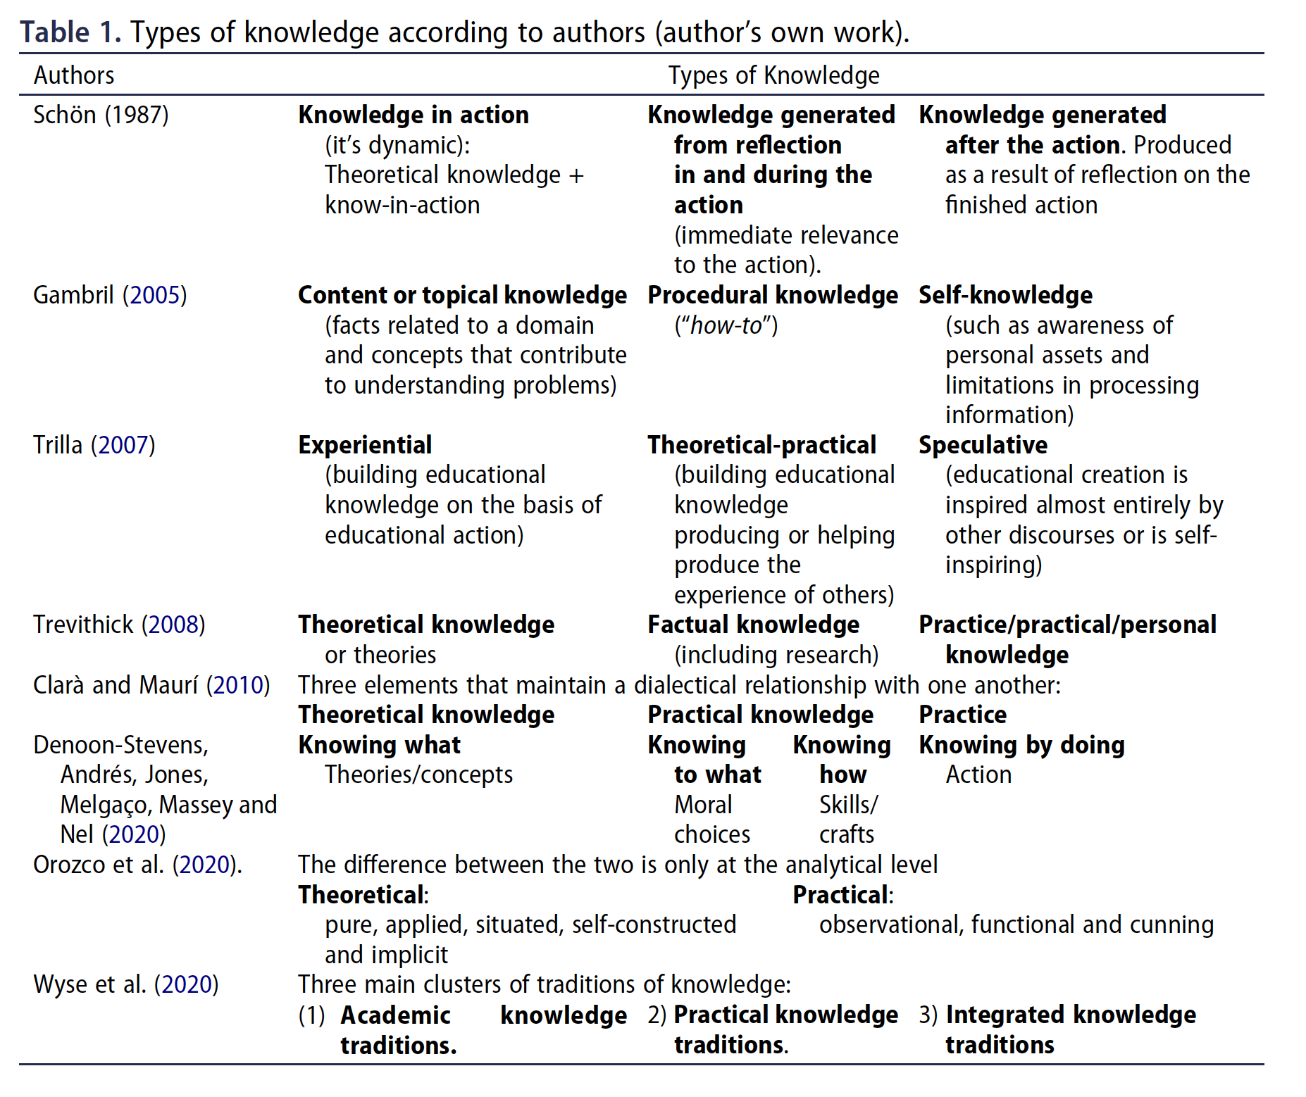
Perhaps it is the last row of the table that best groups or synthesizes the different stances. Beyond characterizations of knowledge by different authors, and beyond the types of knowledge that they enumerate, it seems difficult to escape the polarization of theory and practice. To date, it has not been possible to overcome this classification, beyond a third positioning based on different combinations between one and another or on the establishment of different types or levels of relationship between them.

1.1.2. How are theory and practice articulated in the production and application of (social) pedagogical knowledge?

Numerous questions arise in both the field of pedagogy and that of social work regarding the conceptualization and use of theory and practice and the relationships between them. And this makes sense since both are normative practices (Burbules, 2020; Hämäläinen, 2003; Quintana, 1994); that is, they attempt to generate guidelines for practice. At the basis of all these questions there is a gap, still to be mapped, between “what is known” and “what is done”. It is a gap that is difficult to ignore in the training of professionals in both disciplines, given that both must train future professionals to act in practice (Heikkilä, Liskala & Mikkilä-Erdmann, 2020; Trevithick, 2008). In the field of teacher training, it was first referred to as a “gap” by Dewey in 1904 (Korthagen, 2010; Carr, 1980), and since then this “gap” or “divide” has been the subject of numerous debates, analyses and investigations, with results still inconclusive today.

As I pointed out at the beginning, the above affects all perspectives of science. For example, action research and mixed research methods are only steps forward in this search for approaches that go beyond the simplicity of qualitative/quantitative, theoretical/practical and producers/appliers of knowledge. In this respect, it is also worth noting that numerous authors question the role research plays in and between theory and practice (Wyse et al. 2020; Heikkilä et al., 2020; Farley-Ripple, May, Karpyn, Tille & McDonough; Trevithick, 2008; Carr, 1980).

In these steps forward that we have characterized above, Orozco et al. (2020) point out the extreme positions dividing authors in the theory/practice debate. These range from separating them completely to various forms of integration or articulation, which include different types of dialectical syntheses. Perhaps the best known of the latter, within the framework of social pedagogy, is the theory of knowledge on which Freire built his pedagogy. Trilla (1989) pointed out that a large part of said author’s pedagogical contributions stem precisely from the search for a dialectical link between action and reflection, between theory and practice. Freire reformulated the Aristotelian term of praxis which, from his point of view, constitutes “the human way of existing” (1976, p. 10). Practice and theory are unified in praxis in a movement that alternates back and forth between the two. Because of this dialectical movement, “the two forms of praxis are non-dichotomizable moments of the same process through which we critically know” (Freire, 1974, as cit. by Trilla, 1989 p. 21).

In reality, all these efforts to integrate and articulate theory and practice are aimed at filling the gap referred to previously, which is why I consider the reflection by Orozco et al. to be correct when they state “our interpretation is consistent with the ontological stance that theory and practice are not intrinsically different (but only different at an analytical level)” (2020, p. 15).

I have previously pointed out (Author, 2016a) that people see the world through the concepts, instruments and tools that allow us to interact with it. And these are concepts, instruments and tools that have been learned in a certain sociocultural context. Some countries in northern Europe have up to forty different words to describe and characterize snow, while in the south we only have a few. It would therefore seem clear to me that perspectives on snow vary considerably from one country to another. In this respect, we might state that Western culture has programmed our language to see the reality of the world in a certain way. A good proportion of the analyses carried out to date reveal our inability, we could almost say structurally, to consistently escape from the epistemological structure of knowledge Aristotle established in Western culture. Or to be able to name, and therefore understand, something that is theoretical and practical at the same time. Western culture lacks a specific term to name such a reality. We are capable of perceiving and imagining it, but we do not have a word that recognizes it and serves to describe it precisely. The fact that a specific term is not available to designate what is at once theoretical and practical is only a symptom of the simplified way of seeing and interpreting the world promoted by Western culture throughout history.

Actions and interventions in social pedagogy are complex, since they are nurtured and developed in and on theory and practice across different disciplines. In fact, in a given socio-educational action it is very difficult, if not impossible, to differentiate between or separate what corresponds specifically and only to one or the other. That is why it makes no sense to speak strictly of theorists and practitioners in social pedagogy/education to designate two forms of knowledge and action that are different but far from exclusive.

In fact, no theory of social pedagogy exists that is disconnected from the practice of social education, nor is there a socio-educational practice that is not supported by and grounded in socio-pedagogical theories. Both are reciprocally and continuously nourished by what is conceived or produced in theory, from research and reflection, and from what emerges or is built in practice, from reflection and investigation in action. Theory and practice continuously and permanently interact, feedback and involve one another, and it makes no sense to consider them as being substantially different. The challenge is to invent a new term, not contaminated with denotations or connotations from the past, that helps us to broaden and refine our perspectives in observation, interpretation and action in the world.

- ¿What does “pedagogical knowledge” mean?

Throughout history, there have been numerous authors who have referred to pedagogy and so-called “pedagogical knowledge”. From the pedagogy that qualified the slave who accompanied children to school in ancient Greece, to the pedagogy understood as the science and/or art of teaching-learning, which developed mainly from the Enlightenment onwards and has continued until today. Knowing what comprises pedagogical knowledge can help us, among other things, to elucidate whether pedagogy is at the same time a science and an art, or exclusively one of the two. It is a distinction that has consequences for the educational, practical and professional fields and, as is well known, the debate over it in relation to pedagogy remains wide open. In fact, scholars can be found on both sides of this divide throughout the history of pedagogy and education.

I would like to point out here, in line with that Trilla (2005) posited, that I am a staunch advocate of the practical utility of pedagogy and the pedagogical. In my view, it is this utility and the possibility of providing educators with knowledge that is at the same time reasonable, practical and applicable (Brezinka, 2002) that endows pedagogy with entity and meaning, whether it is understood as a science, art, practice or profession.

If we refer specifically to “pedagogical” knowledge, we need to understand what exactly it is that the qualifier “pedagogical” contributes to those mental representations - which are in some way communicable and understandable - that we call knowledge or, more colloquially, knowing.

A pedagogical knowledge detached from educational practice is not truly pedagogical knowledge; it may be theoretical, speculative or any other kind of knowledge, but in no way is it pedagogical. Pedagogical knowledge implies theory and practice at the same time. As in its original Greek sense, the pedagogical refers to that which leads to learning, and therefore necessarily refers to applicable knowledge; to a knowledge intentionally aimed at generating either the conditions for learning or learning itself. This is what Trilla (2005) meant when pointing out that pedagogy, and consequently pedagogical knowledge, is normative.

The fact that pedagogical knowledge is normative means that it aims to generate norms that guide or orient educational processes in a way that produces learning in the participants. Following this same author, we will understand pedagogical norms, in a broad sense, as principles, criteria, projects, techniques, procedures, materials, instruments (and so on in a long list) that have been proposed and designed in all cases by and for the learning of the people participating in the educational relationship.

However, we must clarify some aspects of the preceding statements. The first refers to the fact that pedagogical knowledge is not validated - or considered pedagogical - because it necessarily produces learning, but because it is intentionally aimed at producing it. It is that specific intentionality, with an educational orientation, that shapes the pedagogical character of a concrete piece of knowledge. Elsewhere, I have referred to the fact of considering pedagogy ineffective or unscientific for not always achieving the learning outcomes that it had proposed as the normative trap. From my point of view, neither occasional ineffectiveness nor supposed unscientificity are due to a weak correlation between the pedagogical norms of a specific educational relationship and its consequent learning outcomes. If anything, they would be due to a linear and mechanical interpretation of the educational relationship in terms of cause and effect. An interpretation that reduces and simplifies the complexity inherent in educational processes in a one-dimensional and radical way.

Learning outcomes are difficult to foresee or plan because they emerge as a “relational property”, that is, as a result of an interaction that can only be updated through the encounter of the instances involved: the pedagogue and the participant(s). It is from this pedagogical encounter that learning outcomes can emerge. Related specifically to social pedagogy this is the current meaning awarded to normativity in pedagogy; a meaning that once again refers to complexity.

An updated normativity requires transforming the teleology of “must be” or “should be” deriving from classical or traditional pedagogy into a probabilistic “could be if...”, or a practical “how can we make it be?” A normativity, in short, that refers to the inalienable and complete involvement of the participant, together with the pedagogue, in most, if not all, of the decisions and phases of the educational process.

All of these considerations lead us to interpret pedagogical knowledge as a highly complex form of knowledge. A knowledge that is at the same time both theoretical and practical, and also a living and situated knowledge, which is in continuous movement; that is, it is continually changing and updating. Dewey said that “there is no educational practice, whatever it may be, that is not highly complex” (2015, p. 12). This is the original source of pedagogical knowledge: the educational practices that constitute the core of any relationship, be it an educational or a socio-educational one. And this is why we can affirm that the pedagogical knowledge generated and derived from those practices is complex.

- Levels of (social) pedagogical knowledge production
It is the aforementioned complexity of pedagogical knowledge that leads us to consider that it is produced at the three levels presented here. That is, there are three ways of constructing this type of knowledge, which correspond to the three different types of agents that participate in socio-educational relationships in one way or another and adopting one role or another. By socio-educational relationship I understand a process in which an agent, pedagogue or educator works collaboratively with an individual or group subject in a specific socio-cultural context with the objective of endowing said subject with learning resources that help to increase and improve their capacities to be, behave and act in a dignified way in the world in which they live.

Analysing the levels at which pedagogical knowledge is produced allows us to identify who produces it and the situations or contexts in which they do this.

Figure 1 shows the aforementioned levels at which pedagogical knowledge is produced and the people responsible for it. As mentioned in the previous section, we have taken the complexity of said knowledge as a starting point, it being produced in a continuous, always increasing, cumulative and changing spiral in which the theoretical and the practical are inextricably intertwined.

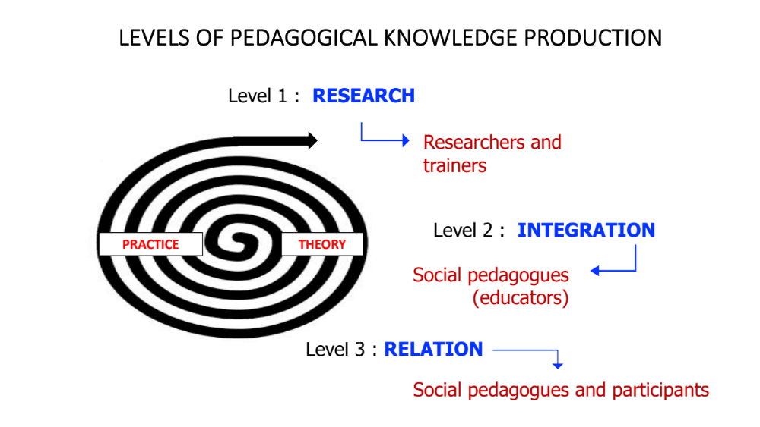
Figure 1: Levels of pedagogical knowledge production. (author’s own work)

  - Level I of pedagogical knowledge production

Level one, which we call the “research level”, refers to knowledge that is fundamentally constructed by researchers of educational phenomena. The question at this level is: Where do we obtain the knowledge that will serve as a basis for or make possible the development of pedagogical norms to guide the actions implemented by educators? The answer is found in the so-called “educational sciences”. It is a knowledge that will be generated by researchers of educational facts or phenomena. In this respect, it is a diverse, fragmented and divergent knowledge. As we know, researchers in psychology, sociology, economics, anthropology and all disciplinary fields concerned with studying educational facts produce new knowledge (Hämäläinen, 2012; Carr, 1980). The same is the case in the field of social work, which, as Fine et al. point out (2020), feeds off knowledge generated by different disciplines and professions. To illustrate this point, when the sociolinguist Basil Bernstein posits his “elaborated and restricted code theory” as a result of his research, he is providing background information - level I knowledge - that helps social educators to interpret the contextual and life realities of participants in the educational relationship and, as a consequence, to think, design and implement pedagogical actions to fit these realities.

The new knowledge produced by researchers in the educational sciences is an objectifiable and fundamentally descriptive knowledge of educational facts that, in many cases, is formalized or in the process of being formalized within the different educational sciences. It would coincide with what many authors have called “theoretical knowledge” (Orozco et al., 2020; Clarà & Maurí, 2010; Trevithick, 2008; Gambril, 2005).

It is a knowledge that social pedagogues access through different types of training, be it face-to-face or virtual. These can range from the initial training of different socio-educational professionals (pedagogues, educators, teachers, animators, professors, social workers, etc.) to diverse face-to-face or digital modes of self-training or ongoing training.

This knowledge is objectifiable, given that it can be accessed through texts or audiovisual documents, for example. But it can also be mediated knowledge. In other words, it can be accessed through the particular interpretations, or those agreed on to a greater or lesser extent in the professional or academic spheres, of the trainers who communicate it or teach it in training processes. Here we find the potential for scientific knowledge being reshaped: initially produced by researchers in the educational sciences, the trainer may or may not introduce changes in said original knowledge. Such changes may involve modifications, a different emphasis or even errors of appraisal, understanding or interpretation regarding the knowledge originally provided by research.

Figure 2 provides an overview of Level I in the process of pedagogical knowledge production.

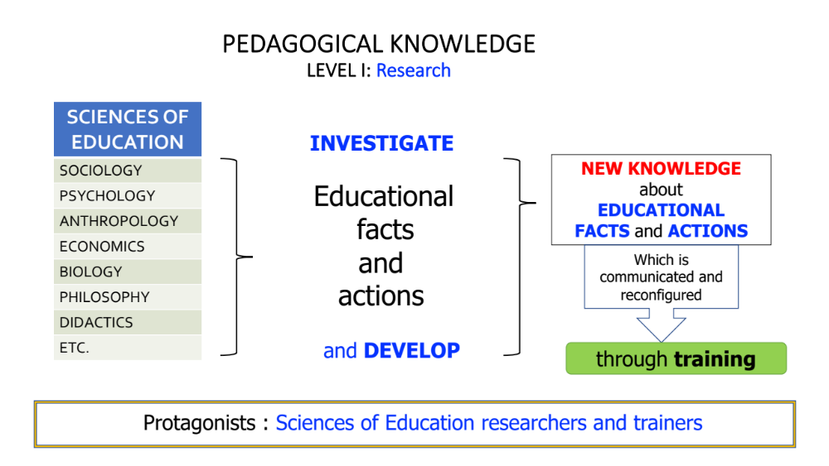Figure 2: Level I of pedagogical knowledge production (author’s own work)

  - Level II of pedagogical knowledge production

I have called Level two of pedagogical knowledge construction the “integration level”. It is a pedagogical knowledge prepared by social pedagogy professionals: pedagogues, social educators, social workers, teachers, etc. The name reflects the fact that it does not emerge directly from a single source, whether research, training, reflection or experience. It emerges or is built from all of these through a complex and not altogether transparent operation of, among others, inference, abstraction, abduction, analysis and synthesis.

This operation is carried out by professionals based on the following three sources:
(1) the Level I knowledge provided by training through the different educational sciences;
(2) their own personal and professional experiences; and
(3) personal reflection on the two previous elements.

In the social sphere, one might say that it takes place, to borrow a computer term, in “real time”. Life does not stop to give social pedagogues time to think about how they have to react to a specific situation or problem, or to choose the best or most appropriate strategy for an action or technique to deal with it. Faced with a conflict or a problem situation, professionals will respond with what is most to hand, that is, with the theoretical, practical and experiential knowledge that they have accumulated throughout their professional practice and life, knowledge that will be manifested through the procedures, methodologies and techniques that they apply in the socio-educational intervention.

These three types of knowledge: theoretical, practical and experiential, are fully and inextricably interwoven in the actions taken by professionals, it being impossible to clearly define where some begin and others end.

Experiential knowledge is that which a person acquires through any relational situation with the world. Examples would be that knowledge a person gains from, for example, drinking water, running a race, talking to a person, reading a book or crossing a street. Whether consciously or not, all of us acquire knowledge from the experiences that shape our lives, generating knowledge that can be both theoretical and practical.

Theoretical knowledge is mainly derived from the initial training undertaken by professionals and the ongoing training processes they participate in throughout their lives and professional careers. Practical knowledge emerges either from application of the theoretical knowledge that social pedagogues construct in concrete situations of the socio-educational practice or from what they themselves infer through the implementation of said practice. Whether consciously and intentionally or unconsciously, this practical knowledge is integrated with prior theoretical knowledge in such a way that it is ultimately difficult to distinguish between the two.

Theory guides practice, just as practice guides theory. Or, in other words, theoretical knowledge guides socio-educational action, which, when taking place in practice, generates new practical knowledge. This, in turn, guides the modifying, expanding and reformulating of the initial theoretical knowledge.

Once integrated, the theoretical-practical knowledge possessed by social pedagogues is updated and tested in each new socio-educational action in which they participate (Storø, 2012; Moss, 2010). This is why Schön stated that, ”in order to deal with problems competently, it is [sometimes] necessary to resort to some kind of improvisation, inventing and testing strategies devised in that concrete situation” (1987, p. 19). That said, however, it should be noted that the curiosity, interest and inquiry capacity displayed by professionals, what Schön calls “in-situ experimentation” (p. 38), will be key elements in ensuring that new experiential knowledge emerges from each new intervention. It could be said that this last form of knowledge originates from the changes that professionals themselves perceive and feel, generally in a conscious way, from the experience of being involved in and working on socio-educational interventions.

The result of integrating all this knowledge gradually and cumulatively constitutes the background knowledge that professionals bring into play in each of the socio-educational encounters in which they participate. This knowledge comprises a repertoire that expands and updates over time; especially if the professional takes the decision to expand it consciously and intentionally.

Figure 3 provides a graphic overview of how this second level of pedagogical knowledge production works.

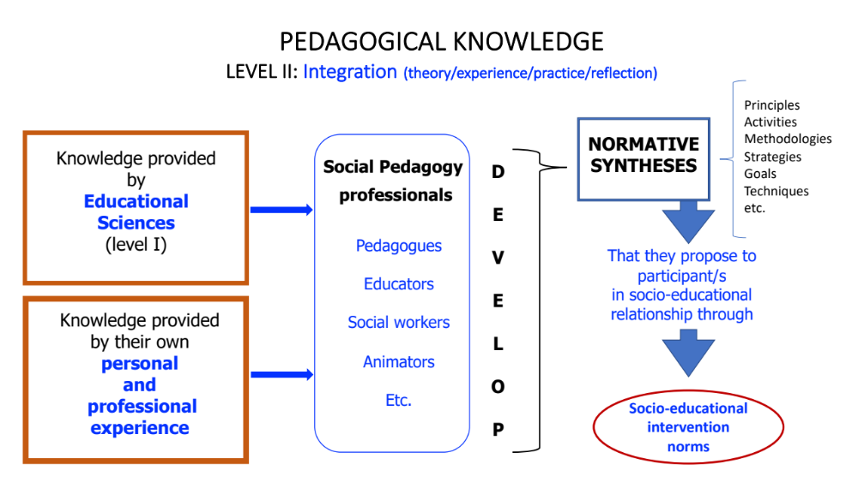
Figure 3: Level II of pedagogical knowledge production (author’s own work)

Level II knowledge is integrated and unique, the product of professionals’ initial and ongoing training and accumulation of particular learning experiences they have had throughout their lives, whether in relation to their own life or to observed, implemented or shared educational practices. The integrated fruit of each individual’s singular reflection, which each professional constructs from the aforementioned elements and their own analysis, knowledge and experiences at each moment in time, is what we refer to as normative syntheses. These normative syntheses are manifested in what we have previously characterized as pedagogical norms; that is, in the principles, activities, methodologies, strategies, techniques, etc. of action that professionals apply in the educational relationship, which result in learning for the participants they interact with on a daily basis.

It is a living knowledge, in a continuous process of change and updating. A knowledge that evolves together with the professional. It is a knowledge that is directly influenced by the particular personal characteristics of each professional. That is to say, it will be more mutable, capable of being enriched and communicable, the greater professionals’ disposition or capacity to experiment, analyse, share and communicate the new pedagogical knowledge experienced and constructed through the integration of the different forms of knowledge they have acquired.

It is a type of knowledge that can be linked to the so-called “knowledge in action” and “knowledge generated after the action” posited by Schön (1987). And also, in part to Gambril’s “self-knowledge” (2005), to Trilla’s “experiential” and “theoretica-practical” knowledge (2007) and, finally, to Trevithick’s “practice/practical/personal knowledge” (2008).

It is a knowledge that is difficult to access if not communicated, in some way and in some format, by the professionals who apply, test and remodel it on a daily basis in the theoretical-practical spiral that we referenced at the beginning.

Elsewhere, referring specifically to social education, I have noted (Author, 2016b) that each time professionals do not communicate - be it in the form of a journal article; a congress paper; a course; an exchange between professionals; and so on - or do not share the problems and discoveries of their daily work within the various action or socio-educational intervention programmes and projects in which they are participating, they contribute to impoverishing and diminishing the heritage of knowledge and techniques of the profession and of the disciplinary field itself, in this case, social pedagogy. Communicating and sharing what we do is a duty and a responsibility not only for scholars, but also for professionals, all of whom are creators of the knowledge that nourishes and shapes the pedagogical disciplines and, especially, social pedagogy.

In my opinion, this is a level of pedagogical knowledge that needs to be increased and improved. It is clearly deficient, at least in the specific field of social education, given that professionals are not generally very keen on writing down their experiences. It is, however, a level of socio-pedagogical knowledge that can only be constructed with the specific assistance of professionals.

To objectify Level II of pedagogical knowledge, that is, to publish it, in some audiovisual or digital medium is to immediately convert it into Level I pedagogical knowledge, making it available for the training of future professionals.

  - Level III of pedagogical knowledge production

Level three of pedagogical knowledge is what I have characterized as the “socio-educational relationship level” or “relational level”. If Level I was characterized by a type of diverse, divergent and fragmented knowledge and Level II a type of integrated pedagogical knowledge, then Level III refers to emergent knowledge, the result of negotiated interactions between social pedagogues and participants in the socio-educational relationship.

Pedagogical norms, understood in a traditional way, used to be represented by a hierarchical educational relationship in which the educator, as a responsible professional, said what to do and the appropriately named “recipient group” or “target group” limited itself to complying with or following the given instructions. According to classical didactics, this would guarantee the achievement of the planned learning objectives.

However, for the most part this has not been the case with the field of social pedagogy, a discipline that was conceived more than a century and a half ago as an alternative to formal school education. Not being subject to a standardized curriculum or to predetermined physical spaces, the school, undoubtedly facilitated the implementation of other types of socio-educational relationships that are not so hierarchical and frequently much more focused on the interpersonal relationship itself rather than on which specific content to learn.

It is my belief that the distinction between school pedagogy and social pedagogy will become increasingly blurred. And this is not only due to the entry of social educators into schools and the latter opening up to the world through the Internet but, above all and among many other factors, due to the increasingly resolute entry of emotions into educational relationships, which are now being forced to redefine the previously predominant role of content in the learning processes. Beyond this, however, to illustrate this third level of pedagogical knowledge, it seems appropriate to consider how current social pedagogy approaches socio-educational relations.

Figure 4 provides an overview of this approach, which will lead us to characterize how the socio-educational relationship works.

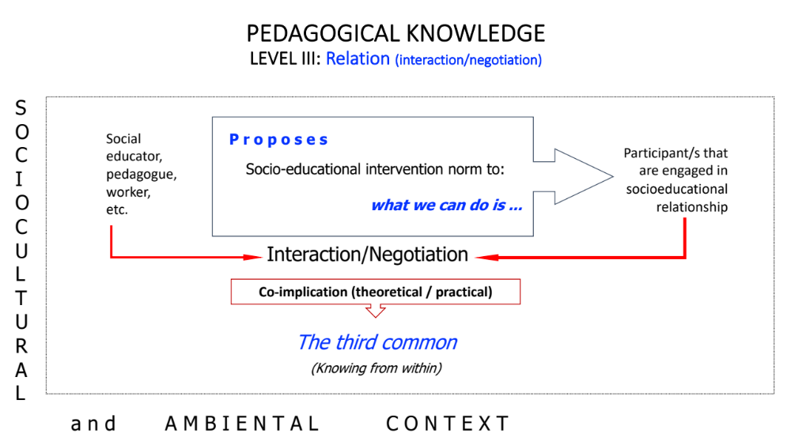Figure 4: Level III of pedagogical knowledge production (author’s own work)

The integrated pedagogical knowledge that professionals contribute to the socio-educational relationship leads them to present participants with specific rules of action that can be focused, as we have already indicated, on objectives, methodologies, techniques or specific learning activities to be carried out. Unlike traditional pedagogy, and in line with the updated form of pedagogical norms that we have defined, what social educators do is propose their pedagogical approach to the participants. It is the latter, as protagonists in their own lives and in choosing their own learning, who have to accept or, in other cases, negotiate the pedagogical proposal educators make for development of the socio-educational relationship. This is precisely why we have characterized (social) pedagogy as a pedagogy of choice (Author, 2016b).

Claxton (1984) clearly defined how learning functions through the metaphor of the horse and the spring: you can lead a horse to drink from the spring of knowledge, but ultimately it will only drink if it wants to, if it chooses to do so for its own personal reasons. Although this is something that education has known for a long time, it continues to mostly ignore this reality. The idea of the third common, conceived years ago in Danish social pedagogy, outlines the way in which we understand and consider the socio-educational relationship.

This so-called third common refers to a new space, which is neither the educator nor the participant. It is a space created ad hoc by the two, to develop on equal terms - although each with their specific role - a socio-educational relationship that aims to meet the expectations of both. It is about generating activities that require the presence and joint participation of the social educator and the participant; activities in which both are genuinely interested and involved. A meeting space in which the two are equal and for which both are jointly responsible. A perspective in which both constitute resources for the success of the socio-educational relationship.

There can be no doubt that, considered in these terms, a socio-educational relationship reformulates the Level II pedagogical knowledge that the educator contributed to the relationship, allowing the emergence of a new pedagogical knowledge, now a collective one, which we will call Level III. It is an interpersonal knowledge generated and derived from interaction and negotiation between the professional or volunteer agent and the subject, whether individual or collective, participating within the framework of a socio-educational relationship that occurs in a specific socio-cultural context and at a specific point in time.

Swedberg (2016) pointed out that we all constantly theorize in our daily lives. Hence the need to emphasize that the repertoire of knowledge that both the professional and the participants contribute to the socio-educational relationship only differs in its orientation. While that of the social pedagogue is a fundamentally technical and professional repertoire, that contributed by participants is generated from their own theoretical and practical life experiences. This is why an effective socio-educational relationship, although initially oriented towards the learning of participant/s, ends up changing the social educator in some way as well.

The difference between Level II and Level III pedagogical knowledge is that the former is the result of either individual integration, if it is a single professional who implements and applies it, or collective integration, if it is the result of analysis and negotiation between different professionals. Level III, for its part, is the result of a single relationship, in which a functionally asymmetric negotiation takes place - between social educator and participant - within the framework of a situation and a specific socio-cultural and environmental context that has influenced said negotiation in a direct way. One might say, in metaphorical terms, that the socio-educational relationship is the “black box” that Level II pedagogical knowledge enters, to then leave converted into Level III.

Both educators and participants can be depositories of the new pedagogical knowledge that has been produced, although it is more likely to be educators who are really aware of both the new emerging knowledge and the reformulation of Level II into Level III knowledge. And even more so if they systematize and reify it (Wenger, 2001) in some type of communicable information. If this is not the case, then Level III knowledge is lost, since it is ephemeral, and often barely perceptible in the dynamics of the socio-educational relationship.

Perhaps the clearest equivalents of this type of knowledge are the third type of knowledge proposed by Schön (1987), which we have characterized in Table 1 as “Knowledge generated after the action. Produced as a result of the reflection on the finished action” and the, also previously mentioned, third type of knowledge posited by Shotter, knowing from within, since this is knowledge that can only be accessed after having participated in the relationship.

What we have already stated in relation to the communicability and reification of Level II pedagogical knowledge also applies to this new type of knowledge. Whether it becomes Level I knowledge and made an object of training for social pedagogues will depend on the availability and abilities of each professional.

Bibliography
Brezinka, W. (2002). Sobre las esperanzas del educador y la imperfección de la pedagogía. Revista Española de Pedagogía, LX, 223, 399-414
Bruhn, A. (2019). Social and caring professions in European welfare states. Policies, services and professional practices, Nordic Social Work Research, 9 (2), 199-201.
Burbules, N.C. (2020). Phronesis and complexity. Teoria de la Educación. Revista interuniversitaria. 32 (1), 11-22.
Carr, W. (1980) The Gap between Theory and Practice, Journal of Further and Higher Education, 4(1), 60-69.
Clarà, M. & Maurí, T. (2010). Una discusión sobre el conocimiento práctico y sus relaciones con el conocimiento teórico y la práctica. Infancia y Aprendizaje, 33(2), 199-207.
Cleary, B. (2019). Reinterpreting Bildung in Social Pedagogy. International Journal of Social Pedagogy, 8(1), 3.
Denoon-Stevens, S. P., Andres, L., Jones, P., Melgaço, L., Massey, R., & Nel, V. (2020). Theory versus practice in planning education: The view from South Africa. Planning Practice & Research, 1–17.
Dewey, J. (1997). Experience and education. New York: Touchstone.
Dewey, J. (2015). Las fuentes de la ciencia de la educación. Lapislatzuli Ed.
Eichsteller, G. & Holthooff, S. (2012). The Art of Being a Social Pedagogue: Developing Cultural Change in Children´s Homes in Essex. International Journal of Social Pedagogy, 1 (1), 30-46
Elster, J. (1990). Tuercas y tornillos. Una introducción a los conceptos básicos de las ciencias sociales. Barcelona: Gedisa.
Fine, J., Tor-Johan, E. & Malmberg-Heimonen, I. (2020). Social workers use of knowledge in an evidence-based framework: a mixed methods study. European journal of social work, 1-14.
Freire, P. (1976). Educación y cambio. Buenos Aires: Ed. Búsqueda.
Gambril, E. (2005). Critical Thinking in Clinical Practice Improving the Quality of Judgments and Decisions. New Jersey: John Wiley & Sons, Inc.
Gustavsson, A. (2003). The role of theory in social pedagogy and disability research. A comparison between two practice-oriented, multi-disciplinary knowledge fields. In A. Gustavsson, H. Hermansson, & J. Hämäläinen (Eds.), Perspectives and theory in social pedagogy (pp. 164–186). Bokförlaget Daidalos A.
Hämäläinen, J. (2003). The concept of social pedagogy in the field of social work. Journal of Social Work, 3, 69-80.
Hämäläinen, J. (2012). Social pedagogy in Finland. Kriminologija i socijalna integracija, 20 (Br. 1), 1-132.
Hämäläinen, J. (2013). Defining social pedagogy: Historical, theoretical and practical considerations. British Journal of Social Work, 45, 1022-1038. https://doi.org/0.1093/BJSW/BCT174
Hegstrup, S. (2003). Tendencies and trends in social pedagogy in Denmark at the turn of the millennium. In A. Gustavsson, H. Hermansson & J. Hämäläinen (Eds.), Perspectives and theory in social pedagogy (pp. 72-83). Göteborg: Bokförlaget Daidalos A.B.
Ibáñez, T. (2001). Municiones para disidentes. Realidad-verdad-política. Barcelona: Gedisa.
Jarning, H. (1997). The many meanings of social pedagogy: Pedagogy and social theory in Scandinavia. Scandinavian Journal of Educational Research, 41(3–4), 413–431. https://doi.org/10. 1080/0031383970410315
Korthagen F.A.J. (2010). The Relationship Between Theory and Practice in Teacher Education. In: Penelope Peterson, Eva Baker, Barry McGaw, (Editors), International Encyclopedia of Education. volume 7, pp. 669-675. Oxford: Elsevier.
Lorenz, W. (2017). Social work education in Europe: towards 2025. European Journal of Social Work, DOI: 10.1080/13691457.2017.
Meirieu, P. (2016). Recuperar la pedagogía. De lugares comunes a conceptos claves. Paidós Argentina.
Moss, P. (2010). We cannot continue as we are: The educator in an education for survival. Contemporary Issues in Early Childhood, 11 (1). www.wwwords.co.uk/CIEC
Nussbaum, M. C. (2007). Las fronteras de la justicia. Consideraciones sobre la exclusión. Barcelona: Paidós.
Orozco, M., Gijbels, D. & Timmerman, Ch. (2020). Conceiving the relationship between theory and practice in T-VET. An in-depth study on key actors’ epistemological perspectives, Journal of Vocational Education & Training, DOI: 10.1080/13636820.2020.1715468
Quintana, J.M. (1994). Trabajo social y pedagogía social: relaciones entre sus campos y competencias profesionales. Pedagogía Social, 9, 173-183.
Rosendal Jensen, N. (2013). Social pedagogy in modern times. Education Policy Analysis Archives, 21 (43), 1–16. https://doi.org/10.14507/epaa.v21n43.2013
Rothuizen, J. J., & Harbo, L. J. (2017). Social pedagogy: An approach without fixed recipes. International Journal of Social Pedagogy, 6(1), 6–28. https://doi.org/10.14324/111.444.ijsp.2017. v6.1.002
Schugurensky, D. (2014). A social worker, a community development worker and an adult educator walk into a bar: On strange bedfellows and social pedagogy. Postcolonial Directions in Education, 3 (2), 360–395. https://acortar.link/Pcy2Sc
Shön, D. (1987). Educating the reflective practitioner. Jossey-Bass Publishers.
Sloterdijk, P. (2007). El mundo interior del capital. Para una teoría filosófica de la globalización. Madrid: Ediciones Siruela.
Storø, J. (2012). The Difficult Connection between Theory and Practice in Social Pedagogy. International Journal of Social Pedagogy, 1(1), 17-29.
Swedberg, R. (2016). El arte de la teoría social. Madrid: Centro de Investigaciones Sociológicas.
Touraine, A. (1997). ¿Podremos vivir juntos? Iguales y diferentes. Madrid: PPC.
Trevithick, P. (2008). Revisiting the Knowledge Base of Social Work: A Framework for Practice. British Journal of Social Work, 38, 1212–1237.
Trilla, J. (2007). Educational Discourse and Educational Practice. Encounters on Education. 8, 127– 142.
Trilla, J. (1989). La relació teoria-pràctica en la pedagogia de Paulo Freire. Temps d’educació, 1, 15–32. https://raco.cat/index.php/TempsEducacio/article/view/139162
Trilla, J. (2005). Hacer pedagogía hoy. En J. R. Berrio (Ed.), Pedagogía y educación ante el siglo XXI (pp. 287–311). Departamento de teoría e historia de la educación.
Úcar, X. (2013) “Exploring different perspectives of Social Pedagogy: towards a complex and integrated approach”. Education Policy Analysis Archives, 21 (36). http://epaa.asu.edu/ojs/article/view/1282 .
Úcar, X. (2016a). Pedagogías de lo social. UOC Publishing.
Úcar, X. (2016b). Los profesionales de lo socioeducativo como investigadores: la creación de conocimiento. Educación Social. Revista de intervención socioeducativa, 62, 11–23. https://raco. cat/index.php/EducacioSocial/article/view/308220/398228
Úcar, X. (2016c). Pedagogía de la elección. UOC Publishing
Wagensberg, J. (2017). Teoría de la creatividad. Eclosión, gloria y miseria de las ideas. Barcelona: Tusquets.
Wyse, D.; Brown, C.; Oliver, S & Poblete, X. (2020). Education research and educational practice: The qualities of a close relationship. British Educational Research Journal. DOI: 10.1002/berj.3626

Reflecting the current situation in Spain, in this text we will differentiate between Social Pedagogy as an interdisciplinary matrix of knowledge and Social Education, the latter being the concrete profession that embodies the former. The professions of Social Pedagogy in other European countries are social pedagogue and social worker
Úcar 2013, p. 9 stated: I take this concept from Lahire, who notes that instead of cause and effect, some philosophers prefer to speak of "reciprocal disposition partners" even to refer to physical realities. For instance, “when salt dissolves in water, salt and water are reciprocal partners" (Crane, 1996, p. 9) (2004, p. 83).
One might argue that this is difficult in socio-educational intervention with young children or with people with mental health problems, for example. Elster argues that paternalism is appropriate only when freedom to choose is likely to be severely self-destructive and especially when it also harms others (1990, p. 64). Nussbaum, for her part, has pointed out that, in general terms, paternalistic treatment is appropriate if the individual’s capacity to choose and autonomy are compromised (2007, p. 369). Finally, Sunstein refers to “libertarian paternalism” understood as a form of action that preserves the participant’s freedom of choice while guiding people’s decisions along the appropriate path (in the terms that they themselves judge them) (2017, p. 36).
To specify what I understand by a “dignified life”, I will follow the ideas posited by Nussbaum (2007). This author refers to three principles that make up what she calls moral intelligence: (a) The dignity of the human being as an ethical being, which assumes that all people, by virtue of being human and regardless of any criteria, have the right to be treated and to live with dignity; (b) Human sociability, which supposes that it is in common life that human dignity is shaped and sustained; (c) The multiple human needs, which shape us as beings with needs and whom common life must help to exist with dignity. These three principles combined make up the idea of an ethical world where the common and the personal merge together in the concept of human dignity.
It is true that groups of professionals often share experiences and analyses based on their particular educational experiences, which lead them to devise specific normative methodologies or proposals (syntheses) for action that are followed by other groups of professionals. This would represent what we might call “pedagogical schools or epistemologies”. This second level of pedagogical knowledge can be produced individually or in groups.

