Appendix
[Figures and tables]

Figure 1. Percentage of persons at risk of poverty and social exclusion (AROPE, 2015-2020)
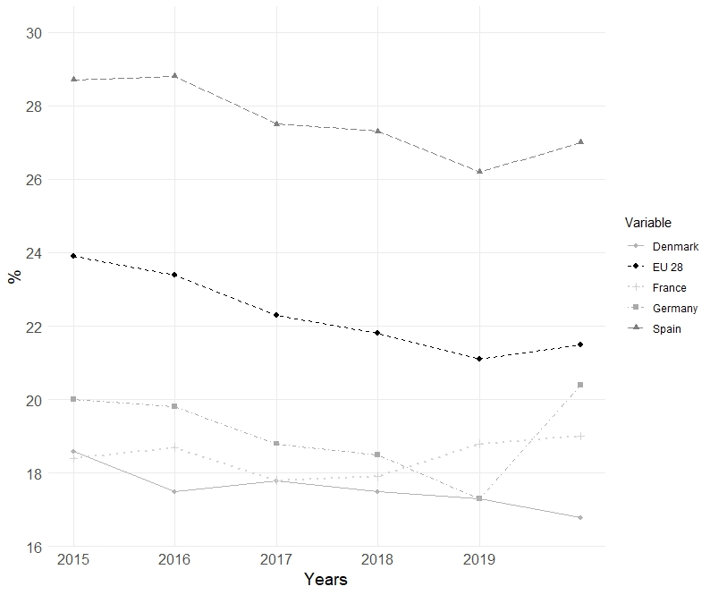
Source: Eurostat, 2024

Figure 2. Percentage of persons at risk of poverty and social exclusion in Spain by household type (AROPE, 2008-2020)
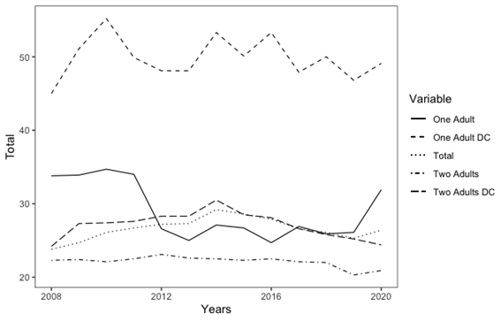
Source: Instituto Nacional de Estadística (INE).
Note: The abbreviation ‘DC’ denotes ‘dependent children’. The Y axis represents the total percentage.

Figure 3. Percentage of support for the ‘Ingreso Mínimo Vital’ by party family
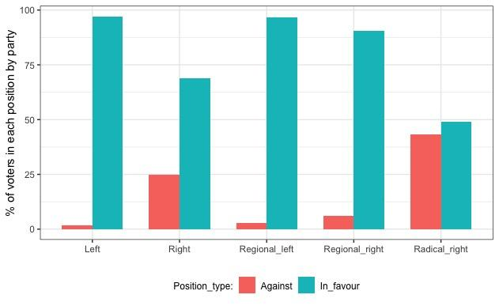
Source: Centro de Investigaciones Sociológicas (May 2020).
Note: The Y variable is the percentage of voters against or in favor of the MVI. In “Left” I have included PSOE and Unidas Podemos. In “Right” I have included PP and Ciudadanos. “Regional left” comprises ERC, HB, BNG and Compromís. “Regional right” includes PNV and PDeCAT. “Radical right” represents only Vox.

Figure 4. Timeline of the reform process
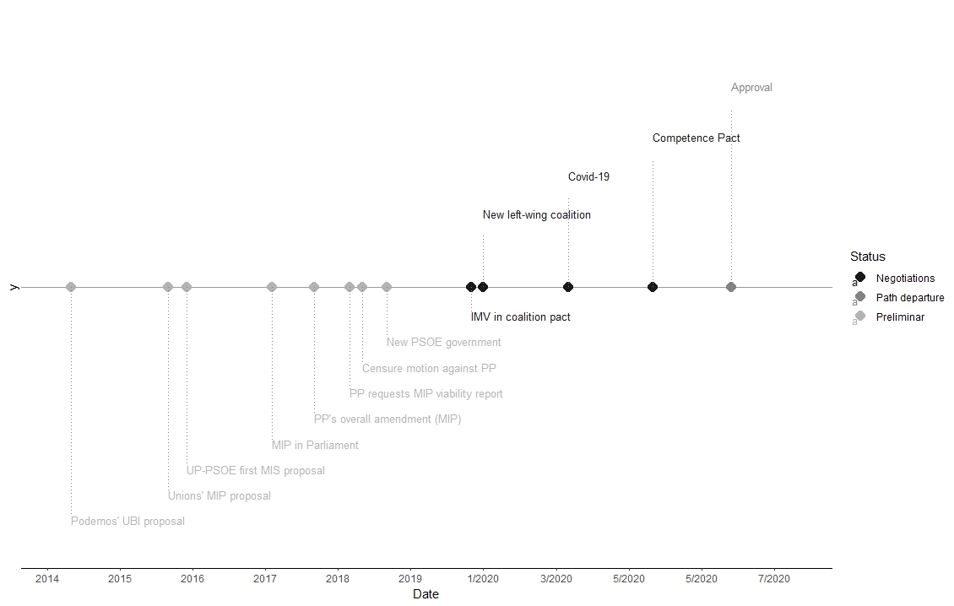
Source: Own elaboration

Table 1. Actors’ acronyms
Name | Institutional role | Acronym
Interviewees
PM | Deputy | PSOE 1  May 16th, 2022
ML | Former Minister of Health, Consumption and Social Welfare | PSOE 2  May 16th, 2022
MP | General Secretary of Inclusion and Social Welfare Objectives and Policies | PSOE 3  May 24th, 2022
IM | Regional Deputy/Minister | PSOE 10  October 31th, 2024
MT | Deputy | PP 1  May 23th, 2022  Online
RM | Director of the Cabinet of the Secretary of State for Social Rights. Ministry of Social Rights and Agenda 2030. | UP 1  May 2nd, 2022  Online
CB | Secretary of Social Protection and Public Policies | CC.OO (TU 1)  May 23th, 2022
GR | Head of the Social Rights Area | UGT (TU 2)  July 5th, 2022  Online
OA | Head of Social Security and Equality areas | CEOE 1  June 26th, 2023  Online
AA | Political Advocacy and Legal Analysis Coordinator | Cáritas 1  May 24th, 2022
Interventions in Plenary Sessions in the Spanish Congress of Deputies, parliamentary hearings or parliamentary committees
Carlos Susías Rodado | Representative of the European Network for the Fight against Poverty and Social Exclusion in the Spanish State | EAPN 1
Simancas Simancas | Deputy | PSOE 4
Ramón Urbano | Deputy | PSOE 5
J.L. Escrivá Belmonte | Minister of Inclusion, Social Security and Migration | PSOE 6
Pedro Sánchez | President of the Spanish Government | PSOE 7
Montero Plaza | Minister of Finance | PSOE 8
Carolina Darias San Sebastián | Minister of Territorial Policy and Civil Service | PSOE 9
Alli Martínez | Deputy | UPN 1
Joan Baldoví | Deputy | COM 1
Carles Campuzano | Deputy | PDCat 1
Esteve Boadella | Deputy | JxCat 1
Pablo Iglesias Turrión | Vice President of the Spanish Government | UP 4
Segundo González García | Deputy | UP 3
Isabel Franco Carmona | Deputy | UP 2
Toni Roldán | Deputy | Cs 1
Del Campo Estaún | Deputy | Cs 2
Giménez Giménez | Deputy | Cs 3
Rufián Romero | Deputy | ERC 1
Iñigo Barandiaran | Deputy | PNV 1
Esteban Bravo | Deputy | PNV 2
Oramas González-Moro | Deputy | CC 1
López Ares | Deputy | PP 2
Pilar Marcos Domínguez | Deputy | PP 3
Ruíz Solás | Deputy | Vox 1
Néstor Rego Candamil | Deputy | BNG 1
Oskar Matute | Deputy | EH-Bildu 1
Isidro Martínez Oblanca | Deputy | FA 1
Source: Own elaboration

Table 2. Political parties’ acronyms - ideology

Name | Spanish acronym | Party Family
Partido Socialista Obrero Español | PSOE | Center-left
Partido Popular | PP | Center-right
Unidas Podemos | UP | Left-wing
Vox | Vox | Radical-right
Esquerra Republicana de Catalunya | ERC | Regional left-wing
Bloque Nacionalista Galego | BNG | Regional left-wing
Compromís | COM | Regional left-wing
EH-Bildu | EH-Bildu | Regional left-wing
Partido Socialista de Euskadi - Euskadiko Ezkerra | PSE-EE | Center-left
Candidatura d’Unitat Popular | CUP | Regional left-wing
Partido Nacionalista Vasco | PNV | Regional right-wing
Coalición Canaria | CC | Regional right-wing
Junts per Catalunya | JxCat | Regional right-wing
Partido Regionalista de Cantabria | PRC | Regional right-wing
Unión del Pueblo Navarro | UPN | Regional right-wing
Foro Asturias | FA | Regional right-wing
Source: Own elaboration

Table 3. Main policy proposals on the field of minimum income schemes

 | CCOO/UGT 2015 | PSOE 2015 | UP 2015 | UP 2019
Policy proposal | Prestación de Ingresos Mínimos  (Minimum Income Provision) | Ingreso Mínimo Vital  (Minimum Vital Income) | Renta garantizada + renta complementaria  (Guaranteed Minimum Income + Supplementary Income) | Prestación de suficiencia de ingresos  (Income Sufficiency Benefit)
Amount (single/two children) | 426/426 + supplements | 426/1008 | 1050 | 1100
Child supplement | Yes (they refer to the Budget Law) | Yes (separated subsidy for households in need) | Yes (incorporated in the benefit by household type) | Yes (increased child benefits: 100 eur/m per family; 125 eur/m for lone parents)
Quantitative target (households) in millions | 2 | 0,7 | 3,3 | 3,6
Means-tested | 75% of minimum wage | Income per person below the severe poverty threshold for household income, or the poverty threshold for child benefits | Household income below the guaranteed thresholds for each type of household | Household income below the guaranteed thresholds for each type of household
Work-related conditionality | 12 months registered as a job-seeker. Mandatory labour insertion programmes | Benefit linked to labour insertion and training programmes | No | Registered as a job-seeker
Work-in-benefit | No. Possibility for special cases (vulnerable individuals) | No | Yes (a minimum of 250 eur/m and a maximum of 900) | Yes (minimum of 100 eur/m and maximum of 1200)
Age requirement | 18-65 | Not defined | Not defined | Emancipated underage individuals are included
Residence requirement | 6 months | Not defined | Not defined | 6 months

Source: Noguera (2019)

