Reading in multilingual environments

Emilee Moore
Universitat Autònoma de Barcelona

Juli Palou Sangrà
Universitat de Barcelona

Bio notes
Emilee Moore is a Serra Húnter Fellow in the Department of Language, Literature and Social Science Education at the Universitat Autònoma de Barcelona. She is a member of the GREIP research group (Grup de Recerca en Ensenyament i Interacció Plurilingües). She studies meaning-making practices in multilingual and multicultural, formal and non-formal educational contexts.
Juli Palou Sangrà is a Professor in the Department of Language and Literature Education at the Universitat de Barcelona. He is the principal investigator of the PLURAL research group (Plurilingüismes Escolars i Aprenentatge de Llengües). He was previously a school teacher for more than 20 years. The relationship between teacher’s actions and their cognition is one of his research interests.
Abstract

Situations and practices that are favourable to the development of literacy and of plurilingual and intercultural competences – or what we refer to globally as pluriliteracies – are considered in this chapter. It draws on the empirical work carried out as part of the KOINOS project, as well as other experiences of a similar nature, to develop a set of principles for guiding how reading is approached in multilingual school environments, anchored in family and community realities. These principles include the need to expand the instrumental view of language, to link pluriliteracies and creativity, to embrace multimodality, to bridge languages and cultures, to establish variable geometries, to promote interaction, to facilitate collaborative formative action, and to evaluate reflexively. The experiences presented in the chapter aim to inspire others working in linguistically and culturally rich environments to develop children’s reading competences creatively, critically and in socially just ways.

1. Introduction

The aim of this chapter is to consider situations and practices that are favourable to the development of literacy, and reading competences in particular, at the same time as they are conducive to the development of plurilingual and intercultural competences. The chapter sets out 9 guiding principles, each developed in a separate section, for an approach to pluriliteracies that we believe is relevant to schools in the twenty-first century. It is inspired by experiences, reflected in short vignettes, from the KOINOS project, as well as drawing on other experiences of a similar nature.

2. Expanding the instrumental view of language

Our use of the term pluriliteracies is adapted from the definition put forth by García, Bartlett and Kleifgen (2007) for talking about activities around plurilingual, intercultural and multimodal texts, which draws on a long tradition of research in literacy studies and in plurilingual and intercultural education. The first principle of a pluriliteracies approach to reading builds on a holistic approach to language and understands that reading is about much more than mastering decoding skills. We propose a competency-based approach to reading, and see engagement with the diversity of texts that make up our semiotic landscape as an opportunity to promoting and nourishing linguistic and cultural diversity in schools.

The following vignette will help demonstrate the educational challenges from which we set out in making these affirmations. In it, one the authors of this chapter reflects on her experience as a volunteer mentor in an out-of-school reading program at a diverse primary school in Barcelona; a school that is similar in many ways to those that have participated in the KOINOS project. The project involves one-on-one reading sessions once per week with children aged approximately 9 and 10 years-old.

Vignette 1

The child I read with is Fatima, a 9-year-old girl born in Barcelona whose parents come from Morocco. She tells me she speaks Arabic at home, although one day I notice that she and her family use Moroccan sign language in the presence of her deaf father. Fatima reads and speaks in Catalan and Spanish quite well (she understands the register of children’s books better than I do!), but gets easily bored. Many other volunteers comment on the irregular attendance of some children and their lack of motivation. Occasionally I hear comments linking the children’s problems (as diagnosed by the school) with reading to a lack of structured literacy practices at home.

Fatima loves reading Dragon Ball comics (in Catalan) and teaches me to read Japanese manga (from the back to the front of the book, right to left of the page). Sometimes, at the end of the 1-hour sessions, I succumb to the pressure of going to the computer room. Fatima, like most of the children, loves playing the games on the website Friv, all of which are in English. Other times she sings along to YouTube videos and shares the lyrics with me. Señorita by Abraham Mateo is a big hit with the children. The lyrics, which Fatima and the other children know by heart, include a mix of non-standard Spanish and English varieties. I praise Fatima on how good she is at English and one day she tells me that she would like to be an English teacher when she grows up. Yet to my surprise, Fatima is convinced that she is bad at languages, an idea possibility supported by her inclusion in the after-school reading program.

From the point of view of the institution of schooling, and perhaps also from the perspective of many well-meaning educators, Fatima’s reading competence in the languages of schooling (Catalan as the vehicular language, Spanish as a second language and English as a foreign language) is lacking. In order to be placed into the program, she had failed to meet the curricular standards expected of her for reading comprehension. In the program, there were 24 more students from the 4th and 5th grades of the primary school, the large majority of them also having plurilingual repertoires that surpassed the expected trilingualism of the national curriculum. Indeed, the latest PISA (Program for International Student Assessment) results for reading comprehension for Catalonia highlight that students of immigrant background, like Fatima, obtain worse results than their autochthonous peers (for an extended discussion see Bonal, Castejón, Zancajo & Castel 2015; Rincón Bonet 2012). Thus, despite being able to mobilise their developing knowledge of language and literacy across modes and media to communicate in ways that were meaningful for them, students such as Fatima are institutionally categorised falling below expectations. Arguably, diagnosing such students as lacking is an outcome of teaching and assessment focused on students’ standard, monolingual and monomodal uses in the languages and culture of schooling, failing to take account of their emergent pluriliteracies in a more holistic sense.

Educational institutions, and the community more generally, face the enormous challenge of educating the school population not only in the standard, monolingual, monocultural and monomodal uses that have been typical of traditional teaching approaches, but also in the dynamic pluriliteracies that allow them active participation in an inter-connected and ever-changing world. Reading, which is the main focus of the KOINOS project, should not only be seen as an academic competence to meet, or as a gateway to academic knowledge, but also a window onto the pleasure of imaginary worlds, an essential vehicle for getting to know oneself, for encountering other languages and cultures, and for learning throughout life. Teachers need to be capable of educating creatively, critically and in socially just ways in complex interactional environments (Schleicher 2012), in order to take advantage of the linguistic and cultural repertoires and the literacy practices of students, families and of their surroundings, not only for developing school competences, but also for sparking the imaginations of children to read for pleasure.

3. Linking pluriliteracies and creativity

With these premises in mind, the KOINOS project’s work in schools was oriented at the development of different teaching and learning resources, among which the ‘flying carpets’ were a primary focus. Adapted to fit the needs of each school that participated in the project, the flying carpets were cumulative sets of resources aimed at developing pluriliteracies, a notion we connect closely not only with imagination, but also with creativity. As Borràs, Canals, Dooly, Moore and Nussbaum (2009) discuss, the notion of creativity has long been used in the field of linguistics and in studies on first and subsequent language acquisition. A well-known use of the term is Chomsky’s (1974) reference to children’s ability to use forms of language they have not been previously exposed – a creativity linked to their novel deployment of internalised grammatical rules in the development ‘ideal native-speaker’ competence (a notion of competence that has since been debunked). To be clear, this is not the approach we take. Rather, we align with a sociolinguistic perspective on creativity, and more specifically with Li Wei and Chao-Jung Wu’s (2009, p. 196) definition of creativity as “the ability to choose between flouting and following the rules and norms of behaviour, including the use of language”. Creativity in this sense is understood as the ability to use different available resources in one’s communicative repertoire in socially meaningful, critical, and ludic ways, including to resist or to re-configure monolingual classroom language policies, to build knowledge across languages and modes, and to play with language.

The flying carpets, examples of which can be accessed on the project website, include texts adhering to different genres, across different modes and media, and using different language. The resources aim to establish links with students’ families and between learners separated by time and space. The flying carpets travel from the local classroom, to the home, to classrooms, students and families abroad. More specifically, two types of flying carpets were produced during the project. The first type of flying carpet aimed to stimulate reading through different activities framed within a classroom project-based learning approach. These carpets travelled to the different schools in the countries participating in the project and were modified by including new projects and new materials. The second was the physical flying carpet (or travelling suitcases) for local families, being sets of materials that students took home, added to, and then shared with other families. In this way, a direct relationship between classrooms, homes and others was established.

In terms of how these resources promote creativity, in sense set about above, we can look to different guidelines in Europe, such as the Framework of reference for pluralistic approaches to languages and cultures (FREPA in the English version). This document emphasises the fact that languages and cultures are interrelated in daily life and in learner’s emergent linguistic and cultural repertoires, and this interrelation is a source of social, individual and educational enrichment. FREPA includes the description of the knowledge, skills and attitudes needed for creative use of linguistic and cultural repertoires for understanding unknown languages, for navigating obstacles, and for learning. When students and their families send flying carpets with resources in their own languages to other families or to students in another part of Europe, the recipient students and families might be encouraged to rely on intercomprehension strategies (see chapter 4) as they engage with texts in unfamiliar languages referencing unfamiliar cultural aspects. They might also be asked to transform information encountered in one language into a different mode and in a different language. Through such creative uses of their developing linguistic and cultural repertoires, students are taught to tolerate linguistic and cultural ambiguity and difference, encouraged to approach plurilingual and intercultural learning with confidence and to manage possible frustrations inherent to such situations. An example of the types of materials that might travel to children in other places through the flying carpets is included in section 4.

4. Embracing multimodality

The materials included in the flying carpets, as we have said, were not only plurilingual and intercultural, but also multimodal in nature. Being able to read across modalities, we argue, should not only be seen as an outcome of reading instruction in educational contexts, but also as a resource that students bring with them to classrooms, that can be the basis for future enrichment, but that goes unnoticed in more traditional teaching approaches. The following fragment is telling in this regard. It involves Amaia, a 9 year-old child and Roser, a retiree who reads with her, both participants in the out-of-school reading program in Barcelona introduced above. In the fragment, Amaia has chosen to read a Shin Chan manga comic – comics being a genre in which information is transmitted using different modes (text, image, spacing on page, etc.). They may not be the type of reading material that comes to mind when we think of traditional, formal education. This data is presented and discussed in more depth in Vallejo and Moore (2016) and was collected by Claudia Vallejo.

Vignette 2

1. AI: això ho llegeixes tu.
2. (0.3)
3. RO: molt bé. (0.5) hem fet analitzar (0.3) les restes de terra (.)
4. que hi havia (.) a les sabates (0.5) del fotògraf federic. (0.3)
5. els resultats indiquen (.) que és d'aquí (.) de la zona (0.5)
6. doku: (0.5) doku: si: shibu (1.7) prefectura de saitama. (2.9)
7. sospitem que podria haver viscut a la comarca (.) de les-
8. (1.7)
9. AI: metes cai[gudes.]
10. RO: [de les] metes caigudes?
11. (0.2)
12. AI: però hi [és per aquí?]
13. RO: [és per aquí?]
14. (.)
15. AI: és jo: [això.]
16. RO: [és per] aquí això?
17. (0.4)
18. AI: hi és per a- això ho llegia jo:.
19. (0.4)
20. RO: eh?
21. (.)
22. AI: això llegia jo.
23. RO: perdona.
24. (0.3)
25. AI: [hi és per aquí això?]
26. RO: [em pensava que volies dir tot el] requadre.
27. (0.3)
28. AI: què és aquell edifici?

At the beginning of the fragment, Amaia assigns the parts of the comic that she and Roser have to read, according to criteria that she appears to understand better than her tutor does. As the two begin to read, Roser hesitates about the pronunciation of certain Japanese words (line 6), self-interrupting (line 7). Amaia interprets all this as signs that Roser has problems reading, and she supports her tutor by advancing the words Roser has to read in line 9. By doing this, Amaia takes on the role of reading expert.

In lines 12 and 13 another problem emerges as Roser reads a part of the text that Amaia had previously assigned to herself to read. According to Amaia’s distribution of the parts in line 1, each person had to read different characters, but Roser is reading by comic strip vignette. Amaia takes the lead in the repair sequence that we observe in lines 15-28, again displaying her competence reading this particular genre.

Current research on children’s literacies, and pluriliteracies in particular, interrogates how children produce and interpret meanings across multiple modes, including written text, image, sound, touch, space, etc., and diverse channels, including digital ones. Studies have shed light on the highly ideological nature of literacy as a phenomenon that is situated within socially constructed epistemological principles; what counts as being ‘literate’ is always embedded in a particular context, a particular world-view and in relationships of power (e.g. Street 2003). The often monomodal nature of school reading activities, along with their usually monolingualism and monoculturalism, and thus the exclusion of many students’ ways of knowing and doing brought from outside the classroom, thus needs critical reflection.

5. Bridging languages and cultures

The fourth principle on which we based our work in KOINOS, which we have hinted at already in this chapter, is that reading activities need to contribute to processes of linguistic and cultural decentralisation. In this section we present some of the flying carpet materials produced as part of KOINOS by year 3 primary school students (approximately 8 years old) in their Spanish class at a school in Barcelona. The students worked on the theme of comics from across the globe and created their own comics reflecting on linguistic and cultural diversity. As a starting point for the project, the students recalled different characteristics of comics, and explored how one particular comic had been transformed from the page to the screen in an animated series. They then brought comics from home that originated from different countries in various languages. They shared the comics, and were then asked to think in small groups about a story they would like to tell, related to their plurilingual life experiences already discussed in the linguistic biography task (see chapter 5), and to think about how that story might be represented across six comic strip vignettes. Finally, the students produced their comics, which were laminated, read and displayed for the school community, as well as shared online to be read by pupils in other countries participating in the project, as the flying carpet travelled on.

The following comic, La isla de las lenguas (The island of languages), was produced by a group of three children. In the first version, transliterated as closely as possible to the original (reproduced in figure 1), the story reads as follows:

Vignette 3

Mi pequeña gran história

un dia Pol Malu y Maria estaven en un avion, pero dere pente
el avion se caio. Y entonses caimos en una isla, Malu
solo sabia hablar Portugues, Pol solo saBia CAtalan y dijo:
English pit English i amB piruletes no em vinguis. Maria solo
saBia aBlar en English iy dijo: What??! Malu dise Quera
faser shi shi. Maria dise What dou you myin Pol dise Que bols
dir! Entonses derepente maria y Pol escc’shan. un shshsh.
Pol dise: Astas fen pipi? Malu responde Sim
ec estou com u maior praser II des.ou es Maria
dise you too can tock english :-) y en aquel
exacto momento el avion res gate llego
pero ellos no saBian que estava en La isla de
Las Lenguas y alla avia un gran tesoro

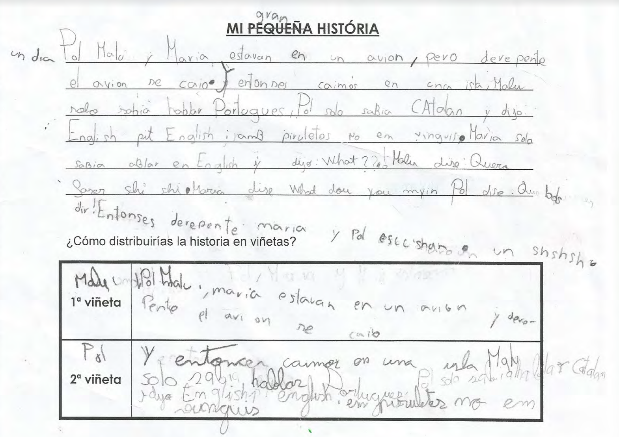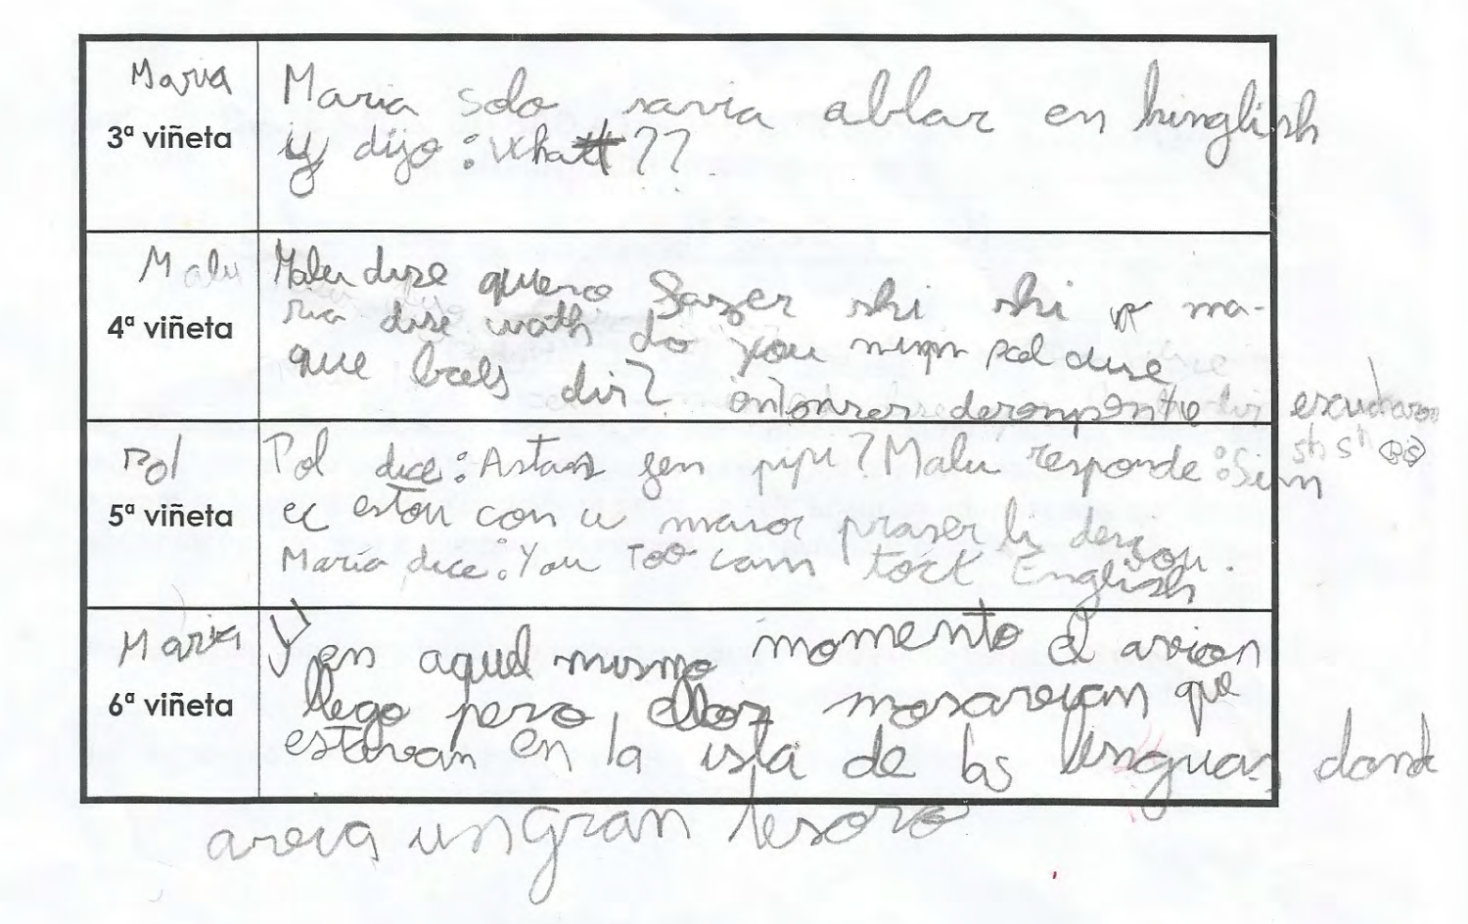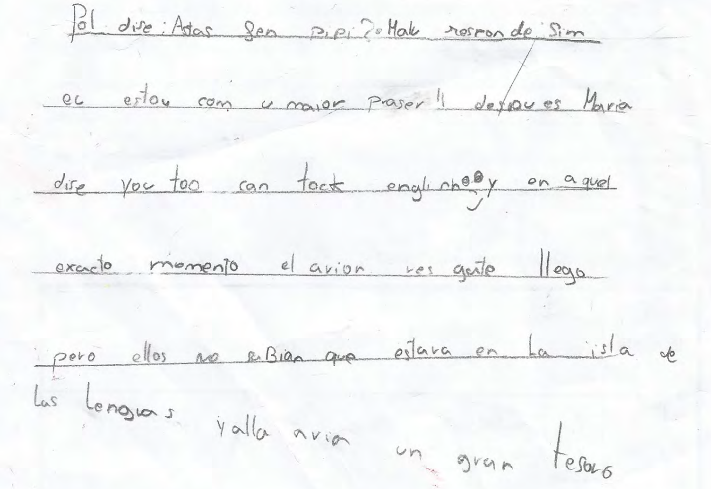
Figure 1: Handout completed by the students

The text tells the story of Pol, Malu and Maria, who were in a plane that suddenly fell onto an island. Malu only knew how to speak Portuguese, Pol only knew Catalan (although he does speak some English in the text) and Maria only knew English. The three characters engage in a dialogue in these three languages, until Maria realises that Pol and Malu also speak English. The rescue plane then arrives, although the three characters did not know that they were on the ‘island of languages’, where a great treasure was to be found. In their text, the children write, often phonetically, using linguistic resources from Catalan, Spanish, English and Portuguese. This version was then revised and placed on the 6 comic strip vignettes (see figure 1).

Finally, the text was revised again and it transformed into the illustrated version of the comic to be shared with others to read. In the final version, again transliterated as closely as possible to the original (see figure 2), the story reads:

Vignette 4
La isla de las lenguas

Pol, Malu y Maria estaban en un avión y
de repente se cayó

Entonces cayeron en una isla.
La isla era mágica y cambio nostras lenguas.
Hello!
؟
Lla algu!

De repente, no nos enten-
día mos y todos hablabamos
idiomas diferentes.
What?
¿Que falas?

Malu se fue a pasear y se encontró
con una poción mágica y se la bebió
¡Oh! ¿Que es esto
SH

Y esta poción hacía que les entendiera
a los dos: Maria y Pol
Os puedo entender
Malu on estabas?
Que miras

Así que finalmente todos
bebieron la poción y como
se entendieron se quedaron alli a vivir
¡Bien! Que bien podemos entender!
Pues como nos entendemos y nos xx tan bien…
NOS QUEDAREMOS A VIVIR!!

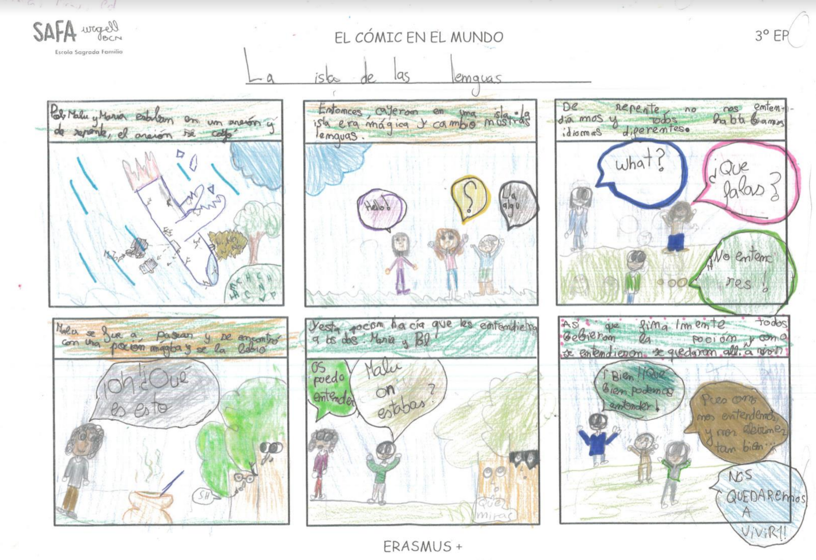
Figure 2: The final comic

In this final version of the comic, which uses much more standard spelling than the first, as well as image, the story goes as follows. Pol, Malu and Maria were in a plane that fell. The island was magical and it changed the languages they spoke (the dialogues include English, Catalan, Spanish and Portuguese). Malu went for a walk, found a magic potion and drank it. She could then understand Maria and Pol speaking their different languages. Maria and Pol drank the potion as well, and because they all now understood each other so well, despite their different languages, they decided to stay on the island to live.

Therefore, probably thanks to the input of the teachers and other students, an interesting transformation takes place from the first to the final version in terms of the message the story transmits about linguistic diversity. In the first version, it was by finding a common language – English – that the three characters were able to communicate. In the final version, it was by finding a magic potion for understanding people regardless of what they spoke that the characters were able to live together happily ever after. In this way, languages and cultures were bridged not only as part of the teachers’ plan for the project, by drawing on comics from different cultures and in different languages as a starting point, and by having children reflect on their own plurilingual experiences in planning their comics, but also by the children themselves in the process of developing multimodal reading materials for others, that both include and de-problematise diversity.

6. Establishing variable geometries

The examples presented so far in this chapter have suggested that practices that favour the development of reading competence in contexts of linguistic and cultural diversity deviate from traditional classroom ones. If we look closely, in the preceding sections of the chapter we have hinted at new ways of interacting with texts, with knowledge and with the social environments in which knowledge is produced. Education that takes into account the diversity of languages and cultures must be founded in processes of decentralisation (Castelloti & Moore 2010). As part of this decentralisation, teachers should not impose the languages or culture of the dominant group, but rather integrate them in the complex network of cultures and languages present at schools. Sources, genres and modes of text should be diversified, and this requires new approaches. Questions emerge such as: what types of visual resources are used? Does one begin to read from the front or the back? Are lines read from left to right or vice versa?

Furthermore, families must be involved in a dialogical process. On the one hand, they need to participants in classroom activities, helping teachers to build bridges between languages and cultures, as we have discussed in the previous section. On the other, they need to be part of institutional discussions aimed at establishing a common schema of understanding, which might sometimes involve seemingly basic cultural issues, such as knowing that the teachers’ voice is always important, whether she or he is a woman or a man.

The decentralisation process we are referring to also generates what we describe as variable geometries, in which there are no fixed centres, but rather interactive scenarios in which everyone plays a significant role. The scene described in vignette 5, which one of the authors experienced at a school he visited in Barcelona, is a good example for taking this discussion forward.

Vignette 5

Five year-old children have read the story, The tin soldier. The teacher suggests making illustrations for the chapters and then to tell the story to a class of even smaller children. Everyone has prepared a small fragment of the story with the help of the teacher; each piece is about the length of a sentence. When the day comes, the children tell the story at a considerably good pace and with significant agility for their age. But when it is the turn of a girl who has only arrived at the school that year, and who whose reading skills in Catalan are less developed, the reading slows down. Then, the girls who are sitting beside the newcomer, realising the difficulties experienced by their peer, start to help her. The girl on her left whispers the fragment to be read into her ear, while the girl on her right puts her hand on her shoulder. The teacher, who is not far behind them, exclaims “Wow, let’s see what happens now!”, filling the moment of silence that has been created. Just before the floor is handed over to the next reader, the teacher repeats the previous fragment in a louder voice, so that everyone can follow the story without difficulty.

The analysis of the reading situation presented above allows us to detect some of the elements of how the reading of the literary text, The tin solider, is approached. Firstly, there is an audience that is not the teacher, but rather other students waiting to hear the text as it is read aloud. Secondly, every child has received the necessary support to prepare her or his fragment. Thirdly, the girl who gets stuck receives effective and affective support from her peers, while the teacher also attends to the need of the younger children in the audience of being able to access the fragments in a clear and understandable manner.

Everything happens quickly in classrooms and it is often difficult to be aware of the wealth of detail that situations such as the one described above afford. In this case, it was possible to watch a video of the interaction with the teachers involved and to jointly reflect on the advantages of organising situations in which reading texts are approached in diverse ways. This activity, organised according to variable geometries, allowed roles to be distributed according to situations as they emerged on the fly. The five year-old students were both readers and also those who detected the support that was needed to help everyone become involved and succeed at the task at hand. The younger children listened attentively to the telling of the story. Finally, the teachers gave up their traditional role at the centre of the classroom interaction, thereby diversifying the communicative contexts emerging in the classroom.

7. Promoting interaction

The ability to interact and interthink (Mercer 2004) with others is a prerequisite for engaging in settings in which the ability to generate diverse communicative situations is to be valued. In all likelihood, the greatest difficulties emerging in interactional processes in plurilingual and intercultural scenarios are related to misunderstandings due to linguistic and cultural differences.

In one of the schools participating in the KOINOS project a meeting was held to present the physical version of the flying carpets for families (or the travelling suitcases). Besides books, the carpets included a blank notebook for each family to write down whatever they wanted in the languages they wanted. The idea was that different families would receive the notebook as the carpet continued its journey and could read what others had written there. The following vignette is the re-enactment of a dialogue that took place in Spanish after the meeting.

Vignette 6

After the meeting, a father approached the teacher and asked:

“I understand that we have to collaborate and share, school and family, so in the notebook my child should put his name (points to the cover) and I set him homework (opens the notebook and points to the first page).”

The teacher responds:

“Well, think that this book is for sharing with all the families of the class. You or your child can write or draw something related to what you have read in the books in the suitcase.”

The father cuts her off and asks:

“For example, I put words that I do not understand.”

The teacher:

“If that's what you want to share with the other families, yes. Think that the notebook has to be returned inside the suitcase. When the suitcase comes back to the school the teacher will read what has been written in the notebook to all the children. The next child will take the suitcase home, and they and their family will see what you have written and add their opinion.

The father:

“Oh yes, share!”

Interacting means having the ability to imagine different points of view. As shown in this vignette, the father’s preconceived ideas led him to interpret the message from a particular perspective that could translate as something like: school is mainly about homework. He at first applied a vertical perspective on the learning situation being promoted. Interaction with the teacher helped him to adopt a horizontal perspective ("you or the child") that promotes joint commitment to the task to "write or draw something related to what [both of] you have read in the books in the suitcase".

Dialogue is never entirely predictable. There is always room for surprise, as in any communicative situation, because what characterises it is openness to otherness, and to the novelty involved in encountering another. In the case of reading, the other is usually a text. In the case of writing, the other is not the corrector, but the reader. Like in any other type of dialogue, the reader should be open to what the text has to say. This means establishing connections between the lines being read and what they know, and with the reader’s own sensitivities. For this reason, ever reader is unique, because everyone gives a different meaning to what she or he reads. In this game, as Gadamer (1975) points out, everything is possible, and what is discovered in a text cannot be ignored. Gadamer also argues that there can be no dialogue, no possible interaction, if from the outset one is not willing to accept that they have something to learn from another. The displacement and mobility of points of view are essential requirements for any learning situation. This is particularly so in contexts where different languages ​​and cultures coexist.

8. Facilitating collaborative formative action

Richard Sennett (2010) recalls that since the times of Aristotle and more recently of Hannah Arendt, the ideal public space has been understood as a place where one learns from people who are different from them. He also reminds us that on occasions we do not have the capacity to react to difference. This is a challenge that we have often found in schools that have more than a noteworthy diversity of languages and cultures. We have often walked through school doors and found that the linguistic landscape was made up of signs written in the language considered to be the vehicular language of the school, and of murals on walls reflecting the culture of an autochthonous minority. We remember the crises amongst teaching staff when we have pointed out this paradox. We especially we like to recall their reactions after discussing these observations over a few training sessions. These reactions can be summarised in the following anecdote, reported by one of the authors of this chapter in his work with a school in Barcelona.

Vignette 7

It was the beginning of a new school year. There were changes in the teaching staff, with some new teachers joining the school. The management team, who had been the drivers of the training we had done at the school, inducted the new teachers by sending them out onto the street, rather than in offices or classrooms. They gave the new teachers a sheet with a series of words and invited them to go to different places in the neighbourhood, to detect how many languages ​​they could hear, and to learn and write down words in those languages. When the new teachers returned to the school, they began to talk about the characteristics of the environment and how to take into account the specificity of the context when designing classroom activities. Needless to say, the ideas that arose were all based on the need to make differences present in the environment visible at the school.

A teacher must map out differences in order to find singularities. In chapter 5 of this volume, the use of language biographies in the KOINOS project is discussed. We would like to highlight here that in their multimodal biographies, students speak about the languages ​​they use, when and with whom. But they also refer to their experience with oral or written texts, so we can gauge what situations they read in, such as in the following language biography text (vignette 8).

Vignette 8

A l’escola quan haig d’agafar un llibre
l’agafo perquè m’agrada la tapa i a part
perquè m’agrada de què tracta. A casa quan
llegeixo, llegeixo al matí quan no hi ha
escola, i quan hi ha escola
al llit fins que tinc son

Figure 3: Original Language biography text

The child explains that she chooses books at school that she likes by their covers and their contents, that she reads at home in the mornings when she does not have school, and in bed at night when she does. It would be naive to believe that every night in every child’s home there is someone telling a bedtime story; as naive as to think that interaction with written texts is standard in all homes. Yet this information is important for facilitating collaborative formative action. A teacher that one of the authors of this chapter worked with at a school in Barcelona came up with the creative solution reflected in the following vignette.

Vignette 9

The teacher wanted to know, at the beginning of the year, where her 8 year-old students came from and what languages ​​they knew, and asked them to write to their grandparents. The idea was to let the grandparents know that the school year was beginning in Barcelona. An exercise like this would not have presented too many problems in some classrooms, but in this one, where linguistic and cultural diversity was more than considerable, it gave rise to many questions. For example: what language should be used to write to grandparents living in Morocco? What if the grandmother lived in Barcelona, but could not read? Based on the questions that came up, the teacher was able to understand, without having to ask directly, what the family language and literacy practices of each of her students were like.

Uniqueness should be afforded recognition, not isolation. One must place him or herself among others to compare, to contrast, and to become aware of what is common and what is different about them. We return to Sennett, this time to refer to the distinction between border and threshold; the border is a limit, while thresholds are areas in a habitat where organisms interact significantly. We could also consider the structure of a cell, distinguishing between the wall and the membrane; the wall is a container, while the membrane is both porous and resistant. A teacher must map out the singularities in her or his classroom, but must do so thinking in terms of thresholds or membranes.

Whenever we hear the voice of teachers engaged in their work in schools where linguistic and cultural diversity are the norm, five issues emerge as significant for a positive learning environment, which we present here without intending to rank them. Firstly, they highlight the importance of good school management. Secondly, they mention the benefits of a horizontal division of labour amongst faculty. Thirdly, they speak of the need for specific training and resources. Fourthly, they express the difficulty that reaching understandings with families sometimes entails. Finally, they say they experience growth, both personally and professionally. Regarding this last point, a teacher describes her experience of working in an environment that facilitates collaborative formative action with these words: “Compartir vivències difícils amb els meus companys i companyes i d’altres més plaents ha representat un creixement personal molt important i el descobriment d’una part de la meva persona que no haurien deixat veure un altres àmbits” (Sharing difficult as well as other more pleasant experiences with my colleagues and others has meant very significant personal growth and the discovery of a part of myself that would not have emerged otherwise).

9. Evaluating reflexively

We have been in secondary schools where a major concern was to teach students Chinese sounds typical of the school’s vehicular language, which was obviously not their native one. We have heard teachers of small children complain that newcomers to their classrooms “did not speak anything” – i.e. they did not speak the language of the receiving country outside of the classroom. Small experiences such as these make us realise that both language teaching and language assessment often continue to ignore the action-oriented and plural approaches made explicit in policies that are now well implemented across Europe, such as the Common European framework of reference for languages: Learning, teaching, assessment, or others that are in others that are more recent in their creation, such as the Framework of reference for pluralistic approaches to languages and cultures.

The official language or languages of a particular territory tend to be prioritised in education, and, at best, the importance of introducing one or two foreign languages is taken into account. The design of language learning and assessment often takes as its starting point the four traditional skills: speaking and writing, reading and listening. We would like to focus at this point on a different linguistic activity that allows learners’ and users’ communicative competences to be activated. We refer to mediation, understood as an ability to interact in a type of transit or to build bridges between interlocutors. In any communicative situation different repertoires are brought into contact; what is expected of participants is that they be able to trigger the resources available to them to adjust the use of their repertoires to the situation at hand. Imbalances may be linguistic, pragmatic and even symbolic. We will present an anecdote referring to each of these dimensions, from which proposals for reflecting on language and culture, as well as on evaluation, might be extracted.

It has always has been true, but nowadays we can perhaps more assuredly assert, that language is gendered; gender would seem to be a universal feature. Yet grammatical gender is a characteristic of no more than 20% of the world's languages, and in all probability it is not a feature of many of the languages present in our schools. The ability to compare languages from the point of view of their linguistic forms of expression is something to be valued by teachers.

Similarly, it is important to realise that while greetings and goodbyes are universal, every culture makes specific and well-established protocols for enacting them available to members. Thus, when we read a novel in Japanese and it says that two people met and then said goodbye, we probably visualise the situation using pragmatic norms that would work differently if the novel were written in a European language, as the rituals that make up this everyday situation might be quite different from those we are more familiar with. We cannot assume, for example, that men and women would kiss each other hello and goodbye in our Japanese novel. If, on the contrary, the novel were situated in France, we might wonder if they exchanged two or three kisses, and even on which side of the face they would begin.

As for the symbolic dimension, we might refer to the mental representation that we have of the main characters of a story we are reading. Let us take a dragon. In Western culture, the dragon figure appears in many stories to represent the image of chaos. If we look closely, we discover that in the figure of the dragon the four elements that were separated by a superior being at the beginning of time, as depicted in Ovid’s Metamorphoses or in the Book of Genesis, come together. The dragon flies, walks, blows fire and swims. It represents, therefore, chaos that must be overcome. Some authors claim that children sleep soundly at night after hearing a story because they feel assured that chaos will not return, that is has been defeated. In Chinese homes, however, the situation may be quite different. In the East, the dragon represents the power of heaven that ordains and creates. The dragon ensures the periodical rebirth of nature and prosperity.

We conclude these remarks by making reference to gesture. The reader, through contact with the words and the situations described in a text, comes up with a mental simulation of what they have red. This means, as Bergen (2013) writes, that we see without what we see being present, or that we act without moving. We simulate in our minds what is described in language. Bergen gives the following example: if we take a sentence like “I spent all afternoon waiting for my brother on the corner”, we can all visualise the situation. It is likely that many Westerners would imagine a person standing, sitting or pacing. But these are not universal images. A person of Oriental origin might rather imagine a person sitting with crossed legs, for example.

All this leads us to conclude that when we are in situations in which linguistic and cultural diversity predominate, it is imperative that we reflexively evaluate the processes undertaken by children in comparing, contrasting, questioning stereotypes, enquiring into their own experiences, and in seeking reasoned explanations of phenomena connected with specific linguistic and cultural aspects of what is read.

10. Building partnerships with libraries

Speaking about the library means speaking about openness. Libraries, without a doubt, need to be spaces open to the circulation of words in their written, oral and audio-visual modalities. We present a vignette that illustrates the experience in this regard of one school in Barcelona that participated in the KOINOS project.

Vignette 10

The teacher proposed to her students to do research on ways of communicating and, in particular, on the languages of the world. After collecting information and discovering that there are many different languages in the world, the students took an interest in learning some of them. This was not a problem, as many of the children’s relatives spoke languages that were not usually present at the school. One father, who was born in the Democratic Republic of the Congo, told them the story, Rita is sick, in Lingala. The children and adults then spoke about the words and fragments of the story that they had understood. The father did provide some clues when he explained that in Lingala:

Orange is lilala,
Syringe is ntonga,
Doctor is moganga,
Sick is malady,
The name Rita is Lita.

The next step was to prepare a play about the story, as well as a drawing to represent it.

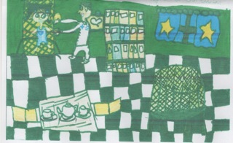
Figure 4: The drawing of Rita is sick

The school library is a reference point for all of the activities described in the vignette:

a) It is where students can research the subjects they are interested in, either through books, audio-visual materials, or using computers and the Internet.
b) It is a place for presenting and talking about cultural activities, such as for storytelling.
c) It can be a place for performances or audio-visual shows.
d) It is a place where stories created by the educational community can be stored for others to read.
e) It is an ideal place to present class experiences to other classes or families.

The openness of the mind and of the library are synonymous. Sometimes libraries might even leave their usual spaces of work and seek out potential readers. Some schools make morning and home times ones for reading or watching stories, using their foyers or playgrounds; adults, not necessarily teachers, become storytellers. Others help bring adult members of the community into their school or community libraries, such as we describe in the following vignette.

Vignette 11

The city of Salt, in Catalonia, has a 40% population of people from other countries, especially from Africa. They run a dual-language program that aims to recover the oral literacy tradition of immigrant families. The local community library organises weekly two-hour sessions with women from different cultural and linguistic backgrounds, who come with their children. In the sessions, the women tell stories that they remember from their childhood. These stories are then written up in Catalan and in the languages of origin of the women, illustrated, and published for schools to use. One of the story’s titles is telling of the experience: Teixint cultures (Weaving cultures).

The UNESCO Public Library Manifesto, approved in 1999, highlights the benefits of collaborative work between libraries, teachers and students. It points out that it has been shown that, when librarians and teachers work together, students’ reading and writing, their learning, their problem solving skills, and their ability to work with information technology and communication, all improve. In our case, we might add that the partnerships promoted by KOINOS between teachers, students, families and the community have helped us to understand that the library is not just a resource, but a dynamic agent of educational practices that aim to promote spaces of openness and dialogue in a world in which the confluence of languages and cultures is by no means an exception.

11. Conclusions

In this chapter we have presented some of the principles guiding the approach to pluriliteracies developed as part of the KOINOS project. The short vignettes have allowed the reader to share some of the experiential baggage that leads us to make the affirmations that we do. It is hoped that these experiences may serve as inspiration to other teachers and educational communities charged with the task of developing children’s reading competences creatively, critically and in socially just ways, in linguistically and culturally rich environments, and of sparking children’s imaginations as they set out on the lifelong journey of learning and becoming through their engagement with texts.

References

Bergen, Benjamin: Louder than Words: The New Science of How the Mind Makes Meaning. Basic Books: New York. 2012.

Blommaert, Jan / Rampton, Ben: Language and superdiversity. Diversities 13(2), 2011, pp. 1 – 22. http://unesdoc.unesco.org/images/0021/002147/214772e.pdf#214780

Bonal, Xavier / Castejón, Alba / Zancajo, Adrián / Castel, Jose Luis: Equitat i resultats educatius a Catalunya: Una mirada a partir de PISA 2012. Barcelona: Fundació Jaume Bofill. 2015. http://www.fbofill.cat/sites/default/files/Dossier%20de%20premsa%20Equitat%20i%20resultats%20educatius%20PISA%202012.pdf

Borràs, Eulàlia / Canals, Eulàlia / Dooly, Melinda / Moore, Emilee / Nussbaum, Luci: Creativity and innovation. Deliverable 4.3: Working Paper 3, 2009, pp. 9-21. http://www.dylan-project.org/Dylan_en/resources/Dissemination/Working-Papers/Working-Papers-4/WoPa4_WP3_26Feb10_inclAnnexes.pdf

Castelloti, Véronique / Moore, Danièle: Valoriser, mobiliser et développer les répertoires plurilingues et pluriculturels pour une meilleure intégration scolaire. L’intégration linguistique et éducative des enfants et des adolescents issus de l’immigration: Études et ressources, 4. Council of Europe: Strasbourg. 2010. https://www.coe.int/t/dg4/linguistic/Source/Source2010_ForumGeneva/4-ValoriserCastellottiMoore_FR.pdf

Gadamer, Hans-Georg: Wahrheit und methode. J.C.B. Mohr (Paul Siebeck): Tübigen: 1975.

Li Wei / Chao-Jung Wu: Polite Chinese children revisited: creativity and the use of codeswitching in the Chinese complementary school classroom. International Journal of Bilingual Education and Bilingualism 12 (2), 2009, pp. 193 – 211.

Mercer, Neil: Sociocultural discourse analysis: analysing classroom talk as a social mode of thinking. Journal of Applied Linguistics 1(2), 2004, pp. 137 – 168.

Rincón Bonet, Aurora: Competències lectores i èxit escolar. Fundació Jaume Bofill: Barcelona. 2012. http://www.fbofill.cat/sites/default/files/569.pdf

Schleicher, Andreas (ed.): Preparing teachers and developing school leaders for the 21st century: Lessons from around the world. OECD Publishing. 2012. https://www.oecd.org/site/eduistp2012/49850576.pdf

Sennett, Richard: “The Public Realm”. In Bridge, Gary / Watson, Sophie. (eds.): The Blackwell City Reader. Wiley-Blackwell: Malden, MA. 2010, pp. 261 – 273.

Street, Brian: What's ‘new’ in New Literacy Studies? Critical approaches to literacy in theory and practice. Current Issues in Comparative Education 5(2), 2003, pp. 77 – 91.

Vallejo, Claudia / Moore, Emilee. Prácticas plurilingües ‘transgresoras’ en un programa extraescolar de refuerzo de la lectura. In: Gandulfo, Carolina / Nussbaum, Luci (eds.): Hablantes bi/plurilingües y prácticas educativas: Perspectivas etnográficas e interaccionistas. Signo y Seña 29, 2016, pp. 33 – 61. http://revistas.filo.uba.ar/index.php/sys/article/view/543

The author learned both Catalan and Spanish as an adult and had had little exposure to children’s literature in those languages prior to this experience.
Available here: http://plurilingual.eu/en/e-portfolio/traveling-carpets
Transcription conventions: Intonation: Rising: ? Falling: . Maintained: , Pause: Short: (.) Longer: (duration) Lengthening: : :: ::: Self-interruption: - Overlap: [ ]
The complete set of materials and the products from the project are available here: http://plurilingual.eu/en/e-portfolio/traveling-carpets/flying-carpet-sagrada-familia-school-urgell-2016.
A video recording of the situation can be seen at: https://vimeo.com/195449563

